Single Family Rents Surge 9.3%
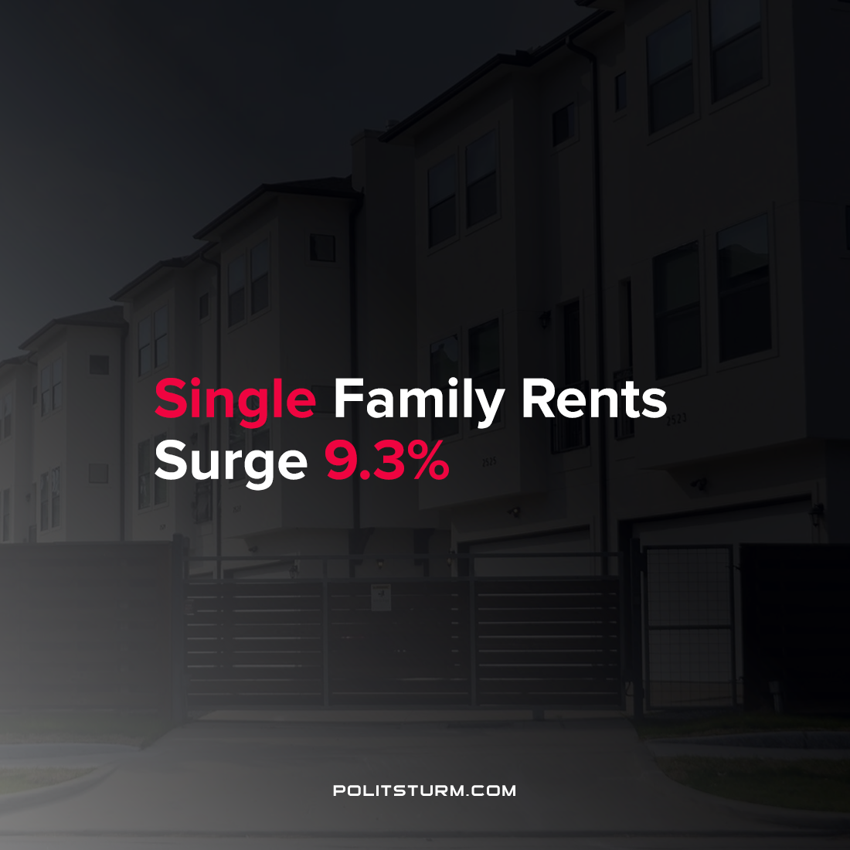

Original article
2021-10-21
1 min read

A report by CoreLogic found that rents are surging across the country as single family rents have increased 9.3% year over year. All metropolitan areas experienced rent growth for the first time since April 2020.
The U.S. was already having problems with housing affordability and the increase in rents will increasingly strain renters.
“The ongoing preference toward more living space — and slim for-sale inventory — is forcing would-be buyers back into renting, putting significant strain on the single-family rental market.”, said CoreLogic lead economist Molly Boesel.
The increasing rents have caused a surge in investment as real estate investors rush to buy rental properties. In the past year alone there were more than 43 announcements totaling $30 billion in capital inflows to the U.S. rental property market, according to John Burns Real Estate Consulting.
Under the capitalist mode of production, housing is a source of profit for the landlords and real estate investors. While the high-cost of housing and rents are a benefit to these groups, it is a detriment to renters. As long as the capitalist mode of production continues to exist, housing will continue to be a source of profit for the bourgeoisie and the private owners of land and capital.
Sources: 1 2

Original article

