“Silent Hiring” is Used by Almost Every Second Employer in Russia
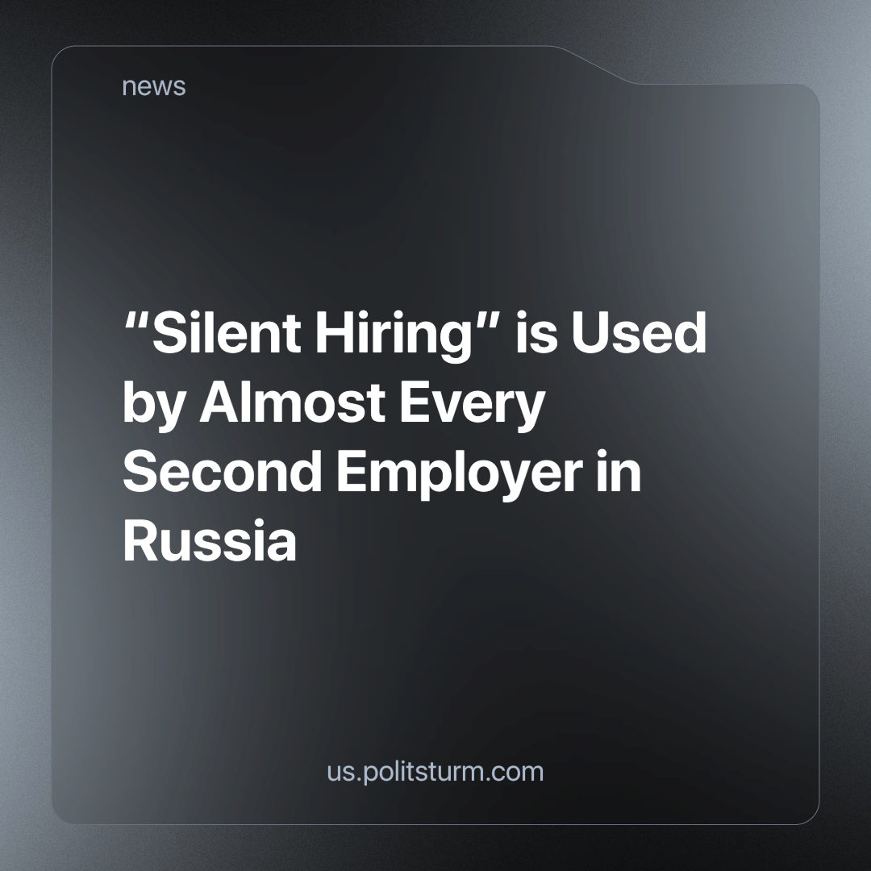

Original article
2024-04-18
2 min read

“Quiet hiring” or “Silent hiring” has recently become a very common system among employers in the Russian Federation. Almost half (46%) of Russian companies reported using silent hiring in 2023 as part of their HR strategy.
What is “silent hiring”? It is a shift of jobs onto existing employees: The employer, instead of spending time and resources on finding a new employee fitted to the job. They will assign an already existing employee to the task, thereby reducing the costs of hiring a new employee.
According to a survey conducted among HR specialists and top management, large organizations with a staff of 1000 or more people most often resort to “silent hiring”.
This highlights the essential goal of any private owner under capitalism - profit. After all, it would seem that larger companies, which have more resources and funds at their disposal to maintain a large amount of workers, might not lose out on hiring new employees suitable to their roles. However, in reality, just like smaller businesses, and often ahead of them, they strive to reduce costs in order to maximize profits. It is always more convenient for any employer to reduce costs, first of all, at the expense of the employees, cutting salaries or reducing the number of employees, and thereby increasing the burden on the remaining workers.
Such employers, of course, always find excuses, covering up increased exploitation with various reasons (real or fictitious), such as shortages of personnel, budgets, etc. However, if we look at the results of “resource optimization through internal employee mobility,” we will only see an increase in profits for the owners of such companies.
As a result, The lives of the workers deteriorate, forced to work longer and harder for wages which don't keep pace with rising prices. What can we say about those who, due to such strategies and “personnel management” systems, cannot find a vacancy or, at best, are forced to be hired under terrible conditions by similar employers, for whom the employee is just a tool for making a profit.
As long as there are those who own the means of production and those who do not own them at all, the latter are forced to wage labour for the former. As long as the market system exists, employers will seek to reduce their costs at the expense of workers, and the latter will remain merely powerless instruments in their hands.
Source: TheHRD -“Every second employer in Russia resorts to “silent hiring” from February 19, 2024

Original article

