Shortage of Skilled Labor in Russia
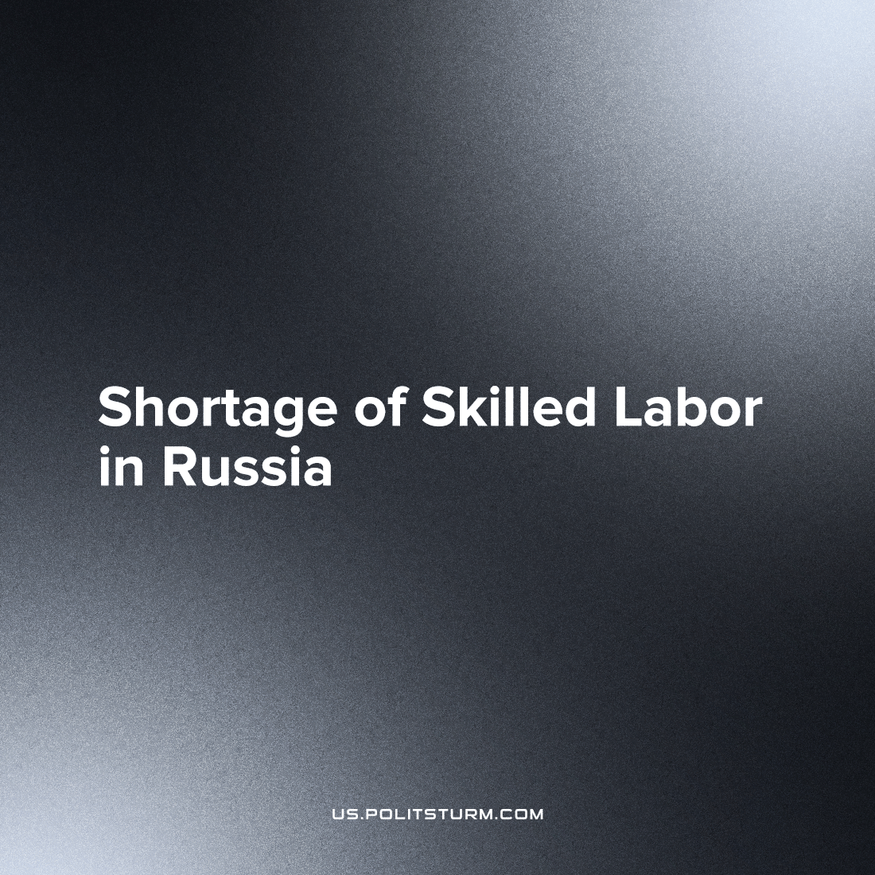

Original article
2023-07-28
1 min read

Russian companies have complained about the lack of qualified specialists. Employers say that due to a shortage of personnel they are forced to raise salaries for applicants, but even despite these raises enterprises cannot eliminate the shortage of personnel.
It is noted the sectors of the economy that suffer the most are those associated with material production.
Large Russian companies such as Russian Railways, Severstal, VTB announced an increase in wages. On average, salary increases for employees amounted to 10-12%.
But there is nothing to be surprised at. The deindustrialization of the country, destruction of enterprises inherited from the socialist USSR, the “optimization” of secondary and higher educational institutions, the methodical transformation of the working man into a stooge, and initiating low wages that dooms skilled workers to struggle to make ends meet, makes the younger generation less likely to choose this path. This situation cannot be corrected by a meager increase in wages for workers, while top management and business owners receive fabulous profits by appropriating the labor of their employees.
Source: 1

Original article

