Shop-Vac Announces Layoffs and Shifts Production to China
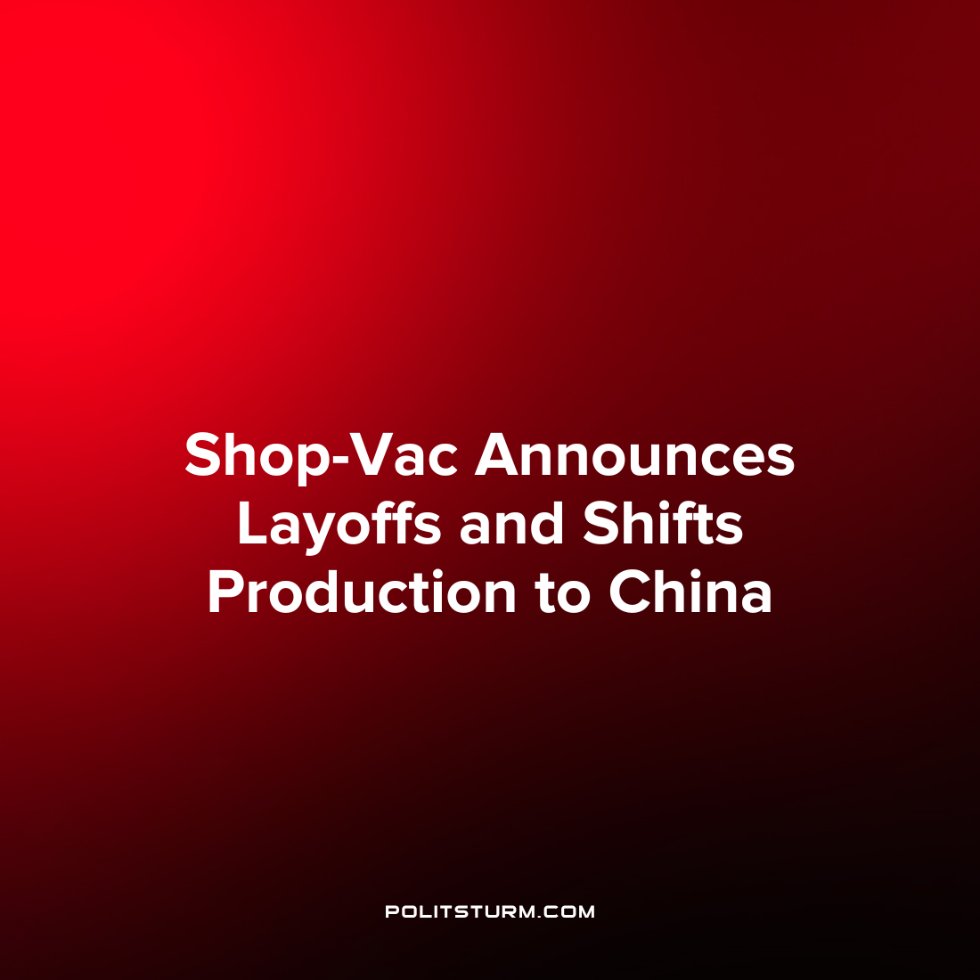

Original article
2023-02-13
1 min read

GreatStar Tools USA Inc., the owner of ‘Shop Vac’ dry/wet vacuums announced that it will be laying off workers and moving domestic production over to China. Greatstar is associated with Hangzhous GreatStar Industrial Co., an industrial hand-tool conglomerate based in China, which announced the acquisition of Shop-Vac back in 2020.
“We are thrilled to add another iconic American brand to GreatStar’s portfolio of brands – alongside Arrow Fastener, Pony, Jorgensen, Goldblatt, and Prime-Line Products – particularly one that gives us the opportunity to bring manufacturing and jobs back to the US”, said Group President of GreatStar Tools Gary DeBoff back in 2020 after the acquisition.
It appears that the “opportunity to bring manufacturing and jobs back to the US” was a short-lived one as the company now announces layoffs and shifts in production. The company will layoff production workers in the United States and will instead shift production of the residential and commercial Shop-Vac to China. Logistics, HR, finance, and IT operations will remain in WIlliamsport, Pennsylvania.
The uneven development of the capitalist economic system demonstrates that production will shift to wherever it is most profitable geographically. Manufacturing employment in the United States has been on a prolonged decline and is currently at approximately 13 million workers, down from 17.2 million workers back in January 2000. Capitalists will move production to wherever they can maximize profit, regardless of the negative implications for the larger society, which ultimately falls upon the workers.
Sources: 1 2 3

Original article

