Several Myths about The Great Patriotic War
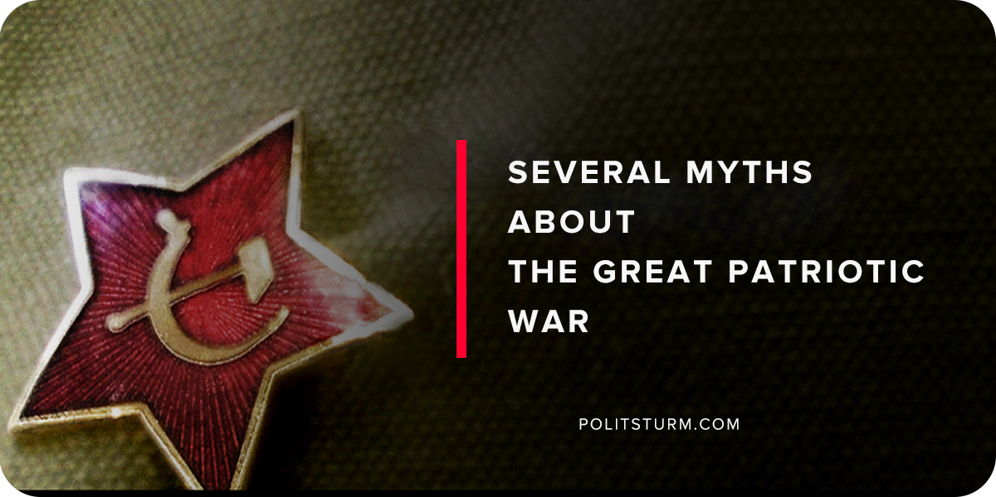

Original article
2018-05-09
15 min read

Myth: The Soviets won because they threw their troops at the Germans and because the Germans invaded during the winter.
Most serious Soviet historians believe that the breakneck industrialization that occured in the Soviet Union during the First and Second Five-Year plans was the key to successfully defending themselves from Nazi Germany. In the 1930s, Hitler had often spoken about destroying the communists, considered the Soviet Union to be the seat of the Judeo-Bolshevik conspiracy, and had written about his intentions to invade the Soviet Union in Mein Kampf. While the rate of industrialization could have taken other paths (Nikolai Bukharin, for example, advocated a more gradualist approach to building socialism), the hostility of the Western powers led to a policy favoring national defense. This was the policy under Stalin. In his defense, he was reported to have said:
“No comrades… the pace must not be slackened! On the contrary, we must quicken it as much as is within our powers and possibilities. To slacken the pace would mean to lag behind; and those who lag behind are beaten…. The history of old Russia… was that she was ceaselessly beaten for her backwardness. She was beaten by the Mongol Khans, she was beaten by Turkish Beys, she was beaten by Swedish feudal lords, she was beaten by Polish-Lithuanian Pans, she was beaten by Anglo-French capitalists, she was beaten by Japanese barons, she was beaten by all – for her backwardness… We are fifty or a hundred years behind the advanced countries. we must make good this lag in years. Either we do it or they crush us.”
Socialist construction transformed a semi-feudal economy into a modern fighting force. The gross output of large-scale industry in 1940 was 11.7 times that of 1913, the output of large-scale engineering and metalworking industries was increased 41 times, and the output of high-grade rolled metal was increased 80 times. In tsarist Russia, there had been no production of cars, tractors, aluminum, magnesium, or rubber. Oil output before the war was 3.5 times more than in tsarist Russia. The eastern regions of the USSR alone produced 2.3 times more coal, twice as much steel, 1.7 times more lead, and 18.8 times more zinc than the entirety of the Russian empire in 1915. In comparison to tsarist Russia, the socialist state was not dependent on foreign capitalist nations for economic production which proved useful in the periods when they were effectively isolated. Because of the increase in agricultural machinery, the Soviet Union was producing several times more agricultural output than during the First World War and was able to build up substantial state reserves before the invasion. The Soviets knew that another conflict was imminent and the pre-war strategy had been to buy as much time as possible to continue the military build-up.
Despite the major setbacks at the beginning of the war with the loss of territory from Belarus to Moscow, the Soviets actually produced more during the war then they had before Operation Barbarossa, quadrupling its output of munitions between 1940 and 1944. Throughout the four years of fighting, factories were able to pump out 100,000 tanks, 130,000 aircraft, and 800,000 field guns. 3,400 military aircraft were being produced monthly.
One advantage of the USSR’s centralized administrative system that the tsarist regimes lacked was the ability to control the flow of food and industrial goods that kept civilians from starving while continuing the war effort. In the early day of the war, entire industrial plants and civilian populations were moved east to the Urals to protect from the Germans. Trains transported workers, engineers, and technicians, kolhoz farmers and their livestock.
The fighting was incredibly intense on the Eastern front when compared with the West because of the Nazi’s ideologial belief in the inferiority of the people of Slavic descent, deeming them to be “Untermenschen” or sub-humans. Millions of Jews, Belorussians, Ukrainians, and Russians met their death in concentration costs. The conquered people quickly understood that they faced either execution, forced labor, or starvation in the death camps at the hands of their German occupiers. In Baba Yar, the Nazis massacred 33,771 Jews with machine guns over the edge of a ravine and in the Russian town of Cherkessk, there existed “twenty-four vast pits filled with the corpses of men, women and children tortured and shot by the German monsters.” The kolkhozes were set delivery quotas much higher than Stalin had ever required. German Field-Marshal Reichenau had reminded his forces that “to supply local inhabitants and prisoners-of-war with food is an act of unnecessary humanity.” This disregard for slavic people could be seen in the Nazis policy of extermination; while Jews in the occupied Western European countries were shipped off to concentration camps in Eastern Europe, so as not to upset the public sentiment of Western Europeans, Jewish people in Eastern Europe were massacred in their own backyard and buried in mass graves. The same policy was to apply to members of the Communist Party.
As these crimes became clear to the Soviet people, mass resistance began. In occupied territory, the partisan detachments, consisting of communists, komsomol members, and anti-Nazi patriots, bravely fought a guerilla war against the Germans and pro-fascist forces from the forests of Eastern Europe, sabotaging the enemy’s supply lines and leading attacks. By mid-1942, more than 100,000 partisans were operating against the Germans in Eastern Europe. German soldiers always remembered that they were hated by the local populations as captured partisan and national hero Zoya Kosmodyanskaya made clear before she was executed: “German soldiers, give yourselves up before it’s too late.” The response by the Wehrmacht was to round up a hundred local inhabitants, selected at random, and execute them by firing squad, for every German killed by partisans. 11 million civilians are believed to have been massacred by the genocidal policy of the Nazis which was a significant contributor to the mass resistance shown by the Soviet people.
Nationalist sentiment during the war kept the fight going and unified many of the once divided political factions within the USSR. In a 1941 edition of Krasnaia Zvezda, writer Ilya Ehrenburg wrote that “all distinctions between Bolsheviks and non-party people, between believers and Marxists, have been obliterated.” Russians and other ethnic groups were encouraged to believe that they were fighting for the Motherland similar to Mikhail Kutuzov and their ancestors who took part in the Napoleonic War. The state even ended the policy of persecuting the Russian Orthodox Church and allowed for the leadership of Patriarch Aleksi who, in turn, collected money for the war effort. Kulaks and other imprisoned individuals from the class struggles of the late-1920s were allowed to enlist in the Red Army in return for their rehabilitation. Restrictions on peasants owning private plots of land were relaxed and they were allowed to sell their produce on the open market. To Russians and other ex-Soviet countries, the conflict is not known as the Second World War, but instead the “Great Patriotic War”.
Regarding the military front, the Soviet people fought for every inch in one of the most brutal fronts in modern history. Both sides applied a strategy of “scorched-earth”, first when the Soviets retreated to the East, and again when the fascists retreated towards Berlin. While in occupied territory, the Germans regularly looted the residences of local people, attacked non-combatants, and bombed city buildings in an effort to terrorize the population.
During Operation Tycoon, the German army, once thought to be invincible, was repelled in the suburbs of Moscow for the first time in the history of the war. In October, German forces encountered considerable resistance from both the Red Army and local recruits that they were effectively blocked from the city. By November, the Wehrmacht had failed to take Moscow, and with winter coming and their supply lines overstretched, the Soviets had prevented them from winning the ‘lightning war’ that Hitler had imagined.
Leningrad was completely blockaded by German and Finnish forces for 872 days, with the only passage out through Lake Ladoga. Cut off from food, fuel, and other supplies, over 780,000 people perished from starvation or the cold over the first winter. Many other thousands were killed by the continuous shelling of the German and Finnish armies. It was not uncommon to find bodies littered on the streets of those who collapsed from hunger. Despite this, the entire citizenry did their part to defend the city. Trenches and barricades were constructed to defend the city from the surrounding armies. When they were not attending classes, children participated in the assembling of military hardware in factories. The Lagoda was used to transport food to the city; by boat in the summer and by trucks in the winter.
In the suburbs of Stalingrad, the Wehrmacht and their allies (the Italians, Romanians, Hungarians, and Croatians) were surrounded in November 1942. Both armies had orders not to retreat and in January 1943, after intense fighting in what is believed by historians to be one of the largest and deadliest battles in the history of warfare, the Soviets reclaimed the city. The death toll for the Soviet side was more than 1,000,000 men while the fascists lost near 700,000 and had 91,000 taken prisoner.
Then in Kursk, the Soviets under the leadership of the experienced General Zhukov defeated the Germans with the use of the superior T-34 tank in the largest tank battle in history.
Every country in Eastern Europe with the exception of Yugoslavia and Albania was liberated from the Nazis by the Red Army up to the point of Berlin. On the 7th of May, the Nazis surrendered to the Western allies and the next day, to the Soviets.
The notion that the winter or the superior numbers of Soviet soldiers that brought about the defeat of the Wehrmacht is not only an incredible distortion of historical record but also a great insult to the huge sacrifice that the Soviet people underwent during the war. If it had not been for the transformation of the Soviet economy in the 1920s and 30s, as well as its flexibility in dealing with war time realities, the state would have surely collapsed as it had in the First World War. The mass mobilization of a rather unified camp all with the intention to defend their homeland from genocidal invaders contributed much to the cause. Finally, the efforts of the partisans and the Red Army in a brutal war for survival eventually won the day for the Soviet people.
Myth: Nationalist groups in Eastern Europe only collaborated with the Nazis to liberate their countries from the Soviets.
Many groups in the Soviet Union collaborated with the Nazis, not out of desperation as could be said for many in the Western occupied states, but out of political ambition and in some cases political affinity with the Nazis.
Lieutenant-General A. N. Vlasov, a “moderate socialist” held a personal animosity towards Stalin for some of the mistakes he had made during the start of the war. In Vlasov’s case, Stalin had refused his request to withdraw his forces before getting surrounded by the enemy in the early hours of Operation Barbarossa. Vlasov was forced to surrender in 1942 to the Wehrmacht. The once patriotic Soviet citizen did not, however, accept defeat as his other comrades did, but instead, chose to fight alongside the Wehrmacht in the “Russian Liberation Army”, created from Soviet POWs, in order to overthrow the Soviet leadership in Moscow. After an interview with Himmler himself, Vlasov was given the authority to create the RLA as early as 1943 with help from German recruiters in the P.O.W. camps. His nieve intention had been to turn on the Germans once he had captured power but Hitler had seen through him and assigned the RLA to guard duties. Vlasov was eventually captured and hanged while his soldiers were either executed or send to prison for terms ranging from 15 – 25 years.
While most of the population of Eastern Europe was considered to be “subhuman”, some, such as the Hungarians and Romanians, sent military contingents to fight alongside the Nazis. In what had been Yugoslavia, Croats were given favored status by the Fuhrer and in the occupied Baltics, the Latvians, Estonians, and Lithuanians were encouraged to form SS units. Volunteer military units from the non-Slavic nationalities, such as the Turkestani, Armenian, Azerbaijani, Georgian, Tartar, and North Caucasian legions, were formed. Some smaller ethnic groups who had collaborated en masse with the Nazis such as the Crimean Tartars, Chechens, and Volga Germans were relocated to Siberia or Central Asia where they would not be a problem. At the end of the war, all accusations of mass collaboration had been dropped and they were all allowed to return to home and reconstitute themselves as a autonomous political units. Unlike the Japanese-Americans, the deported ethnic groups of the USSR were not confined to camps.
In Soviet Ukraine, collaboration took on larger proportions. Many Ukrainian peasants gave the traditional offering of bread and salt to the Germans. In with the Nazi armies came the Nachtigall and Roland Battalions, composed of volunteer Ukrainian nationalists operating under the orders of Stepan Bandera’s Organization of Ukrainian Nationalists (OUN). It is flat out false to say that the Ukrainian nationalists were in fact pro-democratic forces who also struggled against the Nazis as Bandera’s forces received training in Nazi Germany prior to Operation Barbarossa and some were used in the invasion of Poland in 1939, all prior to the invasion of the Soviet Union. In late 1941, these groups were reorganized into police battalions to preside over the restless occupied territories of Poland and Ukraine. During that time, the nationalists published pro-Nazi papers such as Volyn, Krakivski Visti, and Lvivski Visti. In a more regional context, the Ukrainian nationalist forces took pressure off of the German front lines in Russia by concentrating on the domestic partisan resistance in Ukraine. In addition, the pro-Nazi Ukrainians willingly participated in the genocide against the people of Eastern Europe. A Jewish-Ukrainian from Kolomija, describing the nationalists’ bloodlust, recalled that, “the moment the Germans came in, (the Ukrainian nationalists) put on white armband and they went on a killing spree.” She recalls a moment when she and 17 other people were hidden in bunker;
“We heard a shot close by. Later a girl and myself went up quietly from the basement… We looked around, went out, there was a pregnant woman lying. Her baby was moving in her still. She didn’t speak but she was still alive. Then we heard something coming close. We ran away… When I went up to see what was going on, the picture we saw will never be erased from my mind. Ten or twelve Ukrainian police walking by in their high leather boots; all covered with blood. They went to the well which was at the end of our street to wash off the blood.”
15% of the Jewish population of Western Ukraine, or 100,000 people were butchered by German and Ukrainian nationalists in the first eight months of occupation. The role was primarily given to Ukrainians to murder jews, as Kohn mentions; “Whenever Jews were slaughtered, four or five Germans would participate, ‘helped’ by 100 or 200 Ukrainian nationalists. In his autobiography, Kohn explains how the partisan resistance fighters came to the rescue of the Polish inhabitants of Pshebrazhe who had lost more than 40% of its population to Ukrainian fascists.
Nazi-Ukrainian collaboration did not end with the liberation of Ukraine by the Red Army as revealed by Nazi officer Schtolze during the Nuremberg trials.
“During the retreat of German troops from the Ukraine, Kanaris personally instructed the Abwehr to set up an underground network to continue the struggle against Soviet power in Ukraine, to organize acts of terrorism, subversion and espionage. Competent agents were left behind especially to direct the Nationalist movement. Orders were given to install caches, to store munitions, etc. To maintain liaison with these bands, agents were sent across the front line.”

Original article

