Seoul Bus Drivers' Strike Forced to Raise Their Salaries
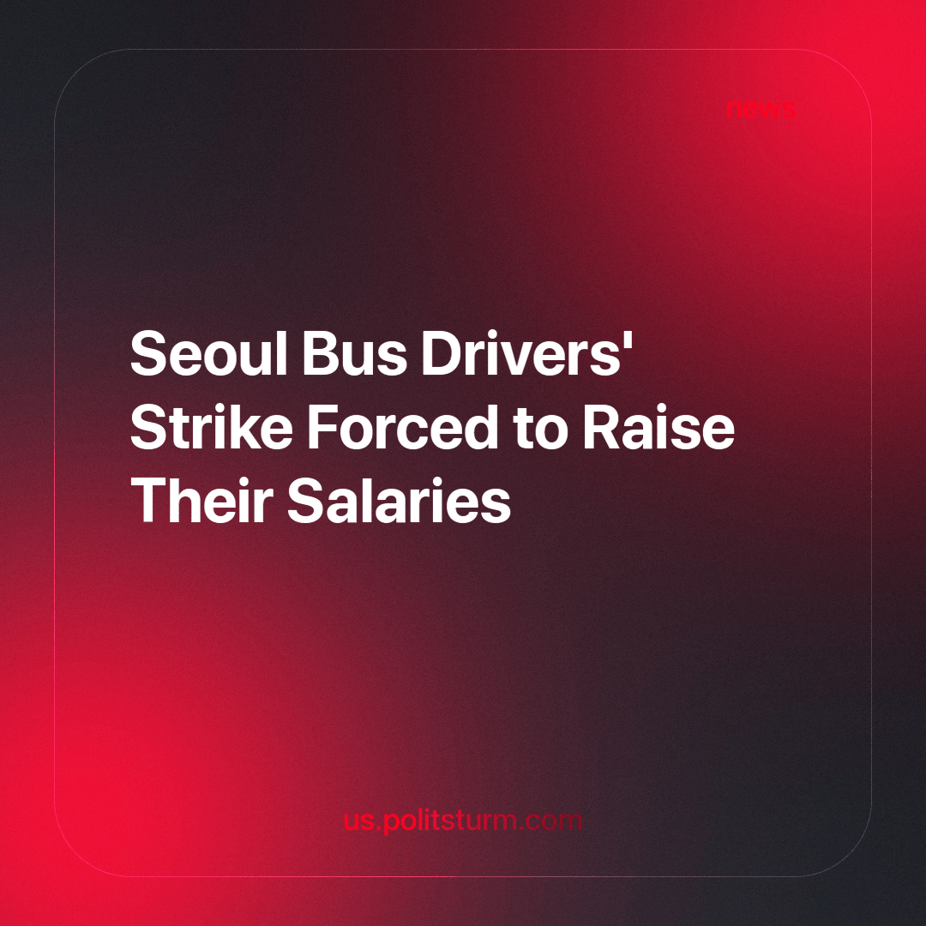

Original article
2024-03-30
1 min read

Recently, bus drivers in Seoul ended their strike after reaching an agreement with management to raise wages by 4.48%. The strike caused chaos during Thursday morning rush hour when everyone was heading to work. Approximately 7,000 out of 7,382 buses were out of service for several hours.
Initially, the union representing the interests of drivers requested a 12.7% salary increase, but management felt that this was excessive and offered 2.5% instead. For reference, inflation in 2023 averaged 3.6%. Despite being the longest strike in 12 years, drivers returned to the road in the evening, and the wage issue was resolved within a few hours. [1]
Meanwhile, young doctors in South Korea continue their strike. They were compelled to do so due to the government’s plans to increase the quota for training doctors, which will result in reduced salaries for specialists. While doctors hold highly paid positions in South Korea, the real concern lies elsewhere. Becoming a doctor involves extensive and expensive education, with costs starting at $100,000. Consequently, many doctors study on credit, work in low-paid positions for an extended period, and only after 15 years can they become highly paid specialists. If more applicants pursue medical studies, young doctors may remain burdened by student loan debt.
The South Korean population supports the government’s decision to expand physician training slots, hoping it will lead to lower prices for medical services and increased affordability in rural areas. This situation pits doctors, who seek to maintain their livelihoods, against the public interest. The capitalists have skillfully intertwined the interests of the medical profession and the general population. [2]
South Korea needs a Communist party that can unite trade unions across different professions and public organizations to fight for the working class. In the case of doctors, it should explain to workers the harmful impact of the capitalist system, which compels students to take out loans just to learn how to save lives. As demonstrated by the drivers’ union, collective efforts yield impressive results. When this collaboration extends beyond a single union to encompass the entire working class, they will be better equipped to fight effectively for their future.
Sources: 1, 2

Original article

