Seizure of Roscosmos Assets in Kazakhstan
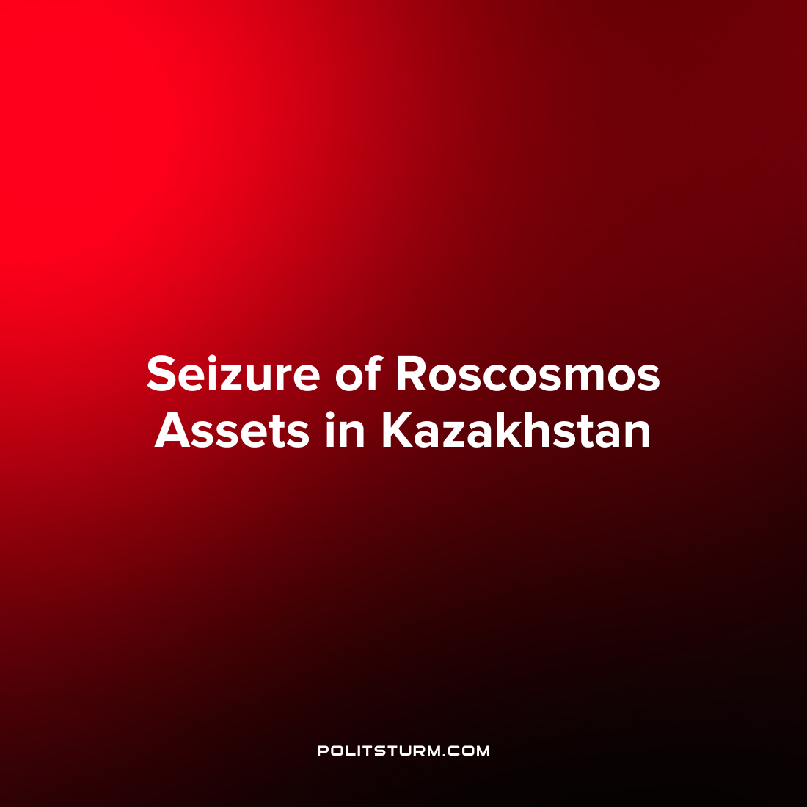

Original article
2023-04-09
1 min read

A Kazakh court has seized the property of the main operator of Russian cosmodromes, the Centre for Ground-Based Space Infrastructure Operation (TsENKI).
The reason for the seizure was a debt of 13.5 billion tenge, or 2 billion roubles, owed to JSC Joint Kazakh-Russian Enterprise Baiterek. The debt arose as a result of environmental impact assessment work carried out on Russia's new Soyuz-5 rocket.
Until the investigation is completed, TsENKI is prohibited from withdrawing any material assets from Kazakhstan and its head is prohibited from leaving the country.
The Baiterek enterprise was established in 2005 for the purpose of implementing a common space exploration program. The program envisaged building a new launch pad and launching new ecological rockets.
It was originally planned that Russia and Kazakhstan would use a Ukrainian Zenit rocket, but after the annexation of Crimea in 2014, this option fell by the wayside. Russia began developing the Soyuz-5 rocket, while Kazakhstan was to prepare a new launch pad for it.
In July 2022, Kazakh authorities reported that the opening of the launch pad was delayed by six months to a year. According to KZ24, Kazakhstan's harsh actions may have been prompted by criticism from the new head of Roscosmos, Yury Borisov, of Kazakhstan's communications minister, Bagdat Musin, who is in charge of the space area.
Borisov criticized the postponement of the launch pad construction, in particular. Musin called Borisov's criticism a "diplomatic miscalculation". The current situation could significantly complicate further cooperation in space exploration.
Whether the debt is the real reason for the seizure of property or a formal pretext is not yet clear. However, there is an interesting trend of gradual estrangement of Kazakhstan from Russia against the background of recent developments, despite close economic, political and cultural ties.
It should be remembered that under capitalism there can be no reliable allies, as everyone is only pursuing their own gain, and as soon as an opportunity presents itself to "take something from their neighbor", it is only a question of how to do it with the maximum output.

Source: Country Capital - "Kazakhstan seizes Roscosmos assets" 13 March 2023

Original article

