Sabre-Rattling Escalates as Kashmir Is Caught Between Powers
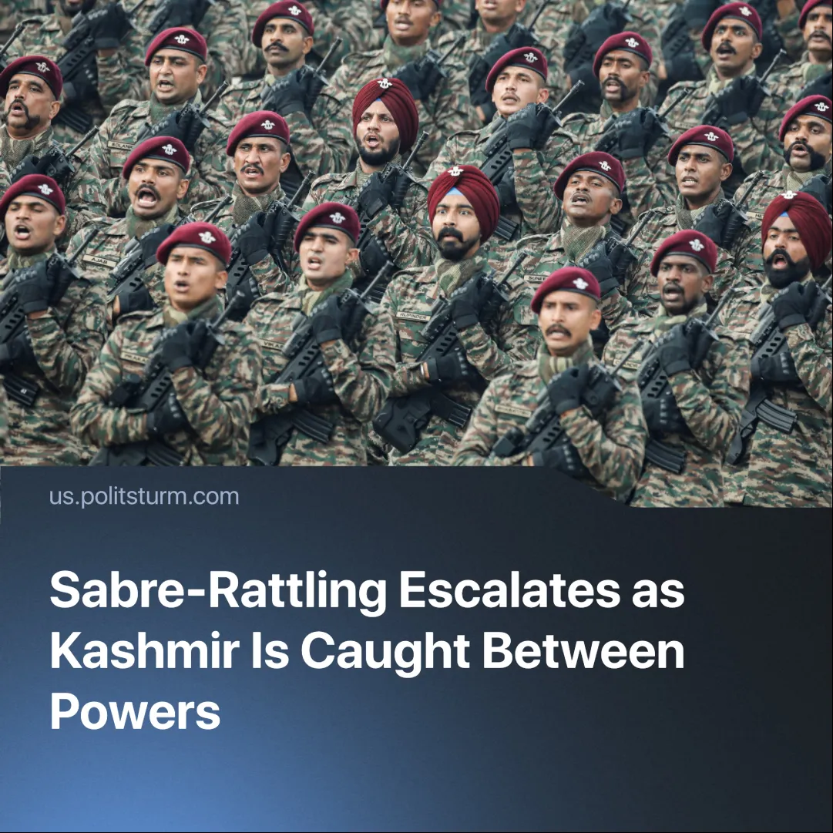

Original article
2025-05-05
2 min read

Tensions between India and Pakistan escalated after a terrorist attack on April 22, 2025, killed 26 civilians in Pahalgam, Kashmir, sparking a diplomatic crisis and intensifying inter-imperialist rivalries and drawing the attention of China.
Details. Indian officials have accused Pakistan of supporting cross-border terrorism. In response, India expelled Pakistani diplomats, suspended the 1960 Indus Waters Treaty—a water distribution agreement vital for agriculture—and deployed its most advanced aircraft carrier, the INS Vikrant, to the Arabian Sea.
► In response, Pakistani officials denied any involvement, suspended trade and the Simla agreement—a key peace treaty—and retaliated by banning Indian aircraft from Pakistani airspace, expelling Indian diplomats, and preparing for what they called an “imminent planned strike” by India.
► Both sides reinforced positions along the Line of Control (LoC)—the de facto border dividing Kashmir into two militarised zones—and have engaged in cross-border gunfire exchanges.
► China, which shares a land border with both countries, called for a "swift and fair investigation" into the Pahalgam terror attack, while reaffirming its strong support for Pakistan in "defending its sovereignty and security interests" amid rising tensions with India.
Context. The Kashmir conflict stems from the 1947 partition of British India. The region’s last monarch, Hari Singh, initially sought independence but dictatorially acceded to India in exchange for military support against Pakistani-backed tribal militias. This unilateral act triggered the first Indo-Pakistani war.
►In 1972, India and Pakistan signed the Simla Agreement in an attempt to improve bilateral relations and restore peace with each other.
►The conflict has worsened over decades of recurring tensions. In 1974, India acquired its first nuclear weapon, and Pakistan followed suit two decades later-intensifying global concerns over potential nuclear conflicts.
► China has supported Pakistan through the China-Pakistan Economic Corridor (CPEC), with major infrastructure and investment interests running through Pakistani-administered Kashmir as part of the Belt and Road Initiative.
►China and India have had a tense border dispute since the 1950s. Although they agreed to avoid firearms and de-escalate after recent clashes, sporadic hand-to-hand skirmishes continue.
Important to Know. The Kashmir conflict serves the ruling classes of India and Pakistan, who fuel nationalism and militarism to preserve power, suppress dissent, and distract from worsening crises under capitalism.
► The Kashmiri nation—defined by a shared language, culture, historical experience, and common territory—has long endured repression under British colonialism and later Indian and Pakistani capitalist rule. The national question remains unresolved under monopoly capitalism, which sustains this oppression through militarisation, denial of self-determination, and systematic violence.
► Armed “resistance” groups have emerged in response, some claiming to fight for national liberation, but these are often manipulated by regional and global imperialist forces. Despite being shaped by real grievances, many of these formations serve the aims of India, Pakistan, or foreign powers rather than the interests of the Kashmiri working masses.
► The conflict is driven by broader inter-imperialist rivalry. The U.S. supports India as a key partner to encircle and contain China, while China backs Pakistan to secure its regional influence and protect strategic investments like the China-Pakistan Economic Corridor (CPEC). For China, escalation in Kashmir poses a direct threat to its Belt and Road ambitions, making it a more immediate concern than distant fronts like the war in Ukraine.

Original article

