Stalin on Ready Made Solutions
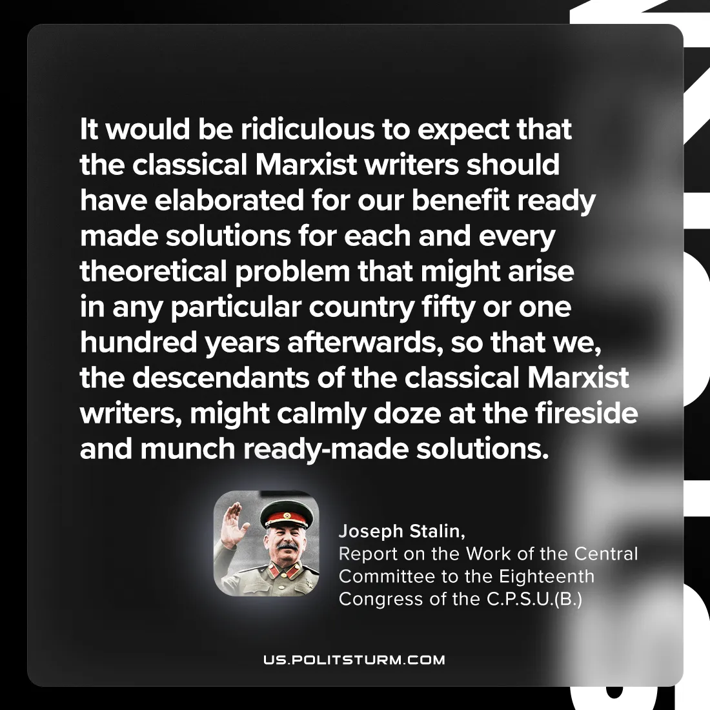

Original article
2024-07-16

"It would be ridiculous to expect that the classical Marxist writers should have elaborated for our benefit ready-made solutions for each and every theoretical problem that might arise in any particular country fifty or one hundred years afterwards, so that we, the descendants of the classical Marxist writers, might calmly doze at the fireside and munch ready-made solutions."
Joseph Stalin, Report on the Work of the Central Committee to the Eighteenth Congress of the C.P.S.U.(B.)

Original article

