Stalin on the Functions of the State
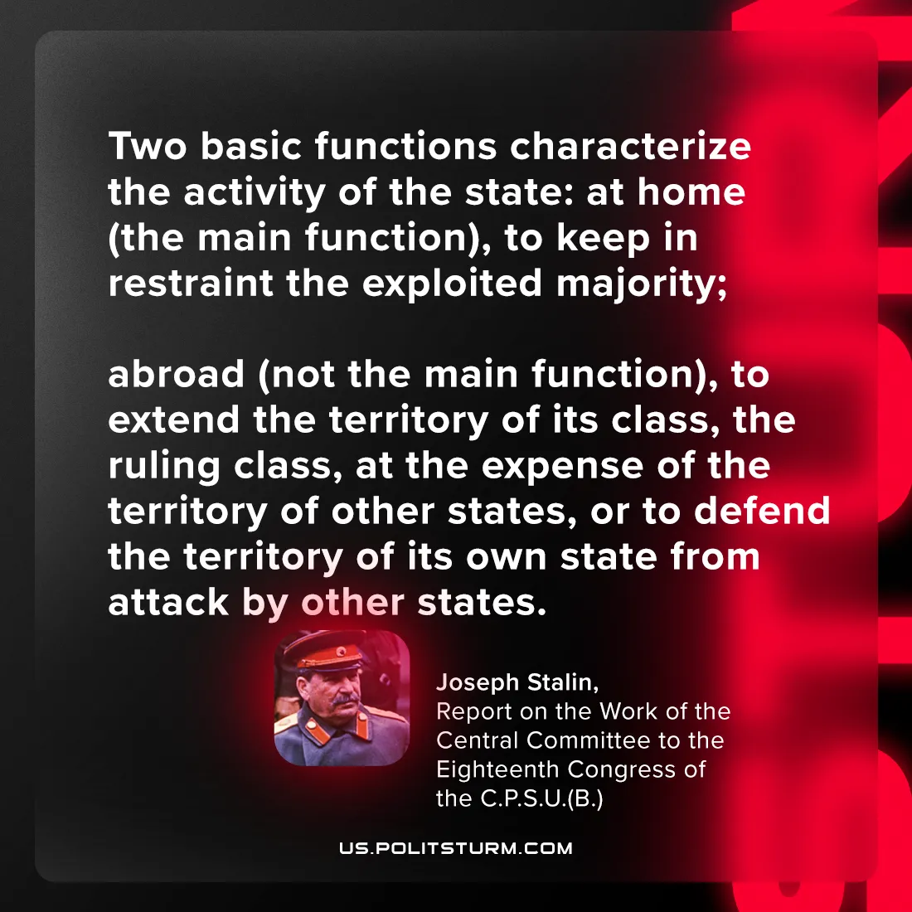

Original article
2024-07-23

"Two basic functions characterize the activity of the state: at home (the main function), to keep in restraint the exploited majority; abroad (not the main function), to extend the territory of its class, the ruling class, at the expense of the territory of other states, or to defend the territory of its own state from attack by other states.”
Joseph Stalin, Report on the Work of the Central Committee to the Eighteenth Congress of the C.P.S.U.(B.)

Original article

