Russians Flee Mobilization in Kazakhstan
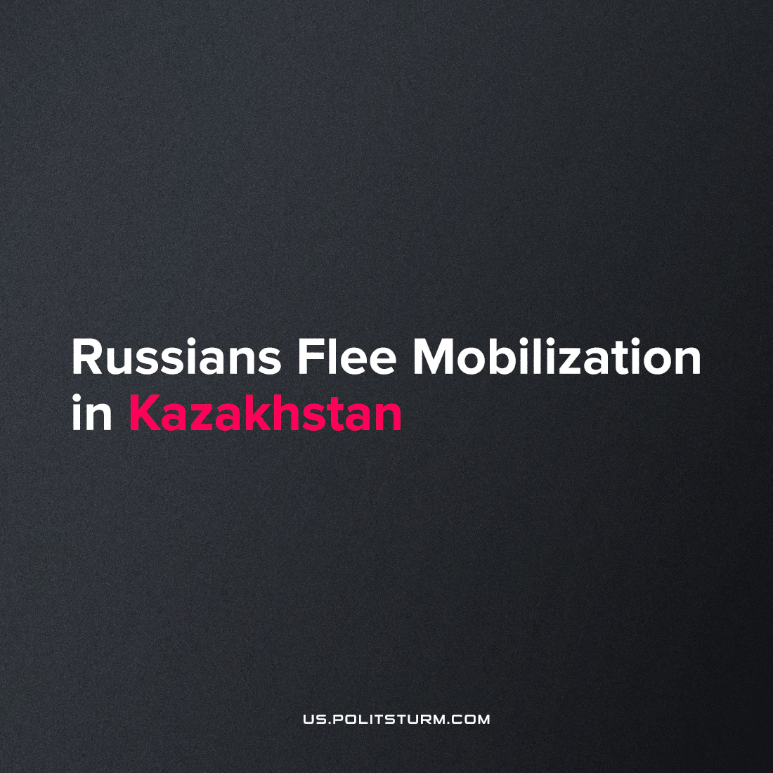

Original article
2022-10-29
4 min read

After partial mobilization began in the Russian Federation, over two hundred thousand men fled to surrouding countries like Armenia, Georgia and Turkey. Reports from Kazakhstan describe their acute issues, heightened by Russophobia.
Russians who left for Kazakhstan after the mobilization announcement dismay over their emigration. Residents of Yugra have complained about the enormous number of documents they must be issued, their homesickness, and expensive housing.
”Warm hospitality”:
One IT specialist from Krasnodar settled in the western Kazakh city of Aktau. A hotel room costs him 1300 rubles (around 200 USD) per night. The man withdraws his salary to a Kazakhstani bank card. Temporary registration only allows him to stay in the country for 90 days.
The man rarely leaves the hotel, living from hotel to grocery to hotel. He’s already faced the negative scrutiny of the locals. One hotel advised him to look for a room elsewhere, and when looking for an apartment, he even heard: “We don’t rent to Russians.”
“That’s how it is. But in fact, the conclusion can be drawn only after a 90-day stay, and not after a week, when I worked on weekdays and slept on weekends.” he summed up.
Migration from Russia to Khazastan:
The “special military operation”, which began in 2022 on the territory of Ukraine, affected all spheres of life of Russian citizens. Hundreds of thousands of people are called to the front, tens of thousands of families are left without fathers, hundreds of thousands of people are escaping the country, facing Russophobia that has grown in other countries, thousands of companies have left Russia, thousands of sanctions will destroy the Russian economy, thereby worsening the life of the working class. In desperation, some people were seen leaving their cars to walk after waiting at the border crossing.
Error loading image
Cars queue at the Russian border with Kazakhstan on September 22.
The head of the Ministry of Internal Affairs of Kazakhstan, Marat Akhmetzhanov, commented on the situation with the migration of Russian citizens. According to him, the current number of citizens arriving from Russia is less than the number of those leaving. He specified that 8-9 thousand Russian citizens arrive daily and 10-11 thousand leave. When asked whether there were cases of deportation of Russians, Akhmetzhanov answered positively but did not precise the number.
On October 4, the Ministry of Internal Affairs clarified that after the announcement of partial mobilization in Russia (September 21), more than 200,000 Russians entered Kazakhstan. According to Akhletzhanov, the situation on the Kazakh-Russian border is under control.
Entrepreneurial citizens of Kazakhstan “smartly” took the opportunity that misfortune offers over these people who didn’t want to die for Russian capital and raised rental prices on the visitors. There are cases when landlords expelled students to rent out housing to those fleeing from mobilization. Prices only for rent have already reached 200 and 300 thousand tenges (roughly 430 and 650 USD, respectively) depending on the region. People run further to wherever’s cheapest, driving demand, for example, in Kyrgyzstan.
Some people manage to find a job, but it’s unlikely that local businessmen treat visitors better than their Russian counterparts. Those who have no other place to go will take on the dirtiest work, the “holiday” of the Kazakh nationalists. You are free to choose; to be mobilized at home, or to work as a loader and overnight where you can find a gig.
All this finds support in society as a “payback to exploiters”. For many years, Russian businesses exploited the cheap labour force from Kazahstan and its emigres, like other middle-east and central Asian countries, taking their documents by force and compelling them to work for pennies. Now this attitude of the Russian bourgeoisie to their brotherly nations becomes a fertile ground for the incitement to hatred against Russians in the region.
Emigration to another country forces many to come face-to-face with the stark capitalist reality in the margins between states, where instead of cooperation and friendship between peoples there is only a struggle for a place under the sun. To integrate, they run through a hundred levels of bureaucracy and bear xenophobia. But in fact, ordinary people have nothing to share, and hostility is beneficial to the oligarchs who distract the people from the true origins of their problems.
Regardless of national interest, the world’s workers have a common object – to live in a better world without war or poverty, where they have power over their future. To overcome nationalism and build a common future under an international banner, it necessary for them to confront a common enemy – the capitalists. The enemy that shamelessly profits from the labour of millions while convincing the toiling masses that they themselves are to blame for this.
It is necessary to understand that the enemy is not a soldier of the Armed Forces of Ukraine, a refugee from Russia, or an ordinary resident of Kazakhstan or any country in the world. Only the flag and a couple of paragraphs in the constitution change from country to country, not the animal essence of capitalism. It is further necessary to understand that by uniting in trade unions and agitating for the construction of a party, workers of the CIS and all other cliques of the world will only then begin to win the battle for their rights and achieve the better life that is deserved.
Sources: 1, 2, 3

Original article

