Russian Budgetary Expenditures on Welfare Programs to Reach Their Lowest Level Since 2011
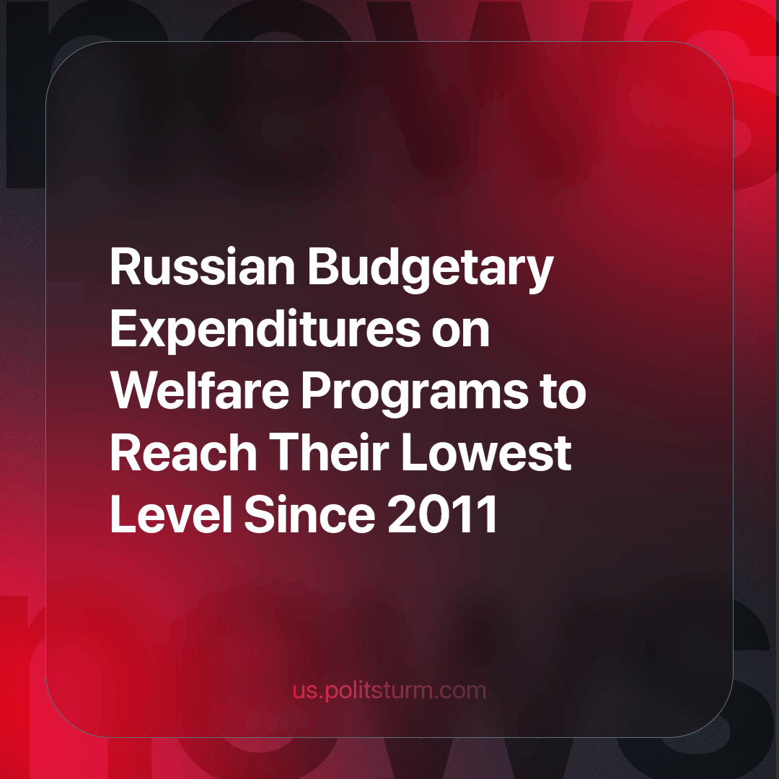

Original article
2023-10-29
1 min read

The share of expenditures allocated to welfare programs in Russia's budget for the next year will be the lowest since 2011. This information is based on the explanatory memorandum accompanying the draft federal budget for the year 2024 and the planned period of 2025-2026, as well as historical data from the Ministry of Finance.
One of the largest budgetary allocations, 'Social Policy,' will receive 7.71 trillion rubles, accounting for 21.1% of total expenditures. This is the lowest share since 2011 (previously, a different classification of expenditures was used, in which a significant portion of social expenditures was accounted for as interbudgetary transfers). On average, from 2015 to 2021, the share of social policy in the federal budget was 28%.
It is reported that the reduction in allocations will affect social payments to the unemployed, monthly allowances for the birth of a third child, and regional pension supplements. Historically, social policy has been a priority in the budget. In 2020, amidst the COVID-19 pandemic, its share reached its highest point at 30.6%. According to the new draft, the largest area of expenditure in 2024 will be on defense.
Policies hailed as 'victories' and 'breakthroughs' by advocates of the market system have pushed the majority of the Russian population into poverty. By justifying the reduction in social expenditures as an ‘urgent necessity’ for ‘enhancing national security’, they only reaffirm whose interests they serve.
The only way to halt the decline in living standards and prevent the majority of the population from sliding into poverty is to replace the capitalist system. In its latest form, this system has proven itself to be responsible for new and worsening global crises and tragedies. This is one reason why it must be replaced with another system: socialism.
Source: Central Trade Union Newspaper “Solidarity” - “Social Budget Expenditures to Reach Their Lowest Level Since 2011” dated September 26, 2023."

Original article

