Russian Psychiatrist Advises Parents to Send 14-Year Olds to Work
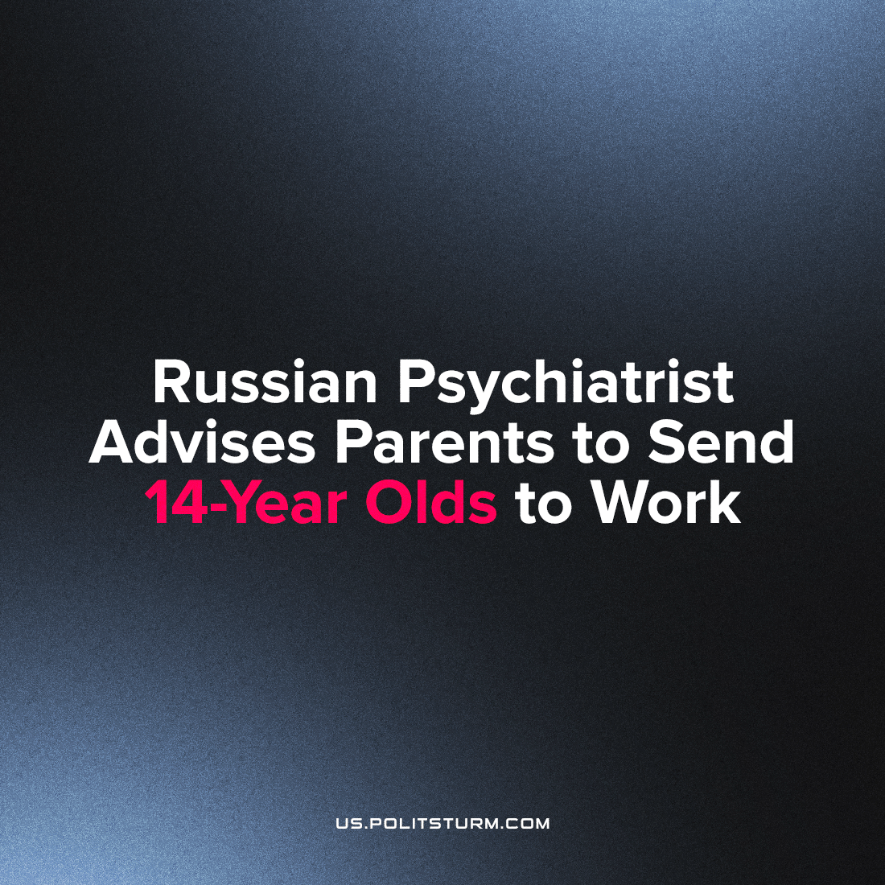

Original article
2023-07-30
1 min read

According to the Moscow psychiatrist Vladimir Skavysh, children at the age of 14 must start working in order to appreciate money. He further advised that parents shouldn't give money to their children, because it doesn't properly encourage their development as individuals under capitalism.
Modern society creates difficult conditions for life and development. In such an environment, it is especially important that children learn and develop creatively, without putting on themselves the heavy burden of selling their workforce for pennies. Many children are already working in illegal and semi-legal offices, risking their safety, health and, most importantly, their time.
Crisis conditions, lack of money in the average family budget – in such conditions, a supporter of liberalism does not consider changes that society objectively needs. No! He advises that children to go to work.
It is simply wrong to describe such a state of affairs as normal. Instead it serves as further evidence that the preservation of the current capitalist order is gradually leading society and each individual within it into miserable servitude.
Source 1

Original article

