Russian PM: "Despite All Challenges and Pressures, Russia Continues to Develop"
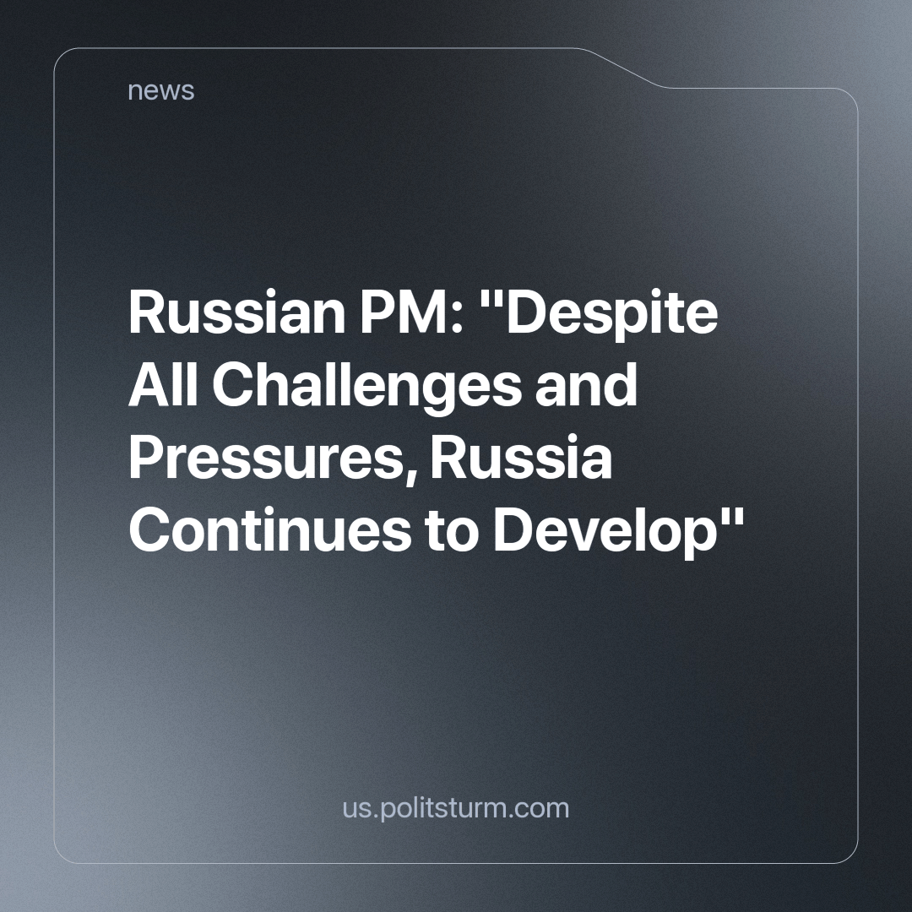

Original article
2023-11-30
1 min read

According to the Prime Minister of the Russian Federation, Mikhail Vladimirovich Mishustin, Russia is making progress despite external pressures. Various statistical data is cited to confirm this growth. However, the question remains: do ordinary people feel it?
The editorial board of Politsturm, among others, publishes material daily, in which ordinary citizens complain about deteriorating living standards, workplace injustices, the absence of social guarantees, and general uncertainty about the future. The only group that perceives an improvement in their lives are the oligarchs who have consolidated the nation's wealth in their hands.
This contrast is particularly striking when compared to the Soviet experience, in which all citizens were provided free education, healthcare, housing, secure employment and other benefits. All the infrastructure left by the Soviet power continues to be exploited today by capitalists through privatization. Is there any reason to hope for modern capitalist society's ability to achieve anything similar?
Source: TASS - "Mishustin States that Russia Continues to Develop Despite Challenges and External Pressure" dated October 19, 2023.

Original article

