Russian Economists Say Raising the Minimum Wage is Dangerous for Workers
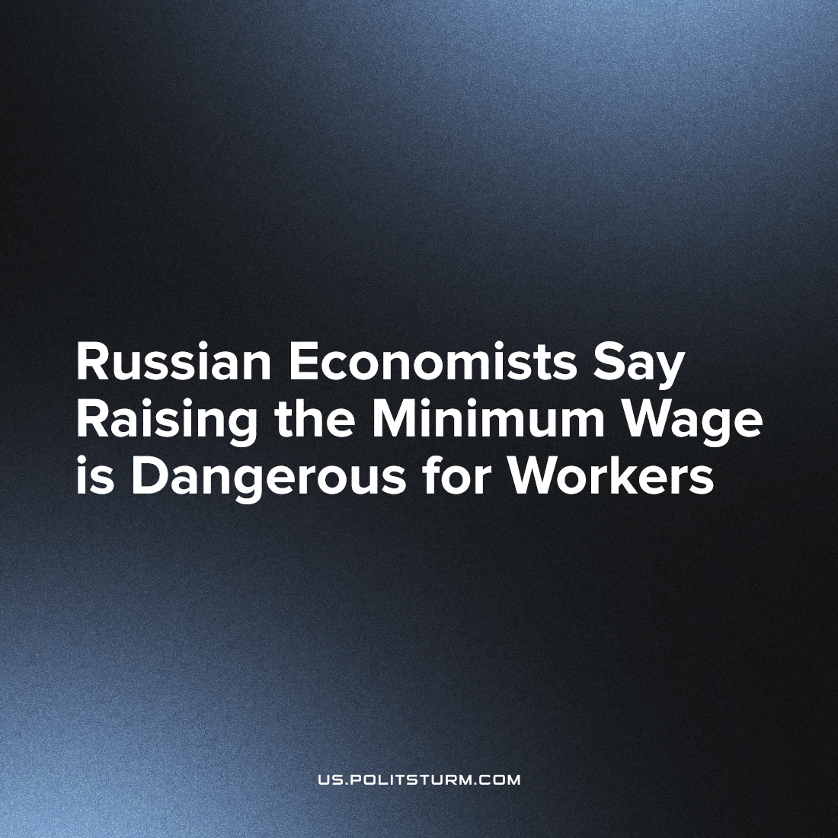

Original article
2023-07-25
1 min read

Economists from the Russian Higher School of Economics (HSE) have stated that raising the minimum wage will bring more problems than benefits: low-skilled employees and part-time workers may face being laid-off.
Experts from the National Research University explain their findings with the desire of employers to reduce costs.
Apparently, it's impossible for businessmen to pay a decent salary and develop production. It's easier for capitalists to throw hired workers out on the street, moral issues do not bother them. This is the main contradiction of a society based on the right of private property — it cannot develop steadily, satisfying the needs of everyone. This right is protected by law and authority. The results of the work of millions of citizens belong to a narrow circle of people - the richest businessmen - only because they have such a right. How they acquired this right is the last question on their mind.
The question of the fairness of the distribution of the results of social labor under capitalism within the framework of the system itself is insoluble. Only the power of the workers, based on public property, guarantees a fair distribution and satisfaction of the needs of all citizens.
Source: 1

Original article

