Russian Economists Have Calculated the Cost of Raising a Child
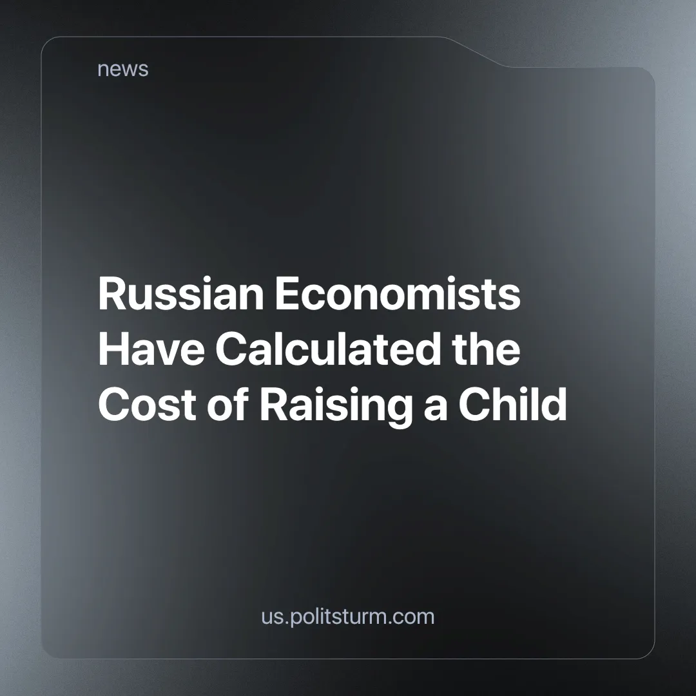

Original article
2024-10-30
2 min read

The threat of a demographic crisis in Russia is becoming more and more tangible, but Russians are reluctant to have children due to a lack of financial stability. Many Russians wish to raise more than two children, but financial constraints hold them back. According to a study conducted by the companies "Yakov & Partners" and "Romir", the main obstacle to having children is the lack of money to support them. The greatest willingness to have children is shown by residents of smaller cities, where a monthly income of 80,000 to 120,000 rubles ($820–$1200) can still provide the necessary standard of living. This fact underlines the key role of a stable family budget for potential parents.
A study by the Non-State Pension Fund "SberNPF" shows that Russians need to save an average of 1.6 million rubles ($16500) to have a child, which includes pregnancy, childbirth, and the child’s first year of life, excluding state benefits. Women estimate the necessary costs higher than men — at 2 million rubles ($20700), due to their more accurate understanding of expenses. In large cities, such as Moscow and St. Petersburg, the need for a "financial cushion" grows even more, reaching up to 3.9 million rubles ($40400) [1].
Capitalism depends on a continuous supply of labor to maintain its system of production and profit generation. However, the system puts up numerous barriers to actually supporting this reproduction of the workforce. The oligarchs don’t recognize that without accessible public childcare, working parents face a stark choice between their careers and caring for their children. Public kindergarten slots are limited [2], and private options are often too expensive, costing nearly half of an average salary [3].
From the moment a child is born, the family becomes a source of income for manufacturers of children's goods, and then sellers of school supplies and clothing. In 2024, the average cost of preparing a child for the school year was about 25,000 rubles ($260) [4], and these amounts are not expected to decrease in the future.
Even education itself is now on the market — both the number of private tutors and their pay rates are steadily rising [5]. Meanwhile, overworked and underpaid teachers are unable to provide students with the appropriate level of preparation for exams and university admissions.
The deeper the demographic crisis becomes, the louder the calls are for more children to be born. However, once it becomes clear that mere slogans do not solve the problem, the government starts introducing restrictions and punishments [6].
Capitalist society sees children as an economic resource, and parents as their "producers." Any attempts to improve this system are futile. As long as capitalism dictates the priority of profits over human needs, people will continue to be treated as assets rather than individuals. From a communist theory perspective, this attitude is inevitably tied to the existing economic system, where everything is subservient to profit. Truly profound changes can only occur with the transition to a socialist society, where, with the disappearance of the oppressor class, the contradiction between the desire to have children and the ability to provide for them will also disappear.
Sources:
[1] Central Trade Union Newspaper "Solidarity" — "A Child as an Economic Decision" — September 25, 2024
[2] GTRK Yugoria — "Citizens of Nizhnevartovsk queued up to register their children in kindergarten" — October 1, 2024
[3] 72.RU — "10 times more expensive than public: prices for private kindergartens in Tyumen" — September 4, 2024
[4] Lenta.ru — "How to prepare a child for school in 2024 and how much does it cost? A list of necessary items for schoolchildren" — July 17, 2024
[5] Independent Newspaper — "The number of tutors is growing, and so are the prices for their services" — April 17, 2024[6] Forbes.ru — "Childlessness tax parameters developed at RGSU" — October 4, 2024

Original article

