Russia's "Victory Day Ceasefire" Highlights Stalemate in Ukraine Negotiations
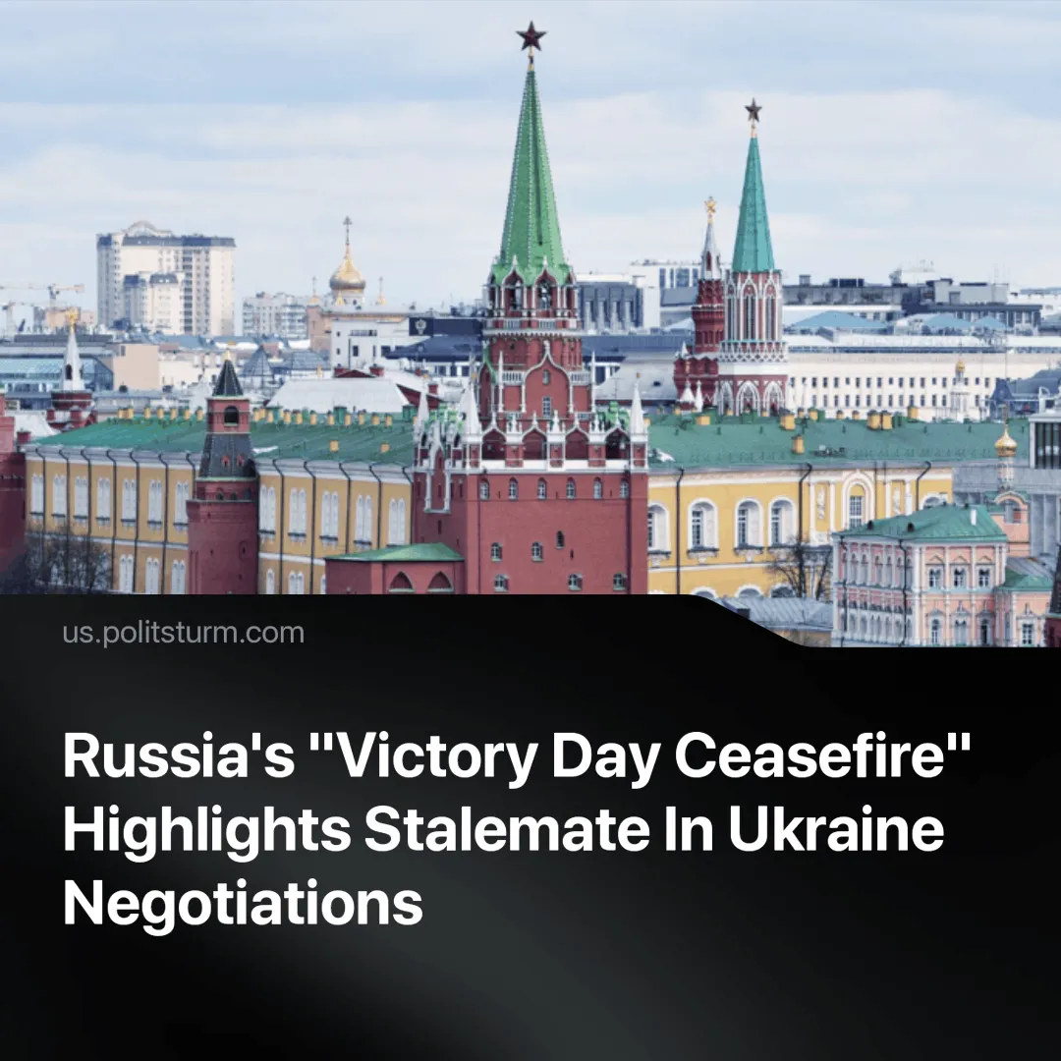

Original article
2025-04-28
2 min read

Russia announced a 72-hour unilateral ceasefire on the 80 years anniversary of victory in World War 2. Earlier this week, we reported on the increased pressure from America for a Russia-Ukraine ceasefire and the short-lived “Easter Truce.”
Details. President Putin announced a 72-hour unilateral ceasefire to take place from May 8 to May 10, to mark the 80th anniversary of Victory Day. Russia cited "humanitarian reasons" and called on Ukraine to respect the ceasefire, warning that violations would be met with military retaliation.
► Ukraine responded by proposing a full and unconditional 30-day ceasefire, arguing that a temporary truce would not be sufficient for meaningful progress toward peace.
► Following the announcement, the White House increased its pressure, with Press Secretary Karoline Leavitt stating that President Trump wants a “complete ceasefire” to end the war, not temporary pauses in hostilities.
► Last week, on April 26, Trump and Zelenskyy met privately for 15 minutes at St. Peter’s Basilica in Rome, before the funeral of Pope Francis. The meeting was described by Zelenskyy as “potentially historic,” and a White House official called it “very productive.” Ukraine reiterated its demand for a “full and unconditional ceasefire” and a long-term settlement.
► Following the meeting, Trump publicly condemned recent Russian strikes on civilians and hinted at the possibility of expanded sanctions, including secondary banking sanctions, if hostilities continued.
► Despite the positive rhetoric, a planned follow-up meeting was canceled due to scheduling constraints, and Trump departed Rome immediately after the funeral.
► In parallel, U.S. special envoy Steve Witkoff held separate talks with Russian officials to discuss a possible ceasefire framework. These talks were described as “very useful” by Putin aide Yuri Ushakov, although Russian officials continue to reject a full unconditional ceasefire, insisting instead on a phased approach tied to political and territorial concessions by Ukraine, particularly concerning Crimea and Eastern Ukraine.
► Following the announcement of the expulsion of Ukrainian troops from the Kursk region and the recognition of DPRK participation, Russian leaders showed renewed confidence. In an interview with O Globo, Foreign Minister Sergey Lavrov reaffirmed demands for international recognition of Crimea and the other four regions, returning to the rhetoric of "denazification and demilitarization."
► In a separate interview with CBS, Lavrov rejected a U.S. proposal to restore Ukrainian control over the Zaporizhzhya nuclear power plant, stating that the plant remains under Rosatom’s management and that “no changes are possible.”

Original article

