Russia and the U.S. Signal Openness to Cooperation
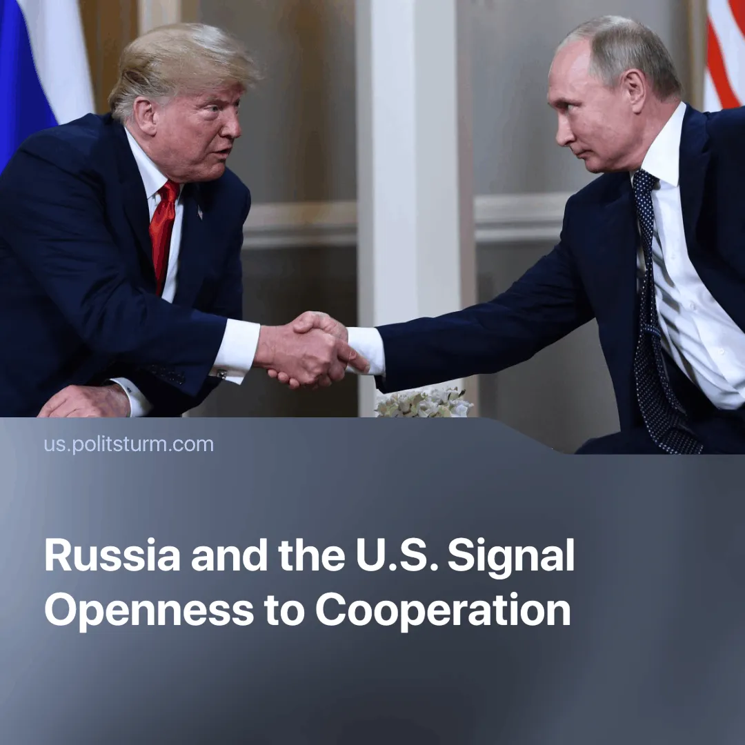

Original article
2025-03-09
2 min read

Kirill Dmitriev, head of the Russian Direct Investment Fund (RDIF), recently stated that both Russia and the U.S. are open to collaboration, emphasizing that ending the “Special Military Operation” is possible following successful negotiations.
Details. On February 18, Kirill Dmitriev, newly appointed as an economic cooperation envoy, represented Russia in talks with the U.S. in Saudi Arabia.
► U.S. special envoy Steve Witkoff stated that if a ceasefire is reached, Russia “would be able to have American companies come back and do business.” RDIF claimed that U.S. firms have lost over $300 billion since leaving the Russian market.
► As a starting point for dialogue, Dmitriev questioned, "Why should [American companies] miss opportunities to gain access to the natural resources of Russia”.
Context. After a prolonged standoff, Russian and U.S. capitalists appear to be reconciling, driven by shifting economic priorities.
► Russia’s economy has suffered heavy losses. Western sanctions forced it to shift trade to non-sanctioning countries, deepening dependence on China. Exports to Europe dropped from 50% in 2021 to 14.4% in 2023. Now, Russia seeks to regain some lost business and lessen its dependence on China.
► European powers have raised concerns over U.S.-Russia diplomacy. France, Germany, Italy, and the UK have sought to profit from Ukraine’s dependency, countering Russia's influence while advancing their imperialist interests.
► The EU has successfully reduced reliance on Russian energy. The EU has increased imports from Norway, the U.S., and Qatar while integrating gas markets across Estonia, Latvia, Lithuania, and Finland. The conflict has directly benefited U.S. capital, disrupting Europe’s gas supply from Russia and increasing the EU’s reliance on American energy.
Important to know. Throughout the conflict, Russian and U.S. capitalists publicly condemned each other while maintaining indirect dialogue. Now, they are openly reconciling—not out of goodwill, but due to shared economic interests.
► As the U.S. shifts attention to China, it seeks to stabilize relations with Russia. China’s growing trade and influence have weakened U.S. hegemony, and this shift was explicitly stated in the U.S. Secretary of Defense’s speech at the Pentagon.
► Trump is using Ukraine as leverage to negotiate with Russia. The U.S. has paused all military aid, exploiting its role as Ukraine’s primary investor and financial backer to dictate terms. Ukrainian workers and resources have been used to serve U.S. financial interests, with full cooperation from Ukrainian capitalists.
► Russia is preparing an independent agreement with the U.S. on natural resources. RDIF’s Dmitriev and gas giant NOVATEK announced a new draft proposal for U.S. monopolies, stating: "The preliminary draft of the agreement on the development of Russian minerals will be offered to the United States in early March."
Conclusion. The apparent thaw in U.S.-Russia relations is merely a tactical shift in inter-imperialist competition. Both sides, having suffered economic and strategic setbacks, seek to restore profits while European powers scramble to protect their interests. These manoeuvres do nothing for the working class—only reinforcing that imperialist alliances are temporary, dictated by profit, and serve only the ruling class.

Original article

