Direct Russia–Ukraine Second Direct Talks Fail
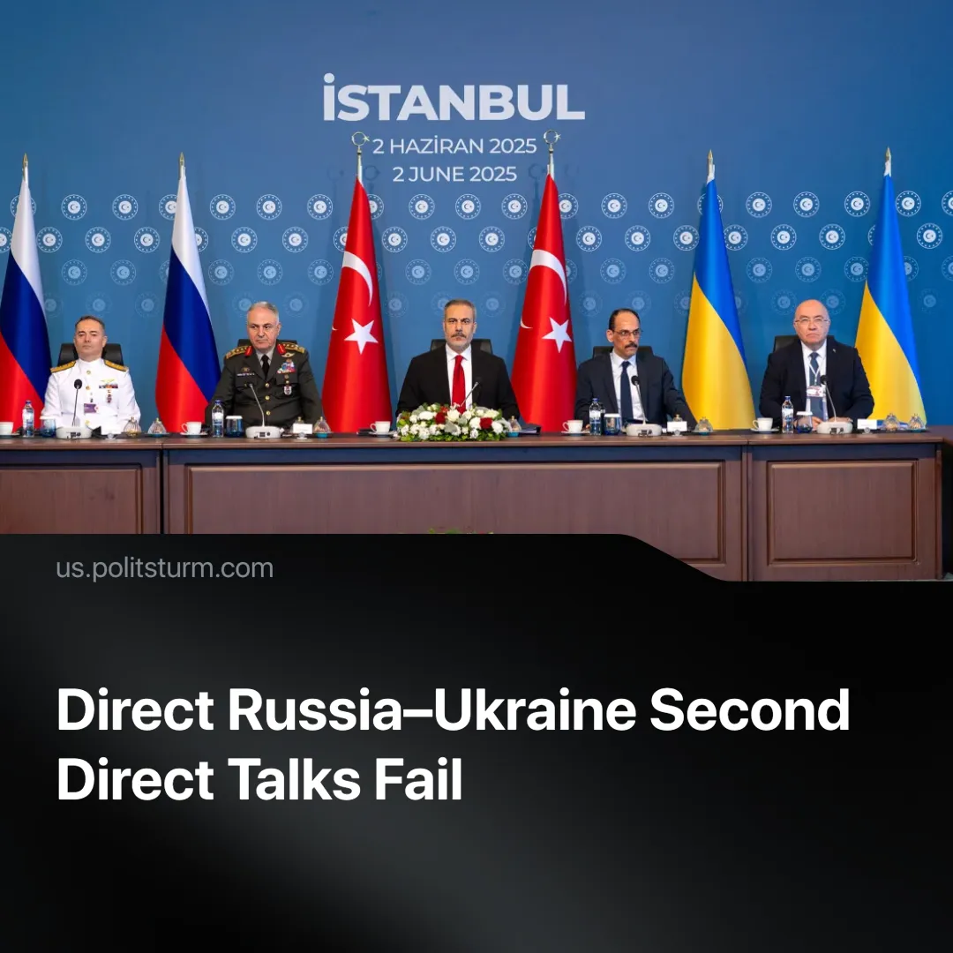

Original article
2025-06-07
1 min read

A second round of direct Russia–Ukraine talks once again concluded without any significant breakthroughs. Russia has blamed Ukraine for the failure of the prisoner exchange, the only issue the two sides had agreed on during the talks.
Details. The talks, held on June 2 in Istanbul, lasted just over an hour and resulted in the now-habitual agreement to exchange prisoners, along with a plan to trade the bodies of 6,000 soldiers from each side on June 6.
► Ukrainian negotiators said that Russia had again rejected an unconditional ceasefire, a demand that is now supported by Kyiv's allies in Europe and the US.
► The Russian team said it had proposed a two- to three-day truce “in certain areas” of the vast front line but gave no further details.
► The Ukrainian defence minister said Ukraine had handed over its truce proposals to Russia a few days before the talks, while Moscow reportedly presented its plan only at the talks.
► Since the talks, Ukraine has failed to turn up for the exchange and has not commented. Kremlin aide Vladimir Medinsky claimed on June 7 that Ukraine had postponed it indefinitely.
Context. We have previously written on the lacklustre results of previous talks, which have continued since both sides benefit politically from the war. These talks are currently being used to signal flexibility or assign blame, but neither Russia nor Ukraine has shown a willingness to make real concessions.
►Ukraine’s latest drone operation, launched the day before the talks, struck deep into Russian territory and was likely intended to gain leverage by eroding public confidence ahead of the scheduled peace negotiations.

Original article

