Russia Stops Selling Oil to Poland
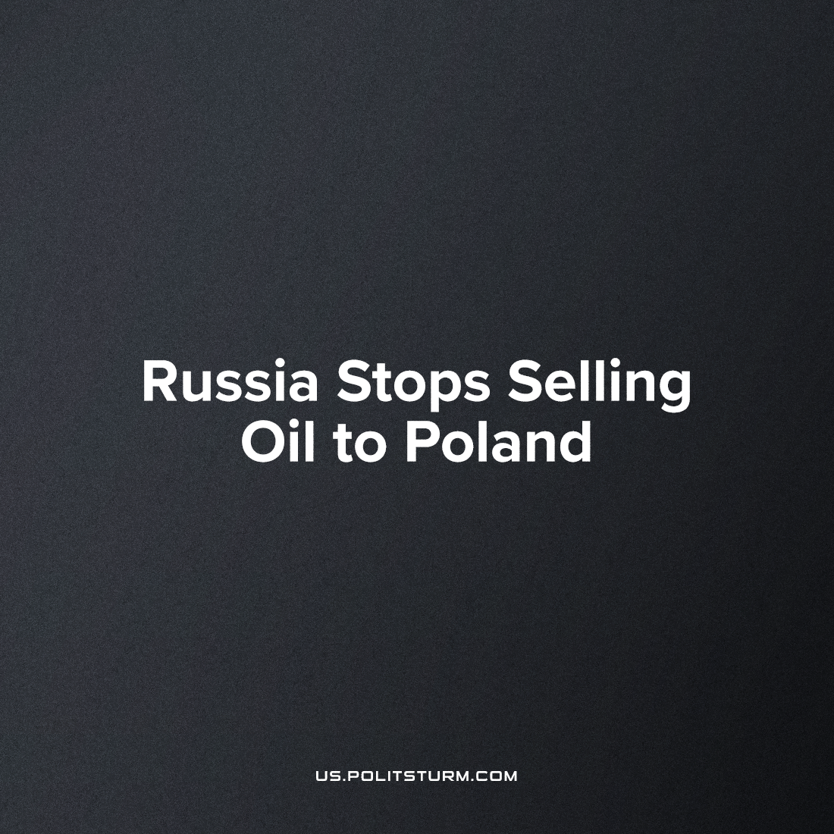

Original article
2023-03-23
3 min read

Last month, Russia stopped oil supplies to Poland via the Druzhba pipeline one day after the first German-made Polish Leopard-2 tank arrived in Ukraine on Feb. 24th. Oil to Germany, however, continues by the same lines from Kazakhstan- a supply which has been accused of mixing sourced crude from Russian sellers.
The Druzhba pipeline (the operator of which is the Russian company Transneft) has been exempted from EU sanctions against Russia, and despite the conflict, it continues to flow.
Transneft has stopped oil transit in the direction of Poland due to the lack of payment for supplies, the company's official representative Igor Demin said[3]. Pumping to Polish refineries was scheduled for the last week of February, but it is claimed that necessary documents for payment confirmation were not provided. However, it is only a reason to comply with the Russian response to sanctions and to all countries that supply weapons to Ukraine. A similar spat occurred in April of last year, which included Bulgaria, when Russia demanded payment in local rubles and shipments stopped when these payments did not come through.

Where does Poland get its oil from?
After the merger with Lotos, the state-owned energy giant PKN Orlen is the only company responsible for importing oil to Poland.
The share of Russian oil in supplies to Poland amounted to 95.5% in 2012, 63.1% in 2021 and about 60% in 2022, but according to Business Insider Polska, Orlen oil purchases in Russia fell by 62% in the third quarter of 2022 compared to the same period a year earlier. Poland continued to import approximately 10% of its oil from Russia on the basis of a contract between PKN Orlen and Tatneft, which was in effect until the end of 2024, if Russian sanctions were not applied.
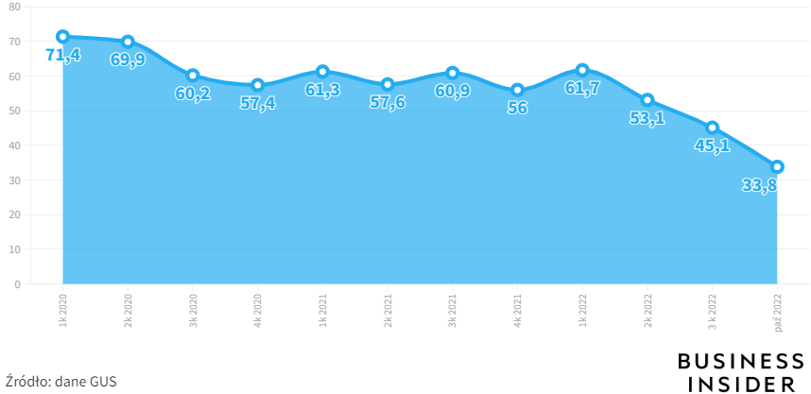
What percentage of crude oil imports come from Russia? (Source)
Oil to Poland comes from Saudi Arabia, the United States, Kazakhstan, Nigeria and Norway, of which Saudi Arabia has the largest share of the market at around 20%.

So, why does Poland still import oil from Russia?
The European Union imposed an embargo on the import of Russian oil on December 5, 2022, but it applies only to sea routes. Surprisingly, the contradictions within the EU do not contribute to the implementation of a unified policy on any issues. Attempts by Poland and Germany to include the Druzhba pipeline in the sanctions were unsuccessful, since its southern branch through Ukraine supplies the Czech Republic, Slovakia and Hungary. These countries opposed the embargo, arguing that they could not abandon Russian oil until 2024.
It is important to note that PKN Orlen also does not want to stop the supply of Russian oil, since it operates refineries in the Czech Republic through Unipetrol. The termination of imports may mean a shortage of fuel from Poland's neighboring partner and will probably entail a demand for rail and road supplies from other sources - which is extremely undesirable for the same PKN Orlen, because it gives a competitive advantage to other oil companies such as Hungarian MOL.
Such problems show the contradiction between the business goals of a public company like PKN Orlen and the priorities of the energy security policy of the state, which is the largest shareholder of the company.
Russia is trying to play on these contradictions, aggravating them to the highest extreme. The effect of sanctions will not be instantaneous, supplies from Russia will find an alternative from the same Saudi Arabia - at higher prices, of course. But in the end, not the manufacturer, but the common people will pay the increased price. Throughout the year of conflict, Russia has transferred its resources to the “hostile West”, and the European Union diligently pays its bills to the “illegal aggressor”.
Sources: 1, 2, 3, 4

Original article

