Russia Prepares for Mobilization: On the Global Change of the Russian Conscription System
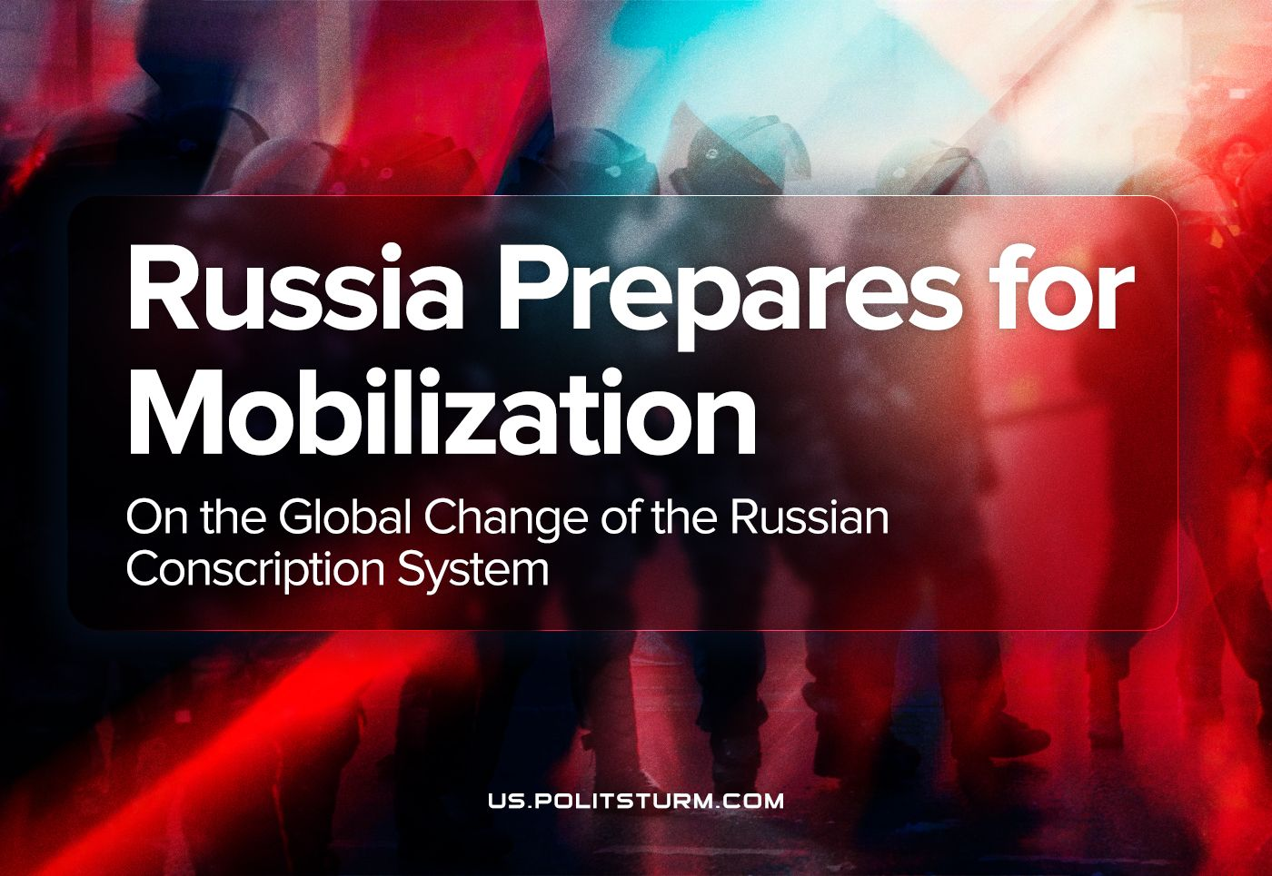

Original article
2023-08-10
15 min read

On the evening of April 14th, Russian President Vladimir Putin signed and officially published a federal law allowing electronic notices for the military draft. "This plan is not connected to mobilization", he said, repeating previous assurances. However, this law means that it will no longer be possible to avoid military service in Russia, which could expedite mobilization in the future. Let us see what led to this law and what the consequences may be.

The First Mobilization Since The Second World War
Conscription military service (known in Russian as “srochnaya sluzhba” – "fixed-term" service) is the involvement of citizens in the performance of military duty established by law. The length of this service is 12 months. Men between the ages of 18 and 27 are called up for military service in the autumn and spring.
Obviously, the state needs a sizable reserve of men who have completed basic military training. They can be mobilised into the army after completing "fixed-term" service in case of military operations, which is exactly what happened.
On the morning of February 24th, 2022, Russia officially launched a "Special Military Operation" (a name given by the Russian government, the word “war” in this context is outlawed and can be considered as “army discreditation” – PS),. As Putin explained, it’s aim was to "demilitarise" and "denazify" the neighbouring state. He also said that the goal of the operation is to protect Donetsk and Lugansk. The goal seemed to be backed by the most honourable reasons.
Many assumptions were made about the duration of the special operation. Dmitry Abzalov, president of the Russian Center for Strategic Communications, believed that it would end in five days. Dmitry Peskov, the press secretary for Russian president Vladimir Putin, said that Russia was hoping that "the operation will reach its goals or end in talks between the Russian and Ukrainian delegations in the next few days, in the foreseeable future." And now the ‘operation’ is in its second year of implementation.
At first, people were called up by the government to take part in the operation only on a voluntary basis. They signed a contract, after which they would be paid a good sum of money. Most often, such people were in a desperate financial situation, and these conditions led them to make such a choice.
Failures at the front hinted at the high possibility of the mobilization. On September 13th, 2022 Dmitry Peskov said that the Kremlin did not discuss the issue of full or partial mobilization of military service. Nonetheless, ‘partial mobilization’ was already announced on September 21th, and just in a month more than 300,000 men were sent to the Russian army, while hundreds of thousands fled the country. Russia’s first mobilization since the Second World War caused chaos and anger across the country.
First of all, the mobilization was carried out in places with a high concentration of hired workers: factories, large retail chains and commercial structures. The police officers could simply catch the workers, take them to the bus and hand them orderы to the army for the nearest dates. Meanwhile, the state was not concerned about the irregularities in further work without these workers.
People in regional centres, villages and other small settlements were mobilised as well. So-called "raids" also took place in Moscow and St. Petersburg.
"Military service will apply only to citizens who are currently in the reserve, especially those who have served in the Armed Forces, have certain military specialities and relevant experience", Vladimir Putin said. Despite all the assurances, there were cases in which unsuitable and disabled people were mobilised.
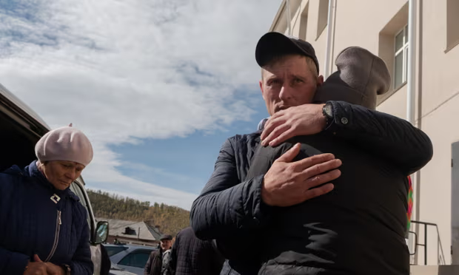
There were emotional scenes in the eastern Siberian republic of Buryatia as drafted men said goodbye to their families. Photograph: Ayuna Shagdurova. Source: The Guardian.
In reality, it was possible to avoid receiving recruitment lists by simply not receiving them in hand. During the autumn 2022, a game of hide-and-seek began. Some people fled to other countries or cities; some were hiding with friends; and some were hiding even in the forests.
The authorities therefore decided to tighten the conscription system without mentioning a new wave of mobilization. The urgent need for this law arose because of the possible counteroffensive of the Ukrainian troops. Since people do not seek to go to war, this measure was needed.

How Was The Law Prepared?
Since the winter of 2022, the digitalisation of the army has been underway. A single electronic database of conscripts was created on draft boards. Vladimir Tsimlyansky, the Head of the Main Organisational and mobilization Department of the General Staff of the Russian Armed Forces, also stated that such a database had already been formed and contained information about more than 700,000 men between the ages of 18 and 27.
Some electronic summonses were sent out during the last spring conscription. However, they were not taken seriously. Such summonses were often ignored, and this was not punishable.
During the mobilization, it turned out to be clear that the conscription system in Russia is terribly imperfect. Accordingly, the preparation for the "improvement" of this system began as soon as possible.
On March 31st, it became impossible to delete an account on the Russian “Public Services” (Gosuslugi in Russian) website. Rumours started to spread that a new system of electronic drafts was being prepared.
And these rumours were destined to be confirmed. In just a day, a law that decided the fate of millions was passed. Of course, people were not given the opportunity for discussion. Even the discussion in the State Duma (the lower chamber of the Russian parliament) was suppressed.
The bill is typically approved by the State Duma in three readings before it gets to the Federation Council and then to the president for approval. According to the document page on the State Duma portal, the bill was submitted to parliament back in 2018, but deputies ultimately postponed consideration. They returned to it again in October 2021. The second reading was in April 2023. Surprisingly, it was a completely different text that deputies saw only on the day of the vote.
The deputies complained that they did not even have time to read the document: they were given only two hours. Those who tried to speak out against it were suppressed. But despite all the objections, the bill was supported by everyone in the Duma, and only one person abstained. It should be said that deputies are too worried about their positions, and they are in fear of every word they say. In any case, opposition in the State Duma is ostentatious as they pursue a certain class interest together.
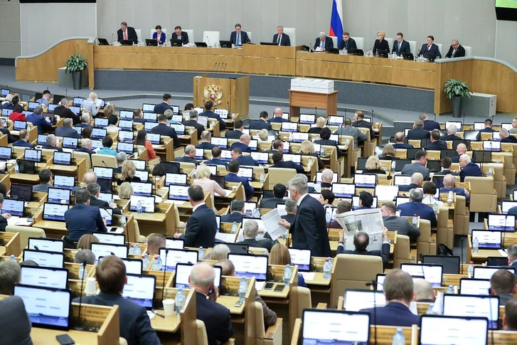
Russian State Duma.
This law has become an obvious necessity for the state to tighten the conscription system. And the opinion of the citizens does not count at all, because first of all, the state cares about having a sufficient number of people to send, as it already needs to make up for the losses at the front.

What Does This Law Mean For Russians?
Earlier in Russia, it was possible to safely avoid conscription by avoiding receiving a draft letter. The fact is that only hand-delivered and signed draft letters were considered to be delivered.
In order to avoid military service, it was necessary to simply hide until the age of 27 and not appear in the military draft office. There were no sanctions for ignoring it if you were not given the draft letter right in your hands. Therefore, during the autumn mobilization people could simply be grabbed on the streets to receive the recruitment lists, as the state could not find another way.
The central figure of the change was the Russian website of Public Services – "Gosuslugi". This is a reference and information Internet portal that helps Russians receive public services in electronic form. It was created in order to simplify and improve the citizen's connection with the state. The portal makes it convenient to interact with government agencies. A citizen can make an appointment with a doctor, get a passport, enrol a child in kindergarten, check and pay fines or court debt. This simplifies all paperwork and helps to keep bureaucracy to a minimum.
Nevertheless, this system has become an evil fate for conscripts. Public services have asked for the creation of a universal registry. "Gosuslugi" also provides the federal authorities with all the information they have about the registered people.
Besides, on this site you may receive extremely unpleasant notifications: electronic summonses. So, now the draft is considered handed over from the moment it is sent and there are serious consequences for non-appearance after such drafts.
But the important thing is that it does not matter at all whether you have an account on a Public Services website or not. The drafts will be in the general Register. Now people are thinking about deleting their accounts on the Public Services website, but this can only save them for a while. A general Register of military drafts will be created soon, where the drafts will be automatically considered handed over 7 days after publication.
Maksut Shadaev, the Minister of Digital Development, Communications and Mass Communications of the Russian Federation, said that a special register of military service will be created approximately by the autumn conscription of 2023. That means that the new notification system, which can "find everyone", will start working by about October 1st, 2023.
The consequences of ignoring electronic summonses can seriously affect the life of Russians. What would happen to a person who did not appear at the military draft office within 20 days after such a draft? In this case, he will not be able to:
- register as an individual entrepreneur or self-employed;
- conclude transactions with real estate and cars;
- drive a car;
- take out loans.
Then, is it possible to leave Russia? As soon as the draft letter is sent, the borders are automatically closed. A person literally becomes locked in a cage, which is now automated and certainly convenient for the state. Still it is unclear how the system will work before the Registry is implemented, so conscripts have a chance to leave the country before the autumn.

The Real Reason For The Law And People's Reactions
"We need to improve and modernise the military draft system," Dmitry Peskov said before voting began, recalling "problems" experienced last year.
Actually, this law gives Russia the organisational infrastructure to carry out a much more thorough and wider mobilization campaign when it decides to do so. That is what Yuri Shvytkin, Deputy Chairman of the State Duma Committee on Defense, said on October 28: "We understand that it is difficult to predict now. Today we are talking about the completion of partial mobilization, but its continuation is possible. Maybe the situation will change and the mobilised will be needed additionally. It will be necessary to take them from somewhere."
Russians very quickly bought tickets for the next direct flights to visa-free countries when the announcement of the first mobilization was made. Russian politician Ella Pamfilova called the Russians leaving the country "rats”, arousing disdain for them among the citizens remaining in Russia.
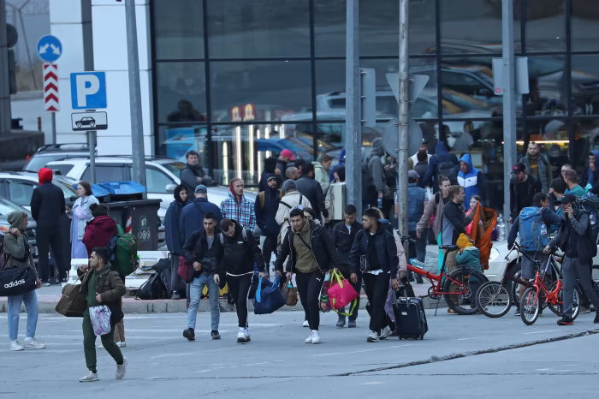
Travellers from Russia cross the border to Georgia at Verkhny Lars on Monday. Photo by Irakli Gedenidze/Reuters.
Dmitriy Peskov claims that the Kremlin is not afraid of panic or a new wave of emigration because of the law on electronic drafts. However, not everyone shares his opinion. Nikolai Slobodchikov, First Deputy Chairman of the Government of the Irkutsk Region, expects that legislative innovations may provoke another outflow of Russians abroad.
One thing is certain: the number of people who want to flee the country will increase significantly when the next mobilization is announced. Admittedly, there is a huge possibility that many of them will not make it in time.
The law on electronic drafts almost abolished draft letters in general. Literally every single man can be drafted at any moment without even knowing it. A human's choice is taken away: it becomes impossible to leave the country, and in his own country, one stays without a number of important rights. Thus, the state begins to reveal its view of people not as citizens, but just as a workforce.
Russian people are already tired of the increasing economic and political problems, but the government continues to put pressure on them. Dissatisfaction with the government is growing. So far, it is not at such a level so as to be awaiting global changes, and the protest is mainly manifested by fleeing the country.
It is expected that anti-war feelings will grow within the country as well. The authorities cannot whitewash the reasons for their actions forever, as they are largely the reason for people's irritation.
Given the above, it is impossible not to admit that the situation is getting tougher. The ‘special operation’ already affects the life of every Russian. At the beginning, the mobilization was voluntary. People went there just for money. Then, the government started partial mobilization: those who did not resist were taken. The bourgeois state continued to dictate its conditions, coming up with new tricks to subordinate the working class to their own interests. Now it seems that it is time for the rest to be taken.
Government officials talk about the need for electronic drafts to modernise an outdated system, but they are actually pursuing other goals. It is true that the system of military drafts is really inefficient. This begs the question, though: why was it not a bother to the government before the mobilization? Clearly, they felt threatened that the mobilization would fail because of that system.
The state began to seriously consider how to minimise the number of evaders. So, there is a reason to say that the stage was set for the next mobilization, a larger one, and one which will not give people the chance to avoid it.
Imperialist conflicts are absolutely inevitable under a capitalist economic system. The capitalist system sinks deeper into crisis, ruining people's lives at the same time. We need to end the system in which war is a way of enrichment, and people fight for the interests of the rich and powerful, who leave them no choice but to die. Only the working class can resist this system and defeat it. However, it can do so only when it’s led by the vanguard party. The only way to create this party for communists is to unite on the basis of Marxist-Leninist theory.
Sources
The Guardian - "Putin announces partial mobilization and threatens nuclear retaliation in escalation of Ukraine war" - September 21, 2022
The Guardian - "It’s a 100% mobilization’: day one of Russia’s drive to build its army" - September 22, 2022
The Guardian - "Kremlin attempts to calm Russian fury over chaotic mobilization" - October 1, 2022
REUTERS - "Russia to soon introduce electronic call-up papers in crackdown on draft dodgers after parliament vote" - April 11, 2023
The Guardian - "Russia rushes through law to tighten military conscription" - April 12, 2023
France 24 - "Russia’s electronic draft: As soon as they hit 'send', you've been called up" - April 12, 2023
TASS - "Putin signs law on electronic military summonses for people liable for military service" - April 14, 2023
INTERMARK - "The Law on Electronic Summonses. What has changed?" - April 17, 2023

Original article

