Russia Keeps Trading with Ukraine Despite Hostilities
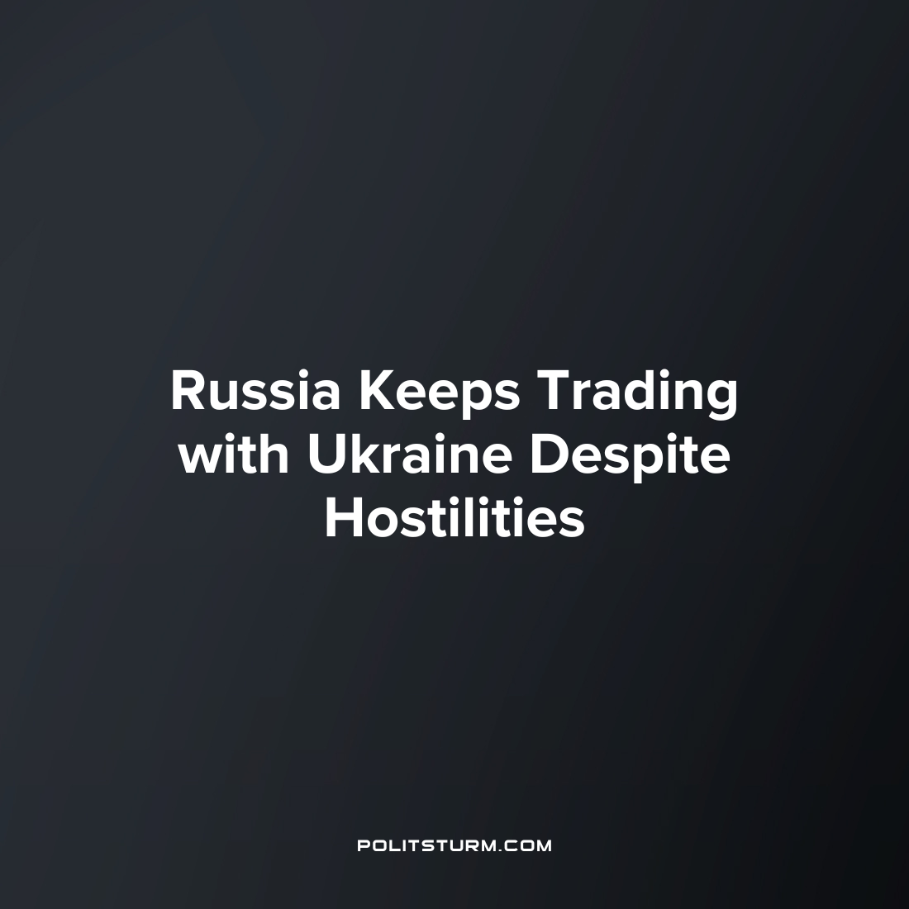

Original article
2023-02-06
3 min read

The so-called “Special Military Operation” of the Russian Armed Forces in Ukraine has been going on for more than 11 months. Its beginning was marked not only by the introduction of many sanctions against Russia, but also by the appearance of countless loud statements by politicians on both sides about the need for unity, about Russia's principled confrontation with Ukraine and other Western countries, and, most importantly, about patriotism.
With respect to trade between Russia and Ukraine, Russian exports to Ukraine increased by 68.8% between January 2021 and 2022. At the same time imports from Ukraine have increased 64.1% over the same period.
The statements of those in power are increasingly in conflict with the real state of affairs. Thus, despite the ongoing escalation of hostilities, Russia also remains one of the most important links in the supply of rare earth metals from China to the EU. Moreover, in the last 9 months of 2022, the volume of trade through Russia has increased more than 2 times and amounted to 36 thousand tons.
More than 90% of rare earth metals used in the European Union are supplied from China. Lanthanum is especially widely used, which is used in the production of armor-piercing ammunition, as well as tungsten which is an indispensable metal in the manufacture of anti-tank weapons.
According to Eurostat data, the foreign trade turnover between Russia and the EU countries for the last 9 months of 2022 amounted to 210.1 billion euros — 19.9% more than the same indicator in 2021. At the same time, exports from EU countries to Russia decreased by more than 35%, while Russian exports to EU countries increased by 53.1% compared to last year and reached 167.9 billion euros.
In the ranking of the largest importers from the EU, Russia continues to occupy the 9th position, and in the list of exporters it is on the 3rd line, just behind China and the USA.
Also, despite the loud statements of officials about the “principled” confrontation between Russia and the united West, the flagship of which is the United States, the total volume of Russian investments in American government securities increased to $2.092 billion in November last year.
The US Treasury Department reports that $80 million is accounted for long—term investments, and, accordingly, $2.012 billion is for short-term investments.
At the same time, the growth in the volume of Russian investments in the US national debt occurred not only in November, but also in October 2022, when it increased from $2.015 to $2.034 billion dollars.
Once again, the loud phrases about patriotism thrown by those in power turned out to be nothing more than a screen, with the help of which bourgeois propaganda is trying to hide the true face of capitalism from the working people.
Appeals to solidarity and love for some abstract “Homeland” in the bourgeois state are nothing more than a deception by which the owners of the means of production try to inspire the workers with submission, which is necessary for the continuation of exploitation.
A capitalist does not and cannot have a Homeland, because the only thing that motivates him is the desire to increase profits by any available means. And if capital can benefit from trade with both unfriendly countries and direct enemies, they will do it without a second's hesitation.
"Capital does not recognize the fatherland, and at the same time it is less patriotic the more it declares its patriotism."
— Karl Liebknecht, a leader of the German and international workers' and socialist movement, one of the founders of the Communist Party of Germany.
Sources:
Источники: MK.RU - «Bloomberg: из Китая в ЕС металлы для бронебойных снарядов перевозятся через РФ», January 22, 2023
Лента - «Россия увеличила вложения в госдолг США» January 19, 2023
Sea News - «Внешнеторговый оборот Россия – ЕС, 9 месяцев 2022» November 23, 2022
OEC Russia-Ukraine Trade Statistics: https://oec.world/en/profile/bilateral-country/rus/partner/ukr#:~:text=Overview In January 2022%2C Russia,%24226M to %24371M.

Original article

