Russia and North Korea Confirm DPRK Soldiers Fought Alongside Russians in Kursk
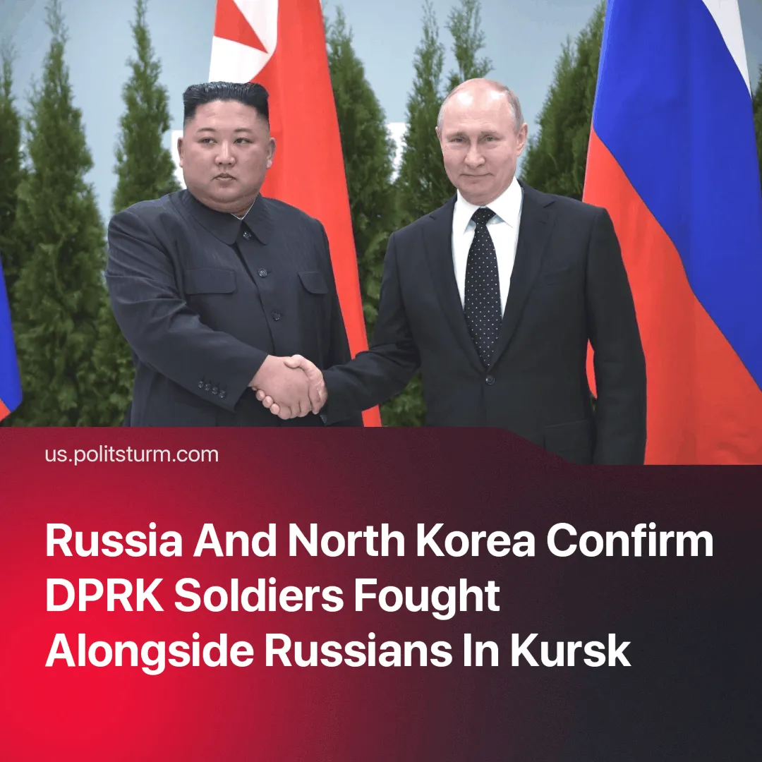

Original article
2025-04-28
4 min read

Russian officials have, for the first time, officially confirmed the participation of DPRK troops in combat operations in the Kursk region. This was later corroborated by North Korean representatives.
► On Saturday, Russian Chief of the General Staff Valery Gerasimov reported to President Putin that Ukrainian forces had been driven out of the Kursk region. In his report, he stated that North Korean soldiers had taken part in the operation.
Quote: “I want to point out the participation of servicemen from the Democratic People's Republic of Korea in the liberation of the Kursk Region's border areas, who, in accordance with the Treaty on Comprehensive Strategic Partnership between our countries, provided significant assistance in defeating the invading group of the Ukrainian armed forces. Soldiers and officers of the Korean People's Army, carrying out combat missions shoulder to shoulder with Russian servicemen, displayed high professionalism, fortitude, courage and heroism in repulsing the Ukrainian invasion.”
Details. Gerasimov’s statement seemingly lifted the ban on publicly disclosing the involvement of DPRK troops within Russian official media. Following his report, Russian Foreign Ministry spokeswoman Maria Zakharova confirmed: “The DPRK soldiers fought in the Kursk region and made a significant contribution to the liberation of its territory.” Later, she added: “The DPRK’s solidarity in liberating the Kursk region reflects the high, practically allied, level of our relations.”
► This information was covered by major state-run outlets such as Russia Today and RIA Novosti, as well as prominent Russian military bloggers. One milblogger posted a photo on his Telegram channel, captioned: "North Korean soldiers who participated in the liberation of the Kursk region."
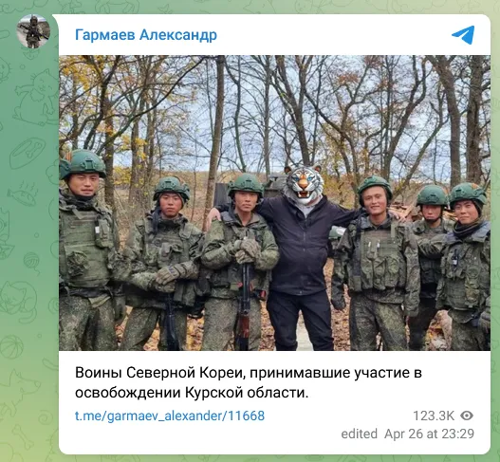
► One of the leaders of the pro-government party “A Just Russia — For Truth”, which adheres to social-democratic views, Zakhar Prilepin, published an article titled "To Die for the Freedom of Ukrainian Chaos: On Rumors About Citizens and Soldiers of the DPRK and Their True National Character." The article is entirely devoted to praising the revisionist Juche regime and North Korean soldiers, while also revealing details about their numbers.
Quote: “North Korea is a unique phenomenon on planet Earth... During the hostilities, out of the 95 North Korean battalions fighting on our side, only two individuals were captured. They endured great hardships. They entered the Kursk front twice. The first time, they learned hard lessons from the situation and returned home. Then they came back fully prepared and fulfilled all assigned tasks. Before going into battle, they leave notes saying: ‘I die for the leader.’ And they go — and die. For the leader, for their homeland, for our homeland.”
► On Monday morning, President Putin issued a statement also highlighting the role of North Korean forces:“We commend the DPRK soldiers’ heroism, their excellent training and dedication displayed while fighting, shoulder to shoulder with Russian soldiers, defending our Motherland as their own. They fulfilled their duty with honour and valour, covering themselves with unfading glory.”
► Following this, Putin’s press secretary announced that Russia, if necessary, could provide military assistance to the DPRK under the agreement between Pyongyang and Moscow, hinting at the possibility of Russian involvement in a potential conflict on the Korean Peninsula.
Reaction of the DPRK. After Russia's official acknowledgment, North Korean leadership began issuing statements as well.
In the early hours of April 28, the Korean Central News Agency (KCNA) published a report titled "WPK Central Military Commission Highly Praises Combat Sub-units of Armed Forces of DPRK for Performing Heroic Feats in Operations to Liberate Kursk Area of Russian Federation." Kim Jong-un praised the army’s actions and ordered a monument to be erected in Pyongyang to honor the fallen.
Quote: “The government of the Democratic People’s Republic of Korea regards it as an honour to have an alliance with such a powerful state as the Russian Federation and is pleased that the participation of the sub-units of our armed forces in the war has further strengthened the militant ties between the two countries and contributed to Russia’s conducting of special military operations. The Central Military Commission of the Workers’ Party of Korea is convinced that the invincible militant friendship between the two countries, verified at the cost of blood in the flames of battles, will greatly contribute to expanding and developing the future relations of friendship and cooperation between the DPRK and Russia in all aspects…it will invariably and fully support the sacred cause of the Russian army and people in the future, too, and remain faithful as ever to any action based on the spirit of the DPRK-Russia treaty.”
Context. This cooperation follows the signing of a Comprehensive Strategic Partnership Treaty between Russia and North Korea in December 2024, cementing military and political ties between the revisionist Juche regime and Russian imperialism.
► Prior to this official confirmation, reports indicated that DPRK troops had been present in the region since late 2024, undergoing training at Russian military ranges before being deployed. Up until now, Russian officials had refrained from admitting the involvement of North Korean forces in combat operations.
► However, indirect evidence had surfaced. In December 2024, the official Russia Today channel on the Russian social network VKontakte reposted a publication from the “Military Chronicle” channel, which reported the involvement of DPRK special forces in the hostilities in the Kursk region.
Important to Know. The deployment of North Korean forces to Ukraine marks Pyongyang’s largest foreign military operation since the Korean War.
► The participation of DPRK troops in imperialist conflicts further exposes the nature of North Korea as a state entirely dependent on the Chinese imperialist bloc.
► For a long time, the DPRK has served as a logistical hub for transporting military goods from China to Russia. The development of military cooperation with Russia has now reached the point where the Kremlin openly acknowledges the involvement of North Korean soldiers in warfare.
► Why is the Juche regime deploying its soldiers and workers to an inter-imperialist conflict? Benefits include: access to Russian military technology, easing of sanctions, access to the Russian market, and gaining valuable combat experience.
Conclusion: These actions are a direct demonstration of the growing power of Chinese imperialism. This marks the first open involvement of military forces from the pro-Chinese bloc in foreign conflicts. Such a development would have been almost unimaginable even five years ago, let alone fifteen or twenty years ago. This situation serves as a prelude to broader escalation. Global capitalism is hurtling towards confrontation.

Original article

