Russia and China Win Indian Rail Contracts
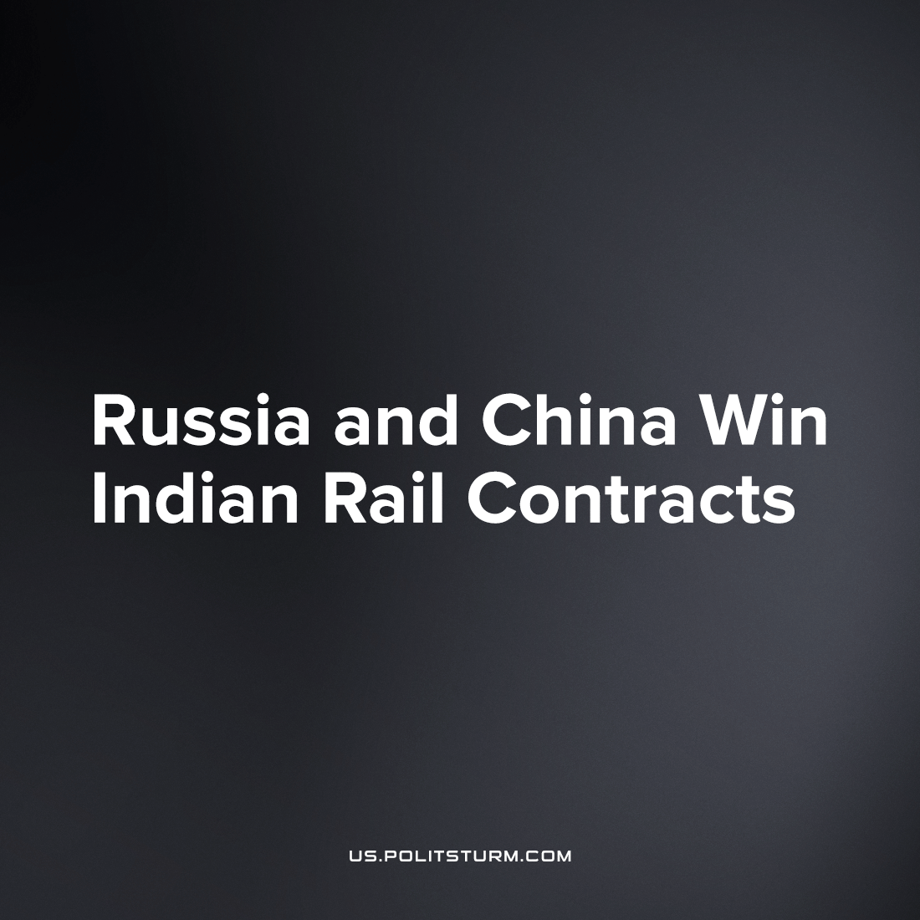

Original article
2023-05-12
2 min read

As India focuses more on the development of it's railway infrastructure, especially for the new semi-high-speed Vande Bharat passenger trains, the role of private sector has been increasing in the publicly owned railways of India. The Modi government's ultimate goal is to completely privatize this important public amenity.
In line with the increasing privatization of the Indian railways, five international companies, including Alstom, Tranmashholding, Medha Servo, and Siemens, have submitted flings for the product of the coming series of Vande Bharat trains. After the bidding process, Russian company CJSC Tranmashholding (TMH) has won the tender for manufacture and maintenance of the new semi-high-speed trains. The contract is expected to be signed between Indian Railways and TMH by June 1 this year. The Indian Railways will pay $1.8 billion for supplying the trains and another $2.5 billion for their maintenance over a period of 35 years.
The increase in involvement of Russian capital in the Indian economy has been boosted by the conflict in Ukraine, as Russia tries to find new markets for its capital amidst the Western sanctions. As conflicts and crises intensify capitalists find any opportunity to pocket more profit for themselves whiles millions of workers will suffer from poverty, war and inequality.
The Indian Rail Minister previously reported that a deal to purchase 30 thousand passenger train wheels from a Ukrainian company was interrupted by the conflict, initiating a “force majeure clause due to inability to supply”
While China has been kept out of the export of their high-speed rail industrial capital to India, instead favoring deals with Japan's Shinkansen for example, the omnipresence of Chinese capital in the world market means they cannot be left out. India’s state railway body has placed a purchase order for 39,000 wheels for LHB coaches from Chinese manufacturer Taiyuan at a slightly higher rate than that offered by the Ukrainians. The regular functioning of the economic system (including such crises) brings about the forming of these ties even contrary to the interests of the Western bloc of states to which India diplomatically adheres, in what Stalin refers to as the second contradiction of imperialism.
Contrary to the government's goal of "independent" and "industrialized" India, this "industrial independence" is dependent upon the whims of greater imperialist powers. The increasing role of the international capital in the infrastructure of India is proof of this dependence, even while India struggles to rise in its position of semi-dependency and rise to equal the capabilities of the great developed states.
Only socialism can break India from the exploitative chains of unequal exchange and establish real independence. Where the infrastructure, technology and planning of heavy industry is in the democratic hands of the Indian workers and peasants, only there can India and its people be free and develop their land by a comprehensive effort with stable economic health and social prosperity.
Sources: 1, 2

Original article

