Revolution vs. Coup d'etat
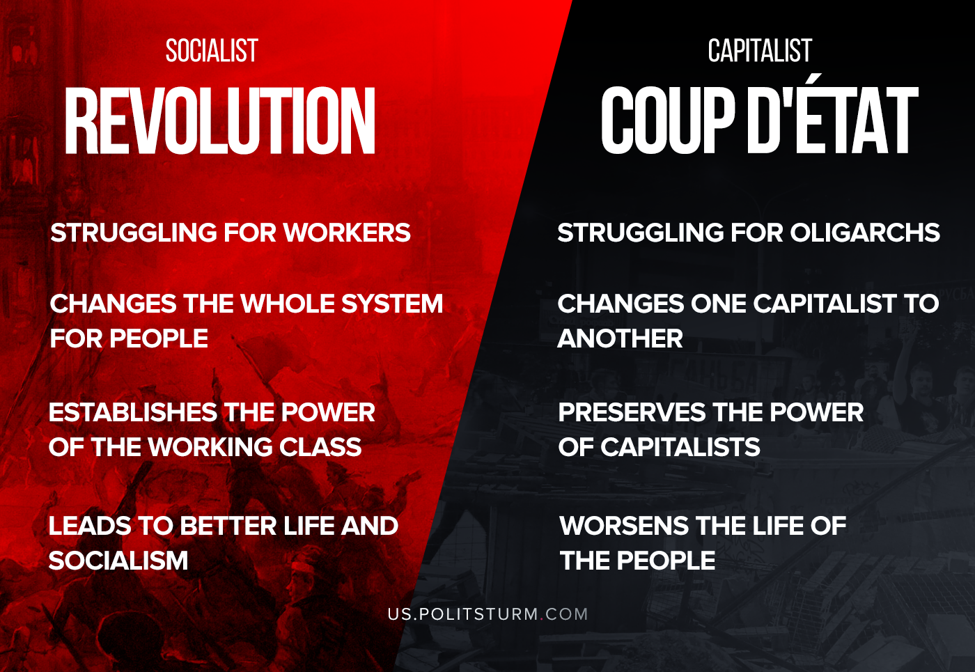

Original article
2020-08-14

It’s time to remind the difference.

Original article

