Restaurants Churn 75% of Workers Annually
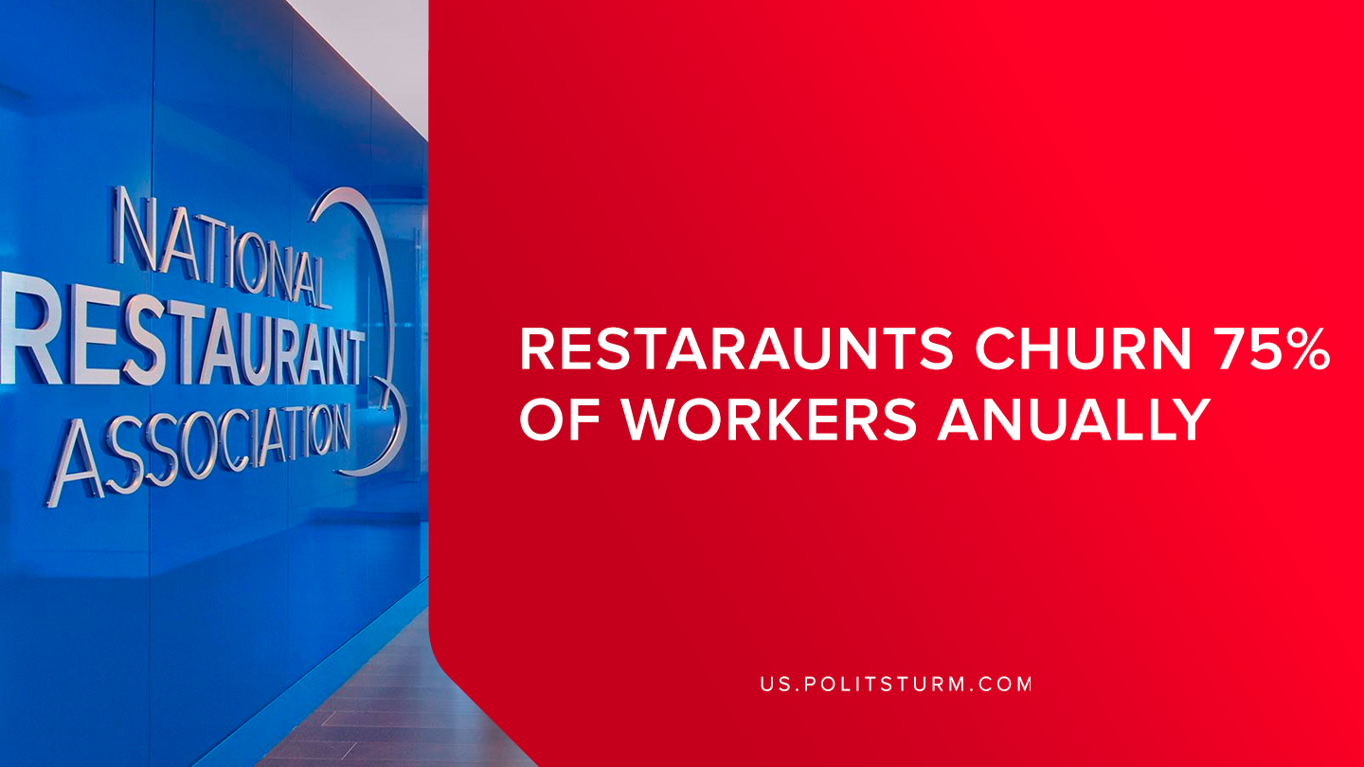

Original article
2019-09-02
1 min read

According to a recent data release from the United States Bureau of Labor Statistics (BLS), the employee turnover rate for accommodations and food service workers was 74.9% in 2018. According to the economists that the National Restaurant Association, which advocates on behalf of 500,000 restaurant business owners, the churning of restaurant employees is “natural” for several reasons.
The association justifies the churning of labor in their industry of a symptom of their young workforce, the fact that many employees are students and part-time workers, and the cyclical nature of restaurant employment which in turn leads to a higher employee turnover rate.
However, there are several other pertinent facts to consider about this industry. Food service full-time workers are paid a median weekly wage of $551 in 2018.
The economists that represent the National Restaurant Association serve the interests of the capitalist class by representing the position of the bourgeoisie and petty-bourgeois restaurant owners. This is why the organization views the high turnover as a “natural” condition, as if to imply that stable employment in this industry would be unnatural and impossible.
The capitalists are simply able to utilize the mass army of unemployed and employ workers for a short period of time, some restaurants are turning over their entire staff annually. The high turnover in the restaurant industry allows business owners to justify the incredibly high employee turnover as a cost of doing business as there is a large pool of unemployed labor to exploit.
The labor conditions in restaurants across the United States and internationally are suitable for the appropriation of unpaid labor in the form of profits by the capitalist class. As a result, the conditions for workers entail low wages and unstable, precarious employment.
Only through the Marxist-Leninist ideological framework is it possible to see through the deception of the bourgeois class and their paid economists. It is possible for restaurant workers to have stable, well-paid employment but not under the exploitative capitalist system. This can only be achieved through the institution of a planned economy and the elimination of the exploitation of man-by-man that occurs regularly under capitalism.
Sources: 1, 2, 3, 4

Original article

