Rents Surge Across the Country
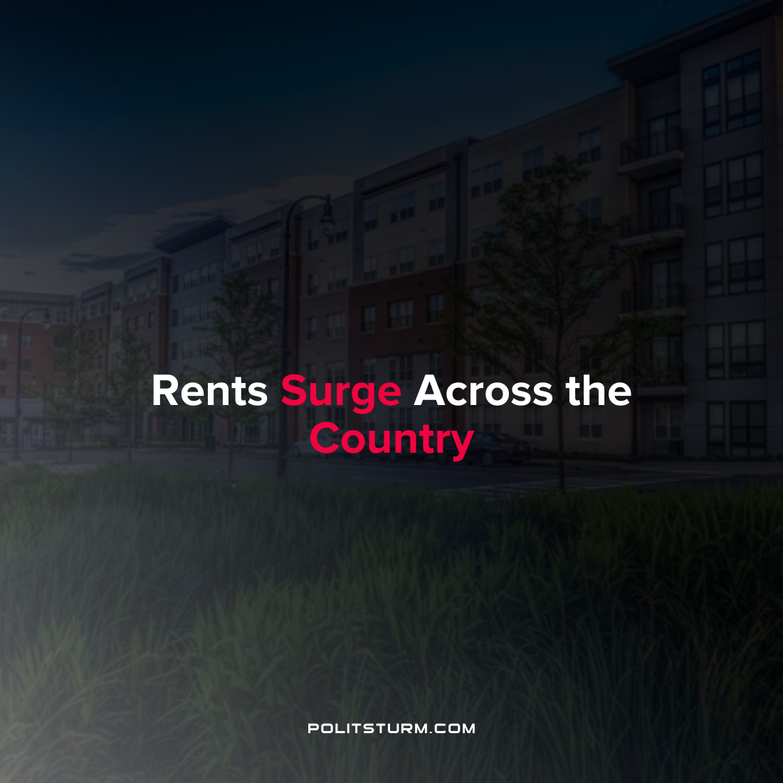

Original article
2022-04-15
1 min read

With housing prices on the rise across the country, the cost of renting an apartment or home has followed suit through the start of 2022. In 2021, rents increased at a blistering 11% across the country. In particular, the cost of renting a single-family home increased at 26% in the previous year.
The most expensive average rent in the U.S. is New York City where the 1-bedroom median rent was $3,210 according to the Zumper National Rent Report. Other cities such as San Francisco and Boston also had extremely high 1-bedroom median rents at $2,910 and $2,660, respectively.
As inflation increases prices for commodities in the economy, the landlords are not having any trouble in keeping up with inflation by increasing rents. Under the capitalist economic system the privately-owned housing stock benefits the class of landlords and institutional investors who benefit from rising rents and housing prices. The workers who are dependent on their wage-income are squeezed into giving a larger share of their income to the landlords in exchange for housing. As long as the capitalist system continues to exist, the landlords and capitalists will continue to profit while the average workers are left behind.
Sources: 1 2 3

Original article

