Rents Are On The Rise Across America
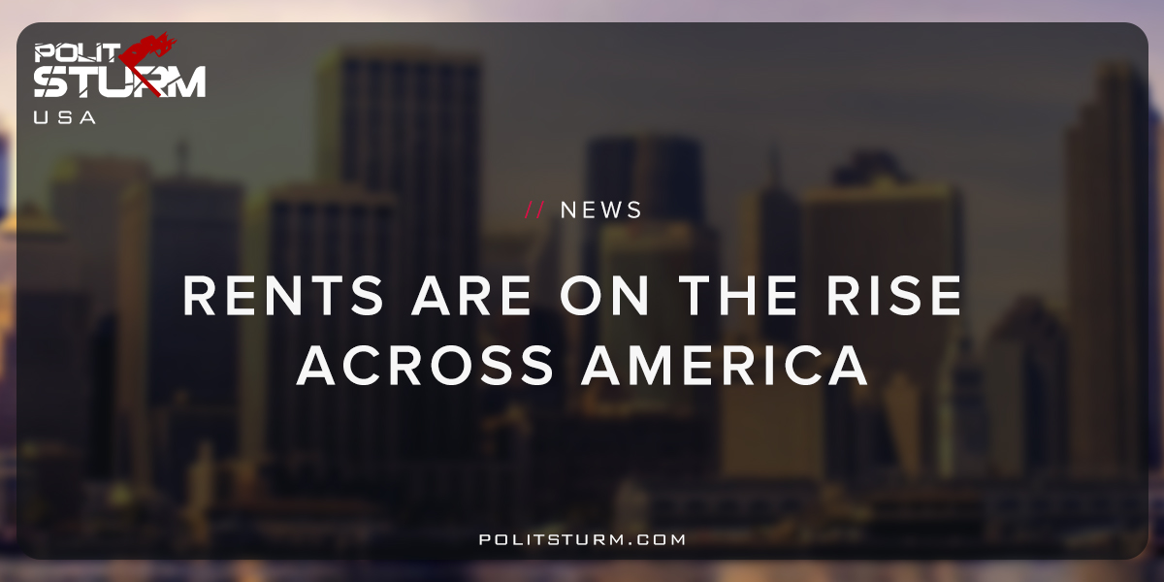

Original article
2018-06-16
1 min read

A report by the Pew Charitable Trust found that 17% of America’s population is “severely debt burdened”. They are spending 50% or more of their income on rent. Rents across the country have skyrocketed while wages have not kept pace.
This is just another example by which the market separates two opposing classes: landlords and renters. As the debts become ever more pressing and onerous for the renters, they are more fruitful and enriching for the landlords and the propertied class.
As of the last estimate, there were over 17 million vacant housing units in the United States. While this number has declined since the recession, the falling supply has led to increased prices.
The rentier class wins first when they are able to buy rental properties at rock-bottom prices during the recession. As the housing stock decreases and investors buy rental properties they win again with the appreciation of prices and rising rents.
The forces of “supply and demand” operate within the framework of the bourgeois state. The bourgeois state protects the interests of the capitalists and landlords. The economic, political, and legal structures within capitalism create these poor results for the working class.
As long as there is private ownership in the means of production there will be wage labor and an exploited working class. Investors will be able to reap profits and rents through buying rental units and receiving rents. Those with money capital can invest and extract rent through leasing out the housing stock. This situation is legal and perfectly acceptable in every state of the country, but it is ruinous for the mass of people.
There are two sides to the coin. On the one side you have the indebted renters who need housing to survive and pass a large proportion of their wages to the landlords every month. On the other side you have the landlord whose interests are diametrically opposed to the renters. The higher rent is negative for one class, the working class, and beneficial to the renting class. To consider rising rents but not the class relations involved is to miss the essence of the phenomenon.
http://www.pewtrusts.org/en/research-and-analysis/reports/2018/04/american-families-face-a-growing-rent-burden
https://fred.stlouisfed.org/series/EVACANTUSQ176N

Original article

