Refugees Found Dead on the Eastern EU Borders
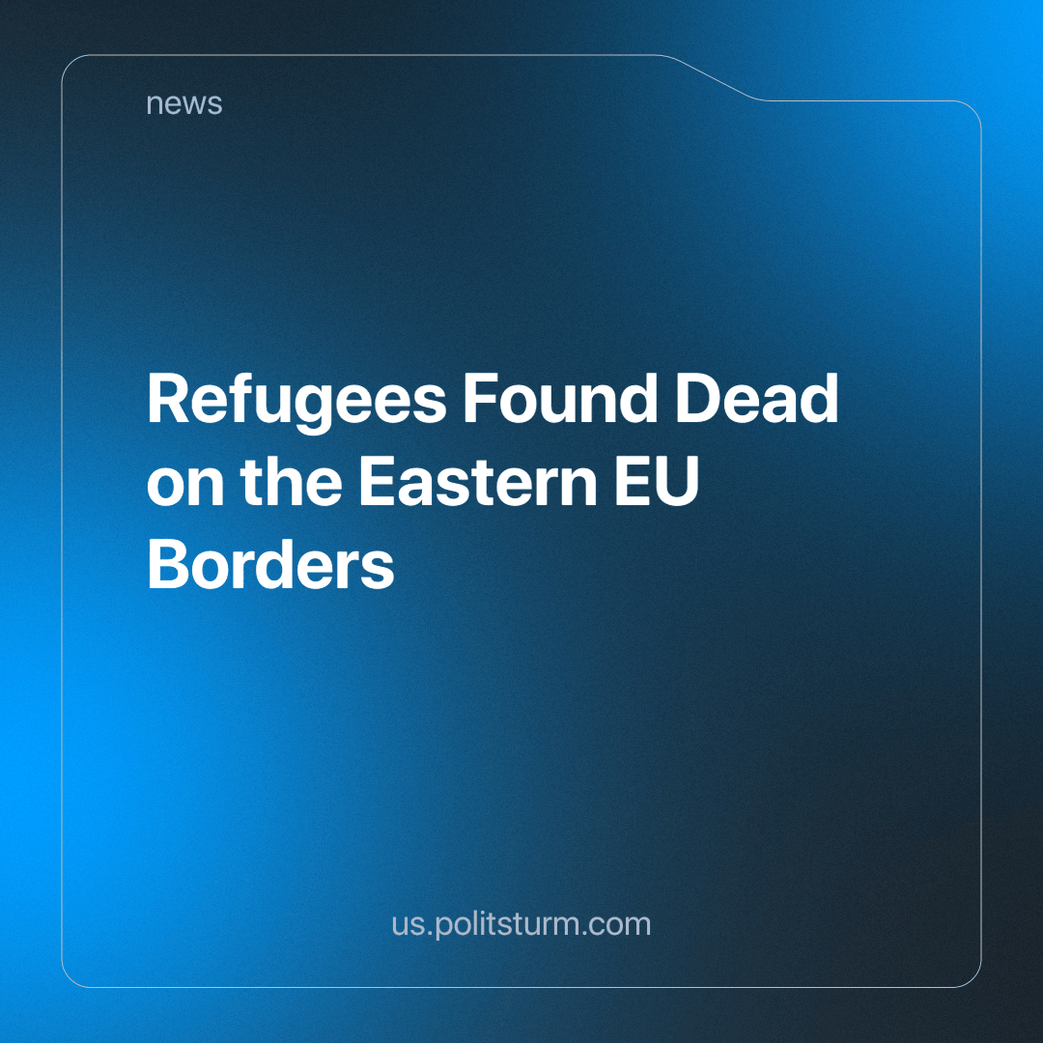

Original article
2023-12-20
2 min read

Belarusian border guards have discovered 38 bodies in total since August 2021 — 10 bodies on the Latvian border, 9 on the Lithuanian border, and 19 on the Polish border.
In 2023, there were 23 casualties, which surpassed previous years, and marked the first recorded deaths on the Latvian border, with 10 foreign nationals losing their lives, exceeding both the Lithuanian and Polish borders.
The State Border Committee attributes these deaths to neighbouring EU states, accusing their authorities of inhumane and criminal actions.
Moreover, there have been cases of severe injuries without fatal outcomes. On October 24, in the Pruzhansky district, two men from Afghanistan and Bangladesh were found with broken legs. The victims claimed that Polish border guards caused these injuries: when the refugees sought help, the guards started beating them, subjecting them to pepper spray, had their legs broken, and the refugees were then pushed into Belarusian territory through an animal gate.
The Investigative Committee's press service commented on the incident:
"Polish law enforcement, with the silent approval of European officials, continues to perpetrate madness against migrants. Refugees are fleeing war and turmoil to the very Western countries that recently extolled their highest values, safety, and compassion. However, migrants encounter unprecedented inhuman cruelty and abuse."
This reported mistreatment reflects a pattern observed in Latvia, Lithuania, and Poland, where this informal deportation procedure is used to discourage illegal border crossings. The implicit message is clear: "You are not welcome here." This approach is both a deterrent and a cost-saving measure on formal deportation procedures, allowing resources to be redirected elsewhere.
It's crucial to remember that border services, like other law enforcement agencies, are tools in the hands of the ruling class. Thus, the inhumane actions of border guards stem from capitalist class interests. However, this doesn't absolve individual border guards of their personal responsibility, both on moral grounds and under their state's laws.
In response, the Belarusian state exploits this situation to fuel national hysteria and chauvinism towards Western and Far Western countries. While their propaganda highlights the dominance of the European centre, it conveniently omits its class-based component. Belarusian propaganda showcases the suffering of migrants but fails to mention that state-funded healthcare is exclusively available to Belarusian citizens, with humanitarian assistance and aid not formally provided under Belarusian legislation.
Consequently, the Belarusian side is hypocritical, capitalising on human suffering, sorrow, pain, victimisation, and fatalities to score political points, while simultaneously condemning other countries for practices that it engages in.
Sources:
BelTA - "State Border Committee: Belarusian Border Guards Found Bodies of 23 Refugees" dated October 25, 2023.
BelTA - "Polish Border Guards Injure Afghan and Bangladeshi Refugees" dated October 25, 2023.

Original article

