Record Profits for Swedish Stores During the Crisis
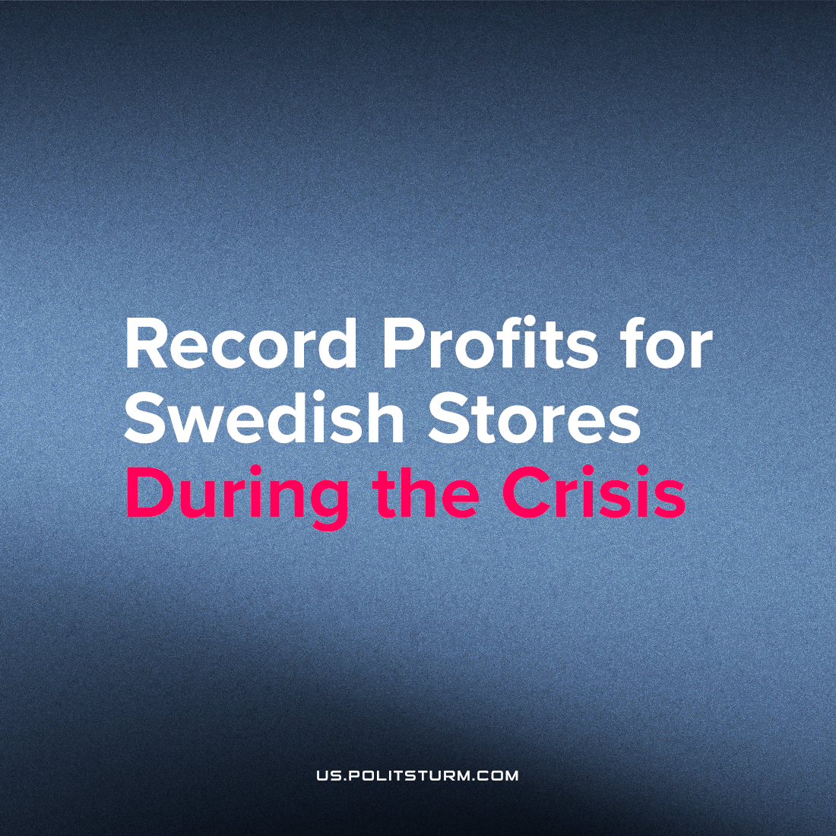

Original article
2022-11-01
1 min read

The profit margins of major grocery chains in Sweden and across Europe have sharply risen since 2020. During the pandemic, people stayed at home more often, traveled less, and as a result, spent more money at nearby stores. However, store owners were not satisfied with the income due to the growing number of purchases. They also took the opportunity to raise the products’ prices. Large chain stores are raking in an unprecedented windfall because of the pandemic. For example, the largest grocery store chain in Sweden, ICA, made a profit of $200 million in 2021 alone. In recent years, ICA has become one of the most profitable food chains in the world.
Even though a long time has passed since Sweden canceled almost all measures related to the pandemic, emergency food prices in Swedish stores only continue to rise. Compared to the previous year, food prices in the country increased by 16.1% in 2022. At the same time, the level of profits of large stores this year has not decreased. It means that owners and shareholders of companies receive even higher profits while it becomes increasingly difficult for their customers to make ends meet.
In an interview with a Swedish newspaper, ICA CEO Per Strömberg proudly stated that the company’s management is doing everything possible to reduce the purchase prices of products. By doing so, he tried to prove that the owners were sincerely fighting against the negative effects of inflation in an attempt to help customers. But in fact, big capitalists like Strömberg are looking for any way to reduce purchase prices, not to alleviate the situation of buyers, but to increase their profits. While the crisis in the capitalist countries of Europe continues to deepen, the gap between the rich and the poor continues to widen.
Source: 1 , 2 , 3

Original article

