Qatar Hypocrisy
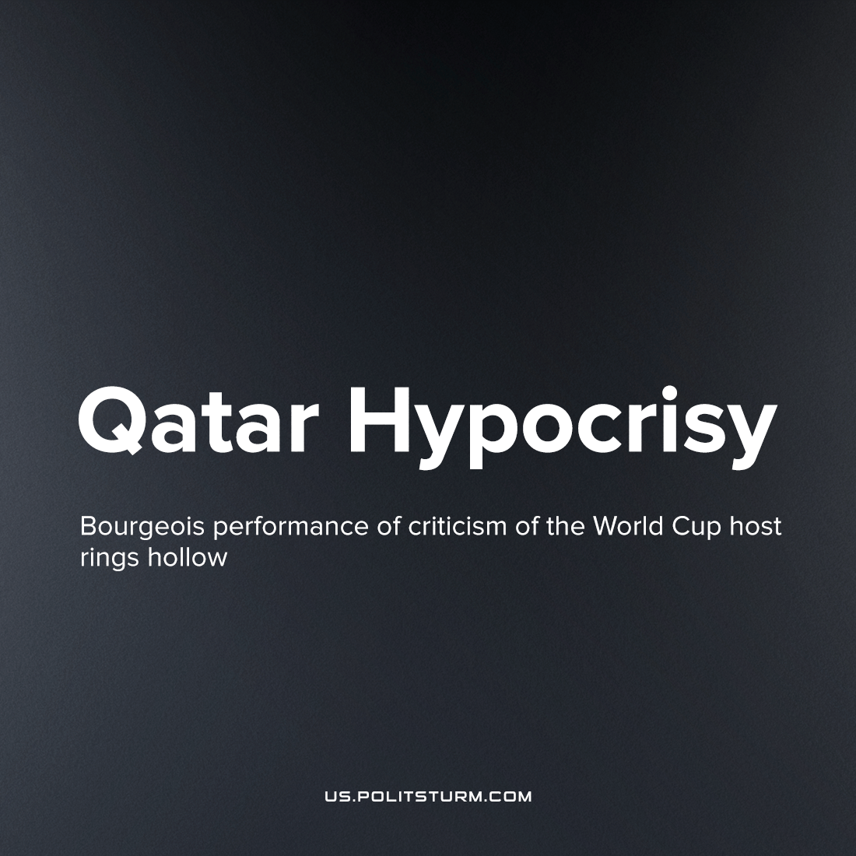

Original article
2022-12-02
5 min read

The World Cup in Qatar has begun and the one of the world's most popular events is being eagerly watched by billions of people. However, this year, instead of presenting the opening ceremony, BBC presenter and former footballer Gary Lineker described it as “the most controversial world cup in history”, before listing the sources of the controversy. Bribery and corruption within football’s governing body (FIFA), the mistreatment and deaths of many migrant workers who quickly built its stadiums, and Qatar’s laws against homosexual relations as well as the restriction of women’s rights and freedom of speech. [1] Similar vociferous criticism of the Qatari state has also been forthcoming from the US, French and German media, hoping to direct the popular discomfort with the realities of their sporting past-time.
The official figure of worker deaths building the World Cup stadiums and infrastructure over the last 10 years is between 400-500, according to the Qatari government, while The Guardian has come to a figure of at least 6,500 by compiling embassy data [2]. Many of these deaths are from unsafe work practices which remain due to the appalling state of workers’ rights Many more die from the long working hours in the summer heat, in a country where temperatures regularly exceed 45˚C - 113˚F. The majority of these workers are migrants from South Asia in search of higher wage employment. Many will go unpaid and are coerced to continue in their positions by the threat of legal or illegal violence, and the common confiscation of their passports by employers. Western criticisms of Qatar have a legitimate basis, of course, but they are entirely self-serving.
Migrant labour is of great importance to capitalist economies, as migrants are generally more vulnerable - being unfamiliar with the local law and culture, more desperate, and more willing to work for less under worse conditions. Those who complain about their mistreatment or attempt to organise their labour in order to raise their wage can be easily deported, or otherwise threatened with legal difficulties. From this, local workers suffer too, and are consigned to unemployment, as the capitalists prefer the cheaper, more disposable labour force. And Western countries cannot resist this temptation themselves, despite decrying the treatment of migrant workers abroad.
In the UK fishing industry, around one fifth of all workers are migrants [3], and abuse is rampant even in this 'advanced' Western nation. Of all migrant workers who responded to a survey conducted by the University of Nottingham, 25% said they suffered injuries at work, 32% said they were threatened with the withdrawal of pay, 35% said they were subjected to physical or sexual violence and 62% said they suffered verbal abuse [4]. On average, migrant fishermen and women work 16 hour days and are legally paid £3.51 per hour – well below the minimum wage. Most of these migrants are brought in from the Philippines and Ghana on a transit visa and compelled to stay by their employer. As it is a transit visa, they have no legal right to stay in the UK, so many are forced to live on board the fishing vessels making them even more vulnerable and dependent on their employer. In addition, due to numerous legal technicalities (which most migrant workers are unaware of), for instance if the employer forces the migrant worker to work on a vessel not named in their contract, the employer can easily cause the migrant worker to violate the terms of their visa and British immigration laws, allowing the employer to threaten the migrant worker with imprisonment or deportation as an additional means of control.
Similarly in the US, the exploitation of migrant labours is especially prolific within the agricultural industry (where an estimated 73% of all workers are migrants [5], predominantly from Mexico and Central America) as well as the H2-A and H2-B temporary visa system in general. When the National Labour Relations Act (which granted most workers the democratic right of collective bargaining) was passed in the US in 1935, the protections were deliberately not extended to agricultural workers – a situation that remains the same in the majority of American States today [6]. Many of these migrant workers go into deep into debt in order to make the journey to the US, and end up being paid far less than promised, subjected to gruelling conditions, long working hours and forced to live in shameful pest-ridden accommodation. Accordingly, many are unable to pay off their debt, which becomes another method of coercion the employer can exercise over the worker. In addition, what few legal protections against age, gender and ethnic discrimination that are extended to H2-A workers are not enforced, allowing farm industry capitalists to discriminate in order to employ predominantly young single male migrants without family in the US who they expect to devote every day to work. These capitalists can reject employment to workers who are not part of this “ideal” demographic. Additionally, they can hire based on whatever ethnic stereotypes and prejudices they have, as well as intentionally sowing and inciting racial hatred with the objective of keeping their workers divided [7]. According to US government figures, 368 farm industry workers out of an estimated total of 2.1 million died in 2020 [8].
In addition, the Qatari state’s military strength was given to it by those same Western countries who are now its loudest critics. Between April and June of this year the UK sold Qatar £3.4 billion worth in arms [9], and the US has concluded a $1 billion weapons deal with Qatar during the US-Iran match [10]. In addition, the UK concluded a £10 billion oil deal with Qatar in May. While they endlessly virtue signal, ultimately the capitalists of the UK and US cannot resist the allure of lucrative arms and oil deals. The spectacle they raise over the abuse of migrant workers in Qatar is only intended to point attention away from the abuse of migrant workers at home. In order to stop the abuse of migrant workers and the exploitation of all workers in general around the world, we need an economic system that does not incentivise their exploitation; one that guarantees that no-one is desperate enough to leave their home and face such harrowing abuse in order to have a livelihood.
We need a system where the means of production are not concentrated in the hands of a small minority, who use this to compel the majority to work for them or starve. Instead, they should be owned in common by society - freeing human labour from its current status as a commodity whose price can be greatly lowered by hiring the more desperate and vulnerable and mercilessly exploiting them. We need a system where things are not produced for profit, but for human use; where one’s own labour is the only legitimate source of wealth, allowing for money to be replaced by a system of direct labour accounting, completely transforming, and demystifying productive relations to those of communism.
“All that is solid melts into air, all that is holy is profaned, and man is at last compelled to face with sober senses his real condition of life and his relations with his kind.” – Karl Marx, Manifesto of the Communist Party

Sources: [1] 2] 3] 4] 5] 6] 7] 8] 9] 10]

Original article

