Putin Announces a "Complex and Important" Stage in Strengthening Russia’s Sovereignty
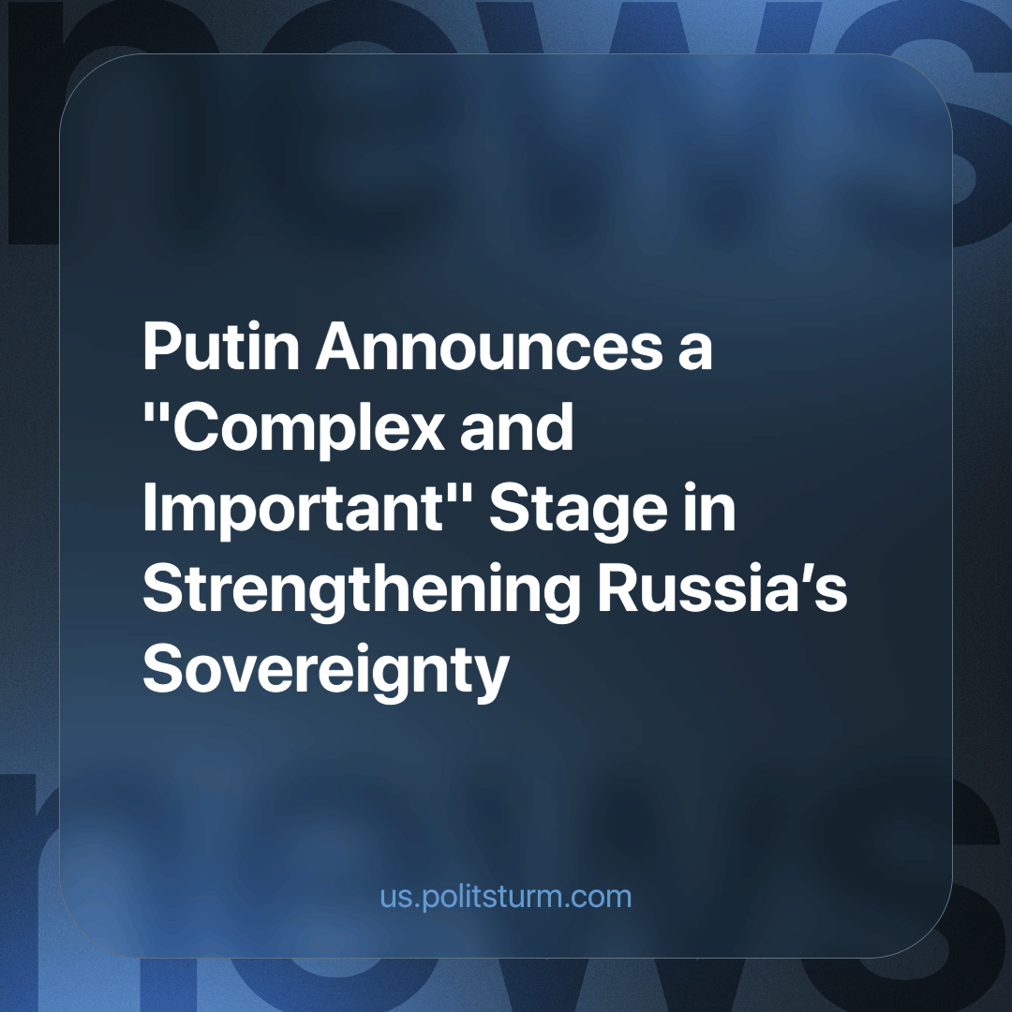

Original article
2024-03-12
1 min read

The presidential candidate of the Russian Federation, Vladimir Putin, stated in a meeting with his trusted associates that Russia is currently addressing the majority of its tasks, undergoing a complex and crucial stage in strengthening sovereignty.
"The overwhelming majority of the set tasks are being resolved, we are going through an important and challenging stage in the country's development. Much has been achieved in recent years. There is something to show to the country and the people, although not all the results have been achieved," said Vladimir Putin.
According to the candidate, the reinforcement of Russia's sovereignty and development is occurring in numerous areas, with the country progressing in several directions.
In reality, the ongoing crisis intensifies, and the vast population becomes poorer—an interesting way for a country to develop in an increasingly 'dynamic' and 'multifaceted' manner. Ordinary bourgeois populism, with the deepening of the crisis, takes increasingly hysterical forms, progressively losing connection with reality
The only way to ensure genuine dynamic and comprehensive development for the majority of the population would be to replace capitalism, which destroyed Soviet socialist industry, plunging millions into poverty, unemployment, and confusion.
Source: URA.ru - "Putin: Russia is going through a complex and important stage" dated January 31, 2024.

Original article

