Putin Discusses the Middle East with Religious Leaders
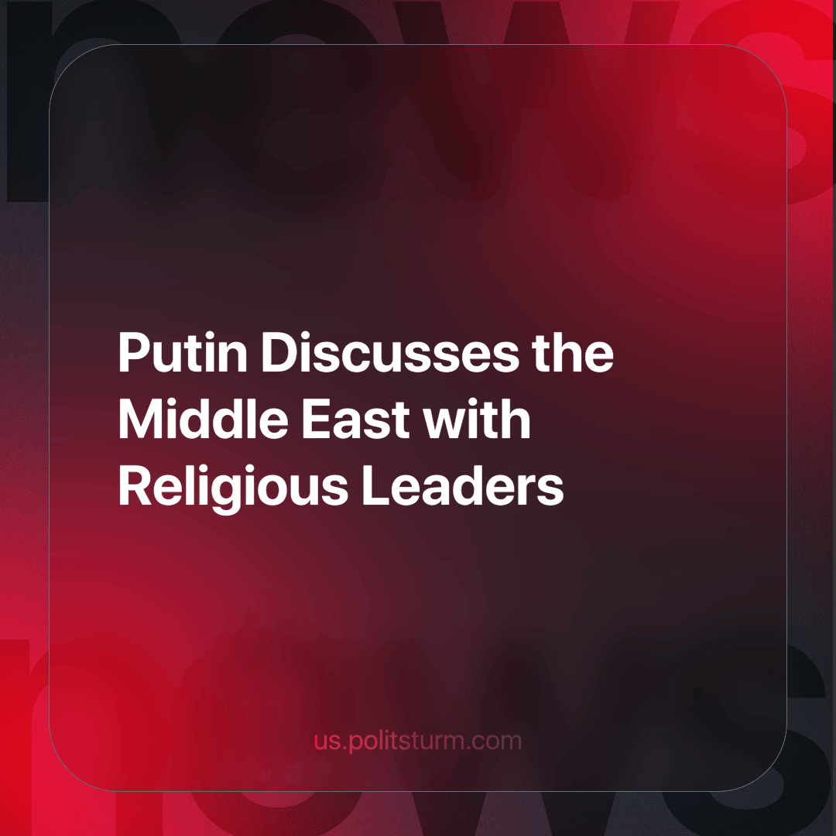

Original article
2023-12-13
2 min read

In preparation for National Unity Day, Russian President Vladimir Putin held a traditional meeting with representatives of various religious denominations in the Kremlin. The primary topic of discussion was the Palestinian-Israeli conflict.
Expressing concerns regarding the events in the “Holy Land”, a region of great religious significance to Christians, Muslims, and Jews, Putin emphasized the importance of ending violence and combating terrorism without resulting in collective punishment and humanitarian crises.
Putin reminded attendees of Russia's support for the UN Security Council's resolutions calling for the creation of two independent states, Israel and Palestine, viewing this as a crucial step toward conflict resolution. He also acknowledged the influence of what he termed as "certain forces," attempting to escalate the conflict by exploiting national and religious sentiments, attributing their motives to shaping Russia’s stance and establishing a "new world order" based on what he referred to as "hypocrisy and double standards."
Representatives from diverse faiths echoed similar sentiments in their speeches, emphasizing the importance of interethnic and interreligious harmony in Russia. They expressed solidarity with initiatives aimed at establishing peace in the Middle East. However, Russia's Chief Rabbi emphasized the impracticality of seeking peace with terrorists, while the Chairman of the Central Spiritual Administration of Muslims, Talgat Tadzhuddin, stated that the core of the conflict lay in injustice towards the Palestinian people.
Despite the rhetoric at the meeting, a contradiction emerges when examining the actions of the Russian state. Putin calls for a resolution to the Palestinian-Israeli conflict, yet the Russian-Ukrainian conflict carries on. While there’s talk of interethnic harmony within Russia, policies are in place that increase migrant inflow, intensifying labour market competition and fostering nationalism amongst Russians. They speak of “hypocritical forces” seeking a new world order, but their proposed “world order” shows no difference.
To conclude today’s article with a Lenin quote that remains relevant to this day:
"People have always been and always will be foolish victims of deceit and self-deception in politics until they learn to seek the interests of different classes behind all moral, religious, political, and social phrases, declarations, and promises." - V.I Lenin (The Three Sources and Three Component Parts of Marxism)
Source: Vedomosti - "What Putin Discussed About the Palestinian-Israeli Conflict in His Meeting with Religious Leaders" dated October 26, 2023.

Original article

