Proud Boys and Antifa Clash in Portland
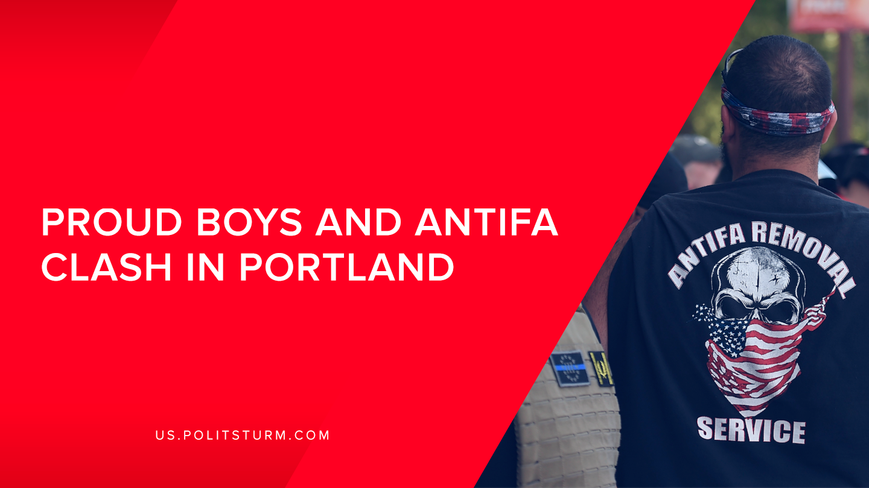

Original article
2019-08-28
1 min read

On Saturday, August 17th, 2019, around 300 Far-Right Activists such as the neo-fascist group The Proud Boys gathered in Downtown Portland for an “End Domestic Terrorism” rally. Their Chairman Enrique Tarrio told the CNN reporter Sara Sidner that “We came over here to raise awareness for domestic terrorism.”The Right Wingers were opposed by around 200 Antifa members, both groups were separated by the Portland Police.
The Proud Boys is a neo-fascist organization that was founded by Canadian Alt-Right Political Commentator Gavin McInnes in 2016 . The Rally was planned out months before Saturday and attracted US President Donald Trump’s attention. Trump tweeted that his administration is considering to name Antifa an “ORGANIZATION OF TERROR” before the Portland Clashes, which caused a huge wave of support from the Alt-Right.
There was an incident caused by one of the“Proud Boys”members tweeting about bringing guns to the rally. As the Rally started the Portland Police had seized several metal flag poles, baseball bats, and knives, no firearms were encountered. Antifaand The Proud Boys were separated by 150 yards and the Portland Police Officers.
The Rally lasted for 1 hour and 20 minutes, with the Organizers calling it a success due to “Go look at President Trump’s Twitter…. That’s all we wanted. We wanted national attention, and we got it. Mission success.” As we can see The Proud Boys are supporting interests the bourgeoisie by promoting nationalism and chauvinism. The capitalist class will support the most reactionary forces in order to maintain class rule and the Proud Boys are no exception.

Sources: 1 , 2 , 3 , 4 , 5 , 6

Original article

