Protests in Ukraine And Protests in Kazakhstan: What's The Difference?
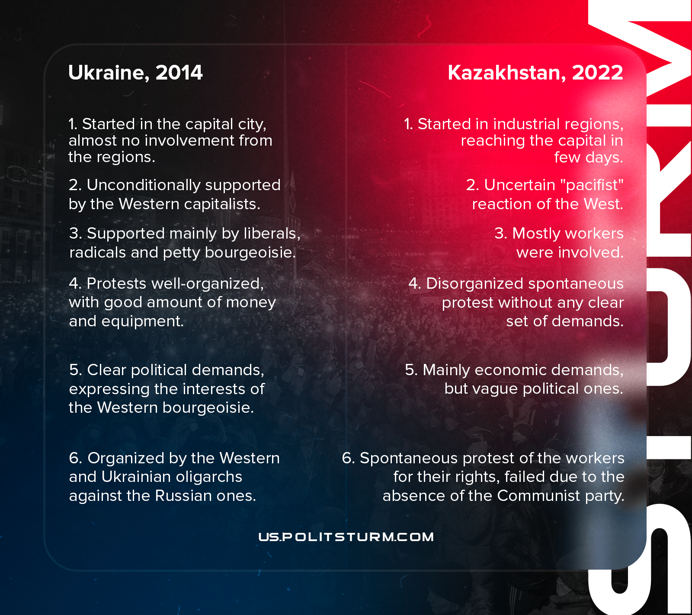

Original article
2022-01-23

Original article

