Protests in Kazakhstan: Everything You Need to Know
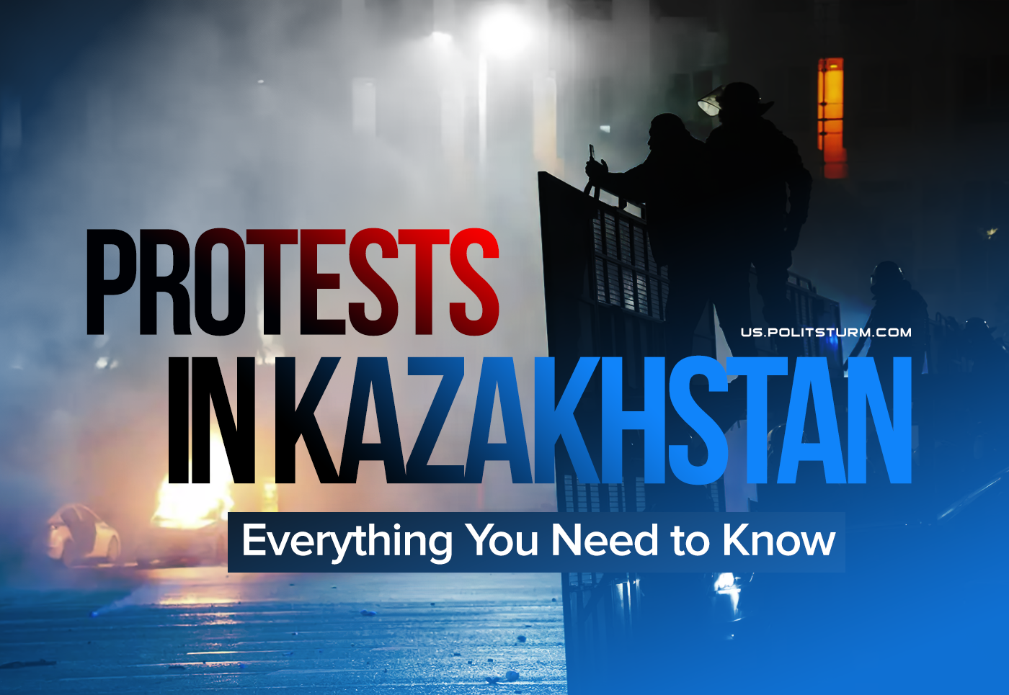

Original article
2022-01-05
4 min read

Massive protests continue erupting right now across the country. They started in the city of Zhanaozen (South-Western part of Kazakhstan) over the rising prices of liquified gas. What can we say about the situation at the moment?
- The rise in gas prices is just a pretext for popular discontent. The main reason for the protests is the plight of the working people of Kazakhstan due to the economic crisis of capitalism.
- Protests are spontaneous in nature: they began spontaneously and they don’t have specific goals or coordination. With all its might, the Kazakh government tries to divide the protest, for which the Internet was turned off throughout the country.
- A significant part of the protest in Kazakhstan is made up of workers of various enterprises. Claims are also made against employers: for example, employees of the Kazakhmys foundry and mechanical plant demanded better working conditions and higher wages, miners of ArcelorMittal Temirtau refused to go to work and went on strike, etc.
- The authorities of Kazakhstan are trying to reduce the intensity of protests and make concessions. The government is dismissed; the authorities promise to reduce gas prices to 50 tenge per liter. The massiveness of the protests is still holding back the bourgeoisie in its’ repressive actions, but the situation is heating up quickly.
- Economic demands predominate among the protesters: improvement of living standards, abolition of high gas prices, lowering food prices, higher wages, etc. The workers are not yet fully aware of their class interests: the political slogans put forward by the protesters are still scattered and are predominantly bourgeois-democratic in nature – the resignation of the government, “regime change” and the president.
Error loading image
- The intensity of the protests and their social orientation came as a surprise for many, including the bourgeois “opposition”, some of which are afraid of the activity of workers and their demands. Some of the frightened liberals even went over to support the ruling regime under the slogan of “keeping the crowd out of power”. Others are trying to impose their agenda on the protesters.
- The lack of a coherent political program is a consequence of the fact that the working people of Kazakhstan don’t have a political organization. Without its party and its firm leadership, things will not go beyond economic demands and petty-bourgeois political slogans. In the absence of a communist party that consistently guides workers in the struggle for their rights and socialism, the protesters will inevitably fall under the influence of the bourgeoisie and will be deceived.
- However, such mass demonstrations of workers in Kazakhstan are the first ones for a long time. Therefore, the unification of the working masses, even in a spontaneous struggle for their rights, can only be welcomed. Given the repressive policies of the current ruling group led by the Nur-Otan party, the revitalization of the country’s political life paves the way for a serious workers’ struggle for their rights and socialism.
- The growing political activity of the masses inevitably affects the political life of the entire country. If hundreds of thousands of workers, united even by spontaneous demands, were able to shake the bourgeois regime, then with the presence of their own organization, clearly knowing their goals and the path to them, workers will be able to win in the struggle against all groups of the bourgeoisie. An organized political struggle and victory can be achieved only under the leadership of the Communist Party. There is no CP right now. But it’s never too late to work for its creation.
- The main troubles of the workers and communists of Kazakhstan are fragmentation, lack of organization and spontaneity. We call on all conscientious readers from Kazakhstan to unite, to educate the local community, especially workers, to help organize trade unions and labour collectives, to send us news and any useful information, and to join our ranks to work in Kazakhstan.

Original article

