The Number of Protests is Growing in China
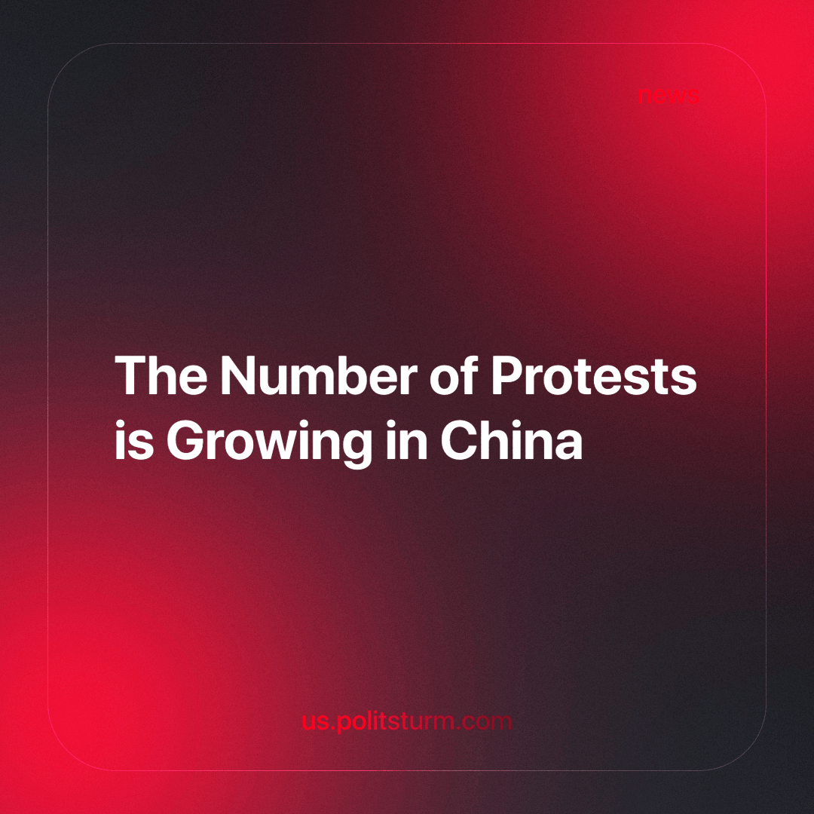

Original article
2024-02-28
2 min read

According to Bloomberg, the number of protests in China increased in the fourth quarter of 2023. About 61% of them were related to labor conflicts, and another 17% related to housing problems. About 18% of the protests took place in Guangdong province, known for its developed industry [1].
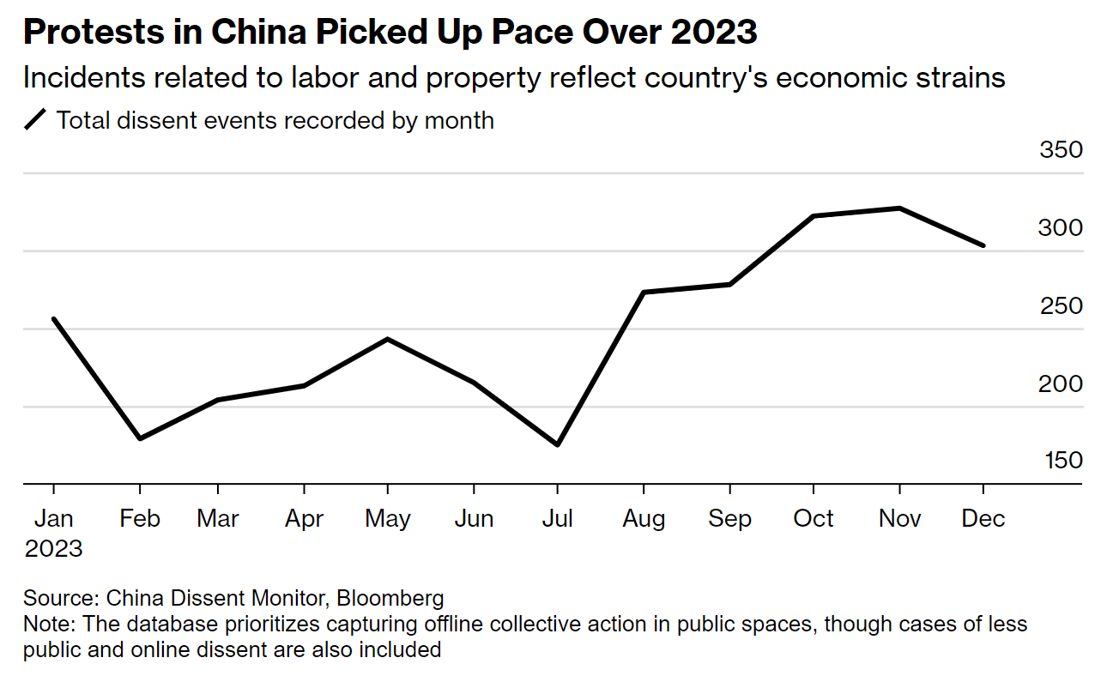
Youth unemployment (people aged 16-24) in China reached a record 21.3% in June last year [2]. After this “surprising” news, the Chinese government temporarily stopped publishing data and then stated that the indicator improved in December and amounted to 14.9% in December after changing the methodology, excluding students from the statistics [3].
The discontent of the local population began to grow after the establishment of covid restrictions — people faced the so-called "Covid Zero system", which seriously undermined the Chinese people's ability to earn a livable income, and their labor rights were curtailed. As a result, the Chinese police dispersed some of the protests by force, correcting and deleting information about them on the Chinese segment of the Internet [4].
In addition to the accumulated dissatisfaction since the lockdown, China's economy has recently been slowing down. This is not meeting the expectations of bourgeois experts, which in the short term may scare off investors. To somehow fight against this trend, a week ago, China carried out the largest benchmark mortgage rate cut in history to spur demand and revive the domestic real estate market amid the collapse of the largest property developer China Evergrande Group. The company went bankrupt due to low demand for housing [5].
In order to compete with Western goods and remain an attractive place for investments, capitalism with Chinese characteristics needs cheap labor, with minimal working rights. After all, this is the best way to attract foreign capital. Despite all the obstacles in the form of censorship, systems of control and surveillance of the population, police violence, and the bourgeois government that protects the interests of billionaires – workers are beginning to fight more and more for their rights.
The crisis of the capitalist system once again clearly shows the working class that only by taking power into their own hands can fight for their happy future. Until then, there will be crises, unemployment, cuts in working rights, a deterioration in living standards, bans on protests and dissidence etc.
Sources: 1, 2, 3, 4, 5

Original article

