Poultry Workers Die From Coronavirus
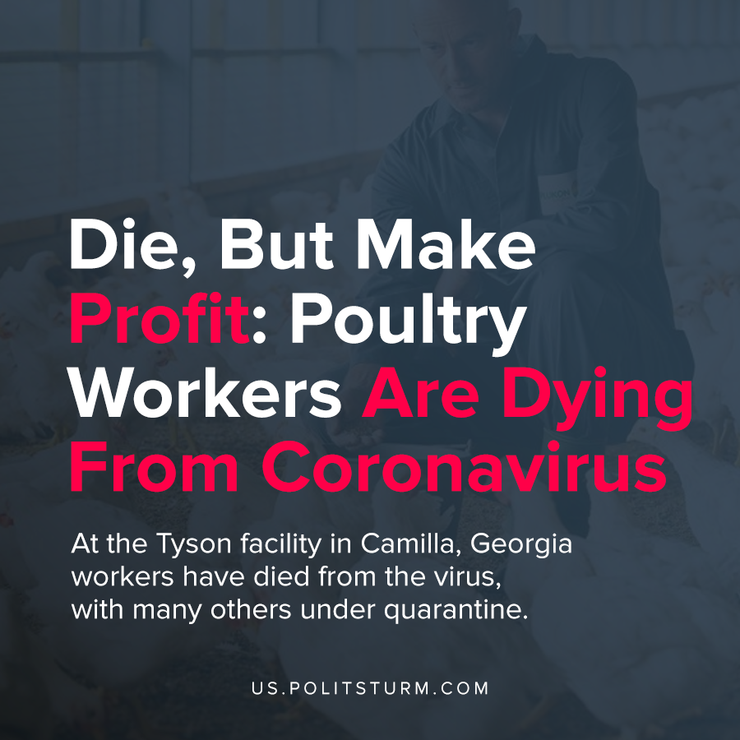

Original article
2020-04-13
1 min read

Amidst the coronavirus epidemic, workers are speaking out about the unsafe conditions that they are being subjected to in their workplaces. At the Tyson facility in Camilla, Georgia workers have died from the virus, with many others under quarantine.
Workers in the poultry industry in Alabama are also working elbow-to-elbow on the production line and were only given masks this week.
In addition to the risk to the health and safety to the workers, there are also tremendous economic problems.
Poultry worker Michael Foster details his experience as a worker at a plant owned by Wayne Farms.
“Nobody is recognizing or appreciating us for what we’re doing. My company could have afforded to at least give every worker they have a box of chicken…I do not have chicken in my freezer.”
The capitalist class is only concerned with the generation of profit and their ability to appropriate it. The workers who are producing the food are being exploited by capitalists and are suffering in numerous ways. Workers are getting sick and dying while working in unsafe conditions. The economic hardships and anxiety are also acute under the capitalist economic system, especially in times of crisis. The only way that this absurd situation can be resolved is if production is in control of and serves the interests of the working class to prevent such needless suffering and loss of life.
https://www.rwdsu.info/poultry_industry_s_delayed_covid_19_response_is_killing_america_s_essential_workers_protect_them_now

Original article

