Police Arrest Anti-Fascists at Neo-Nazi Rally
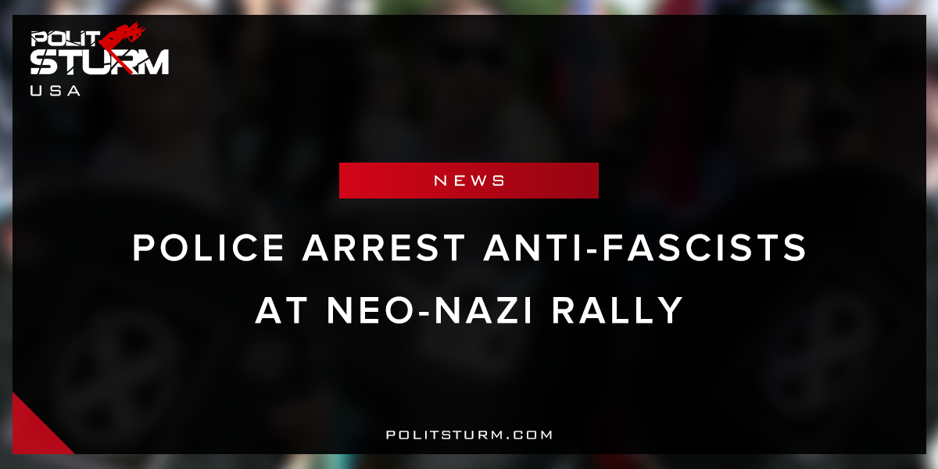

Original article
2018-04-24
1 min read

Counter-protests in the small town of Newnan, Georgia led to the arrest of 10 individuals, all of whom were associated with the anti-fascist counter-protest. Police were recorded and photographed assaulting counter-protesters with extreme force while simultaneously protecting the bigoted Nazi’s right to “free speech and assembly”.
In the United States, reactionary propaganda circulated by the mainstream media portrays “both sides” as perpetrators of violence. The police are always heralded with maintaining order and peace, while simultaneously using excessive force only against anti-fascist protesters. The police are portrayed as protectors and arbiters mediating and resolving the conflicts between the Nazis and counter-protesters.
While the police pointed their weapons and actively suppressed counter-protesters they protected Nazi groups who threatened immigrants and suggested to “round them up and put them in camps if need be.”
The capitalist state and their police appendage serves only to protect the dictatorship of the bourgeoisie. Neo-Nazi groups do not represent a threat to the oppressive, exploitative state apparatus and thus receive preferential treatment from police.
The bourgeois government does not represent the views of the mass of working people. The American mainstream media focuses on exclusively complimenting and flattering the police forces while maintaining the oppressive status quo. The police and fascist forces both protect the class interests of the national bourgeoisie and workers should not be deceived by the insidious mainstream press.
https://www.usatoday.com/story/news/2018/04/21/neo-nazis-anti-fascist-groups-descend-georgia-town-competing-rallies/538857002/

Original article

