Planned Reduction of State-Owned Institutions in the Russian Federation
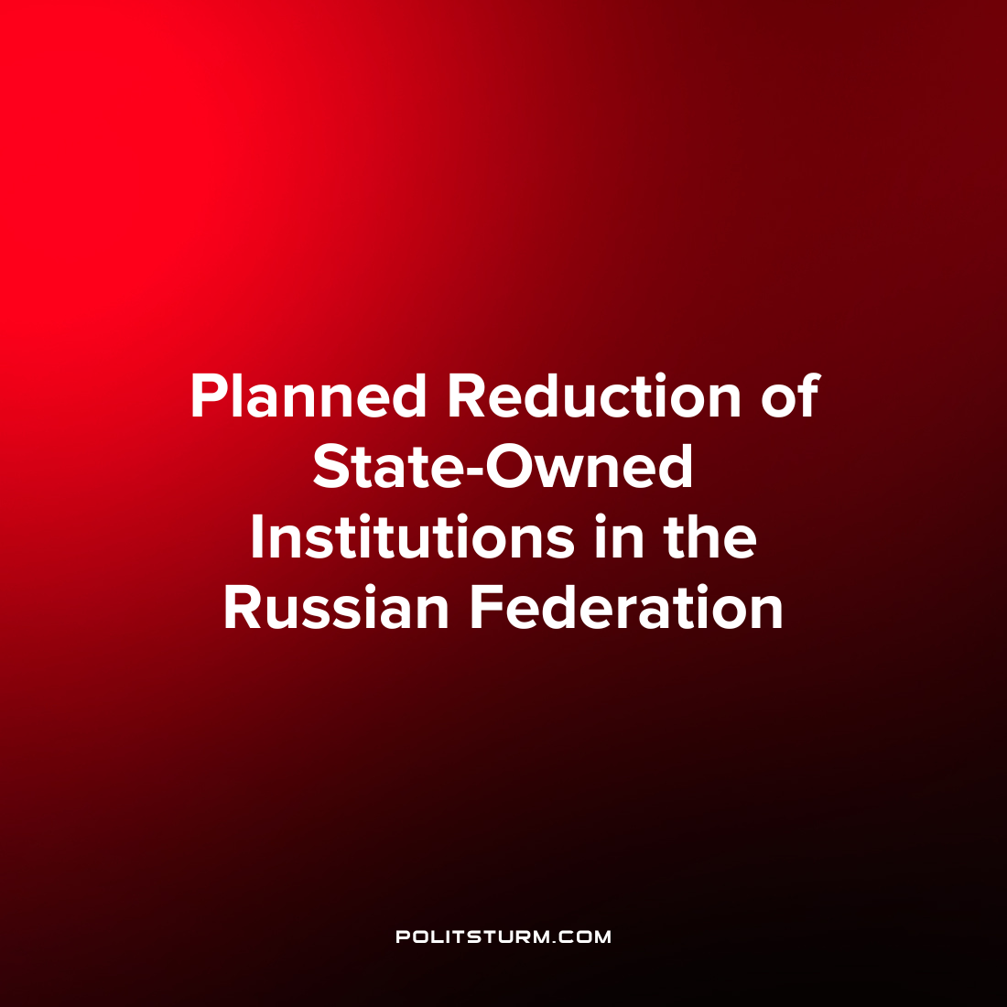

Original article
2023-04-23
2 min read

The Ministry of Finance has planned to reduce state-owned state institutions in order to raise the salaries of the remaining employees. The ministry plans to prepare and submit proposals to the government "on reducing the number of federal state institutions subordinate to federal executive authorities, whose activities are managed by the Government of the Russian Federation." The measure is proposed in order to improve the efficiency of budget expenditure management. Recall: for the first 2 months of this year, there was a rather large budget deficit.
Federal state institutions (hereinafter referred to as FSI) are budgetary institutions whose work is aimed at ensuring the performance of the functions of federal ministries and departments. These are the most numerous in the structure of federal state institutions, about 75% of them.
Among them: military units and military commissariats, penitentiary institutions and pre-trial detention centers, special institutions for the social rehabilitation of minors, specialized psychiatric hospitals with intensive supervision, leper colonies and anti-plague institutions, institutions of the Ministry of Internal Affairs, FMS, FCS, FIS, FPS, units of the Ministry of Emergency Situations and some others.
In 2021, 2.57 million people worked in the FSI, and the wage fund in such organizations amounted to 1.79 trillion rubles, according to Rosstat data.
The department also clarified that the optimization will not affect the state institutions of the "power block". It is worth noting that most of the FCS are under the jurisdiction of the Ministry of Internal Affairs (2402), the Ministry of Justice (1958), the Federal Penitentiary Service (1724), the Ministry of Finance (918), the Ministry of Defense (985) and the Federal Tax Service (634).
Against the background of an increasing budget deficit and the economic crisis in the Russian Federation, a reform is starting to reduce budgetary state institutions. It is quite possible that the upcoming reform will resemble the healthcare reform, as a result of which many hospitals and hospital beds were closed, many institutions were given into private hands, making medicine less accessible to the people. If market transformations reach the FSI, it will mean that for workers either the cost of services will become too high, or the quality will be inappropriately low.
Source: RBC - "The Ministry of Finance has planned a reduction of state-owned state institutions" dated March 28, 2023.

Original article

