“Kurdistan Workers’ Party” Disarms and Dissolves
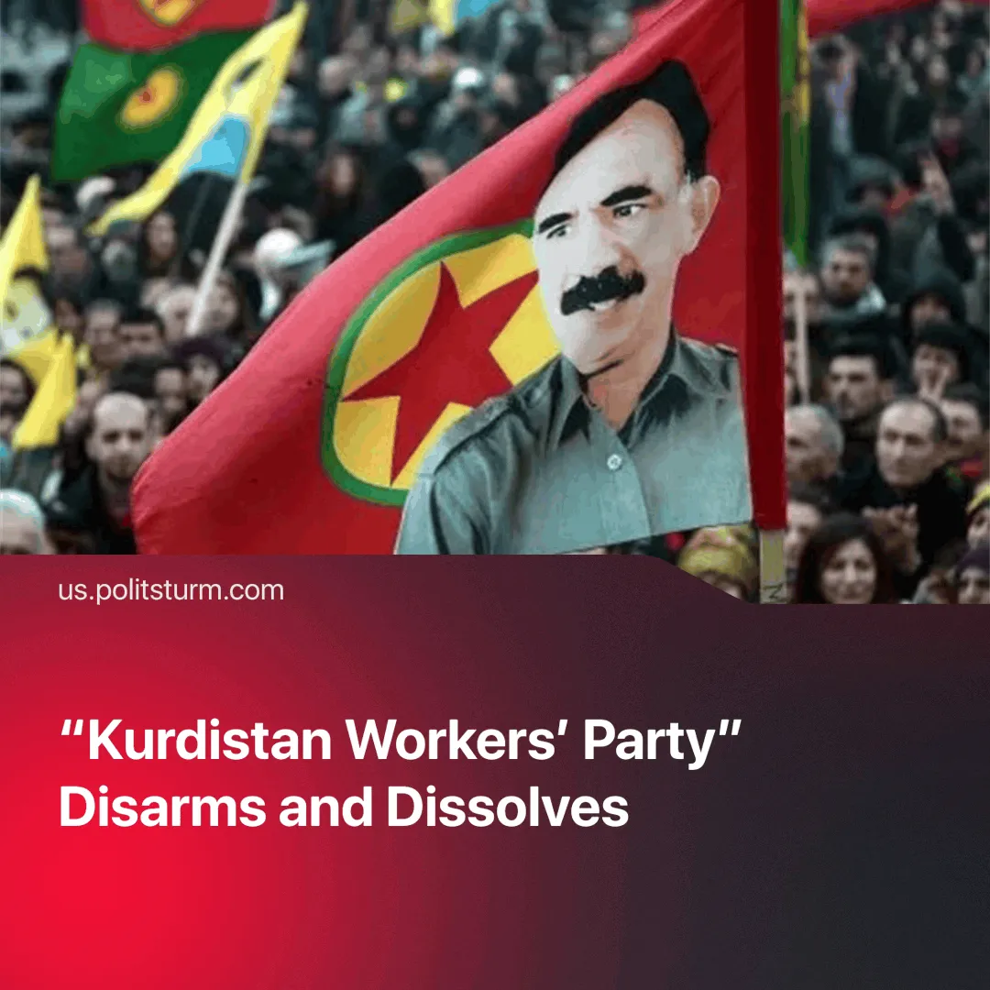

Original article
2025-05-16
2 min read

The Kurdistan Workers' Party (PKK) disbanded after its leader called on supporters to lay down their arms. This marks the third major collapse of "actually working anarchism" in the past five years.
Details. During its 12th Congress, the PKK decided to disband and dismantle, ending its over 40-year-long armed struggle against the Turkish government for a Kurdish state. The imprisoned leader of the organisation, Abdullah Ocalan, called for the PKK to lay down its arms back in February. More than 40,000 in total have been killed in this conflict.
►The 12th Congress has stated that it has "decided to dissolve the PKK's organisational structure and the end armed struggle, with the practical implementation of this process to be led and overseen by (Ocalan)," and that the PKK has "brought the Kurdish issue to the point of resolution through democratic politics, thus completing its historical mission."
►The group believes that the Kurdish people will embrace the liberal-democratic process for achieving its aims. They have stated that "Kurdish political parties, democratic organisations and opinion leaders will fulfil their responsibilities in developing Kurdish democracy and ensuring the formation of a Kurdish democratic nation".
Context. The Middle East is a key battleground for rival imperialist powers. In late 2024, Syrian President Bashar al-Assad, long backed by Iran and Russia, was overthrown by a Turkey-backed offensive led by the opposition. With a pro-Turkish government now in control, the U.S. has begun withdrawing troops that were nominally deployed in 2015 to fight ISIS alongside the Syrian Democratic Forces. The PKK, closely tied to the SDF, came under mounting pressure to disband following Assad’s fall and the U.S. withdrawal.
► The PKK ran autonomous communes, under Ocalan’s idea of a democracy without a state. The “Rojava communes” were praised by anarchists, together with the Zapatistas in Mexico and the “Capitol Hill Autonomous Zone (CHAZ)” in Seattle, USA (which was established during the 2020 Black Lives Matter protests), as examples of modern anarchism in practice.
► "CHAZ" was dispersed by the police within a month. The "Rebel Zapatista Autonomous Municipalities" were dissolved in 2023 due to the Zapatistas' inability to confront cartels. The self-dissolution of the PKK is the third example in five years of how anarchist principles are incapable of sustaining any long-term projects and of resisting capitalist states.

Original article

