President Petro Proposes a Constituent Assembly in Colombia
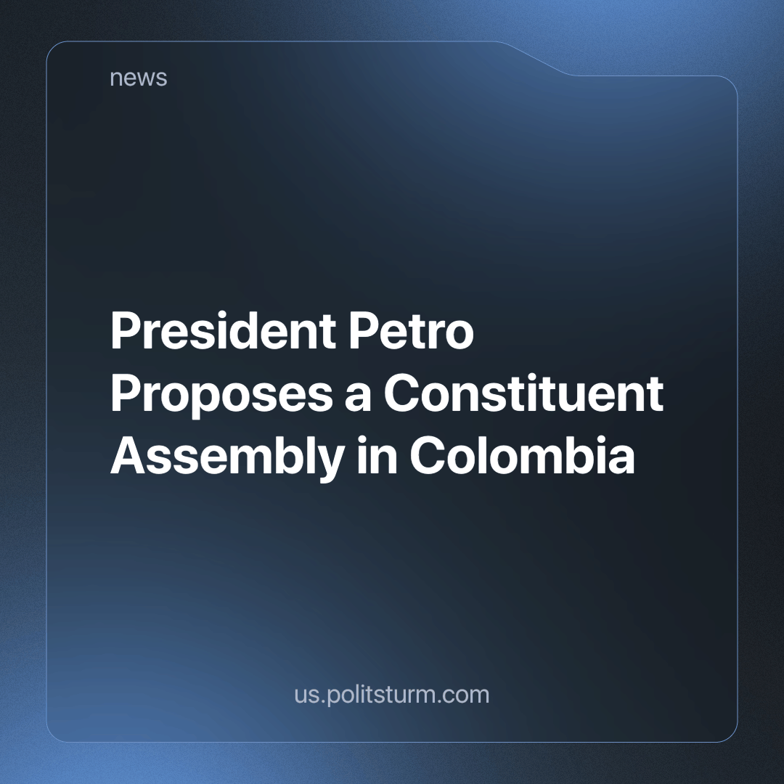

Original article
2024-03-28
6 min read

On March 20th, the Colombian president, Gustavo Petro, gave a speech to his supporters in the city of Cali, where he proposed a Constituent Assembly as a way to implement the reforms that he proposed in 2022 [1]. We already wrote about the probable rejection of those reforms by the Congress and the Constitutional Court and some signals of reconciliation between the government and Colombian monopolist capital. This is another episode in the trail of opportunistic zig-zags and ambiguous appeals to either “the people” or the international reformist consensus that constitutes the political career of Petro, but beyond that, it reveals some interesting weaknesses in the social-democratic discourse.
The event that triggered this proposal was the announcement of the virtual rejection of the healthcare reform project that the government presented to Congress in its first months [2]. As a result of a process of hostile negotiation between the Health Ministry and the representatives of the health companies and their closest parliamentary allies, the reform was modified in order to let these state-subsidized health companies keep part of their capabilities and state funding.
In parallel to this, mutual accusations between the interested actors influenced the public debate on this and the rest of the reforms. The financial oligarchy and the health company owners on one side accused the government of trying to nationalize health and pensions while making it uneconomical for the companies to hire employees because of the benefits offered to them in the labor reform. On the other side, the government insisted on the poor guarantees the private pensions system offers for their affiliates, the corrupt usage of the funds, and the ongoing collapse of the healthcare system. The last point was supported by a recent report on the unjustified debt of the health companies to the service providers, despite the fact that state funds were normally paid to them [3].
Facing this failure, the president declared that:
“If the institutions that we have today in Colombia are not capable of living up to the social reforms that the people, through their vote, demanded and commanded, then it is not the people who are going to kneel down and go home defeated. It is the transformations of these institutions that must be presented.
It is not the people who leave. It is the institution that changes. That is the history of democracy and of free peoples.
And, therefore, if this possibility of a popularly elected government in the midst of this State and under the Constitution of Colombia cannot apply the Constitution because they surround it in order not to apply it and they prevent it, then Colombia has to go to a National Constituent Assembly.”
Gustavo Petro quoted by Adriaan Alsema, Petro proposes constituent assembly to push through reforms, 2024 [1].
But in a later interview about the proposal he said:
“The constituent process I proposed has nothing to do with recovering the bills that Congress will sink, first, because of time. If Congress sinks the health reform, it leads us to a crisis and not because of the president's decision, it’s because that is the reality of our system today.”
Gustavo Petro interviewed by Andrés Mompotes Lemos, Presidente Gustavo Petro: 'No tengo intención de reelegirme y no impulsaré una constituyente en ese sentido', 2024. Translated from [4].
Even though healthcare reform is a hot topic on the big media agenda, the debate on the constituent proposal was not centered on this particular issue. The central accusation was that the assembly was proposed as a means for the reelection of Petro; with this, they tried to link this proposal with the first Constituent Assembly of Venezuela during the Chávez government. The obvious differences between Petro and Chávez and the fact that this has been proposed many times by almost all of the main political actors in Colombia in the last 10 years expose the absurdity of this accusation. Anyway, this shows the superficial and dishonest way media monopolies promote the interests of their sponsors.
What is more interesting are two posterior fragments of the interview we will examine:
“I have not spoken of a constituent to change the 1991 Constitution. That is the main mistake of those who, hurriedly, some hysterically, have jumped to attack the presidential proposal. What we have to examine is what, from the text of the Constitution of ‘91, has not been developed: the prioritization of spending on education for all Colombians; the ease of making an agrarian reform. The fundamental is what, in the last thirty years, the constituted powers have not been able to develop. This topic has to do with six fundamental points.
[…] Why in countries like France, the United States or Korea is there not as much corruption as here? Because in those places, the public interest and property are valued, while in Colombia, unfortunately, private interests prevail. The purpose of the Constituent Assembly is to vindicate the public heritage. To achieve this, we must purify our institutions, which is achieved by filling them with people, not mafias. My performance will be evaluated on the basis of my ability to eradicate these corruption mafias from the state. […] We will develop capitalism. I am a socialist, but a post-capitalist society, whatever it is, will appear because capitalism develops.”
Gustavo Petro interviewed by Andrés Mompotes Lemos, Presidente Gustavo Petro: 'No tengo intención de reelegirme y no impulsaré una constituyente en ese sentido', 2024. Translated from [4]
The six points referred to here are: the implementation of the 2016 Peace Agreement; the guaranteeing of basic living conditions for all of the population; a judiciary reform with the goals of improving the efficacy and transparency of the system; a reordering of the territory focused on both local autonomy and integration of peripheries; climate change policy; and reconciliation from the unfinished civil war.
Firstly, it makes no sense to call for a constituent assembly to restore the current constitution. If we accept the argument about the lack of implementation, then we should acknowledge that the root of the problem is not the text but the underlying power structure that uses it or any other legal right as an empty promise to calm down the working masses. Another constituent assembly will be very similar to the current bourgeois parliament in any country as long as the bourgeoisie exists as a class, with the power that owning the lands, factories, stores, and any other resources gives them over the economy. Then, as in the existing parliaments, we could only expect to have a handful of representatives that could only demonstrate the limits of a liberal republic and the need for a socialist one.
Secondly, and linked with the last part, Petro is simply playing the protagonist of the sad comedy that many reformist leaders play. They disguise themselves as radicals, calling themselves "socialists” but place that goal far in the future while humanizing the face of capitalism; denying its nature. Just like the “libertarians”, this follows the narrative that affirms that either capitalism has never been fully implemented in these almost 300 years since the Industrial Revolution or that “true capitalism” exists only in the industrialized countries, free of corruption and backwardness. To these people, we should ask: What is capitalism if it’s not an economic system based on industrial production and market distribution? If the US or EU are the fairy tale of fully developed capitalist societies where anyone could become a billionaire with a clever idea and enough effort, why do poverty and unemployment keep growing there? Why do big companies keep concentrating their control of markets, property, and influence over the states of these “democratic” capitalist societies?
Social democrats show one more time they are unable to see the absurdity of their proposals; they keep telling themselves that the law and the state exist in the public interest, above social classes. For a reformist, it’s a constant frustration to see how the capitalist class doesn’t follow the rules of the same “democracy” that only benefits their interests while condemning the majority of the population, mostly composed of workers, to poverty and instability. They keep wondering why the owners of the most obscene concentration of wealth refuse to implement measures to make production more efficient by incorporating the unemployed and to stop choking the workers with crumbles of the goods they produce. Evidently, most of these people are too confident in the promises of the liberal republic to realize that the state closes its doors to the working people in unwritten ways while fully opening them to the same people who can fund electoral campaigns and offer well-paid positions to their allies.
The worker class must not give any credibility to any prophet of or any form of capitalism, nor liberal or interventionist, nor globally integrated or nationally adapted. Socialism already existed and provided a decent way of life to millions of people while developing production at a quicker pace than the competing imperialist metropolis. This experience began in the USSR with the October Revolution in the backward Tsarist Russian Empire and started to die with the pro-market reforms of Kosygin and Liberman that slowly rebuilt capitalist dynamics until the country finally collapsed at the hands of corrupt elements. We must not repeat the failed attempts at fixing a system that shows more signals of collapse by the day. Instead, we must organize and educate ourselves with the rest of our class to study and correct the errors that led to the infiltration of liberal elements into the proletarian state that managed to open the gates of space while giving bread, housing, employment, and education to everyone.
Sources:
[1] https://colombiareports.com/petro-proposes-constituent-assembly-to-push-through-reforms/
[2] https://www.elespectador.com/salud/norma-hurtado-firma-ponencia-de-archivo-de-reforma-a-la-salud-ya-son-mayoria/
[3] https://www.portafolio.co/economia/finanzas/deudas-de-las-eps-superarian-los-25-billones-segun-informe-de-la-contraloria-598681
[4] https://www.eltiempo.com/politica/gobierno/presidente-petro-no-tengo-intencion-de-reelegirme-y-no-impulsare-una-constituyente-en-ese-sentido-3325476

Original article

