Trump’s Plans for Peace in Ukraine Controversial Amongst EU Countries
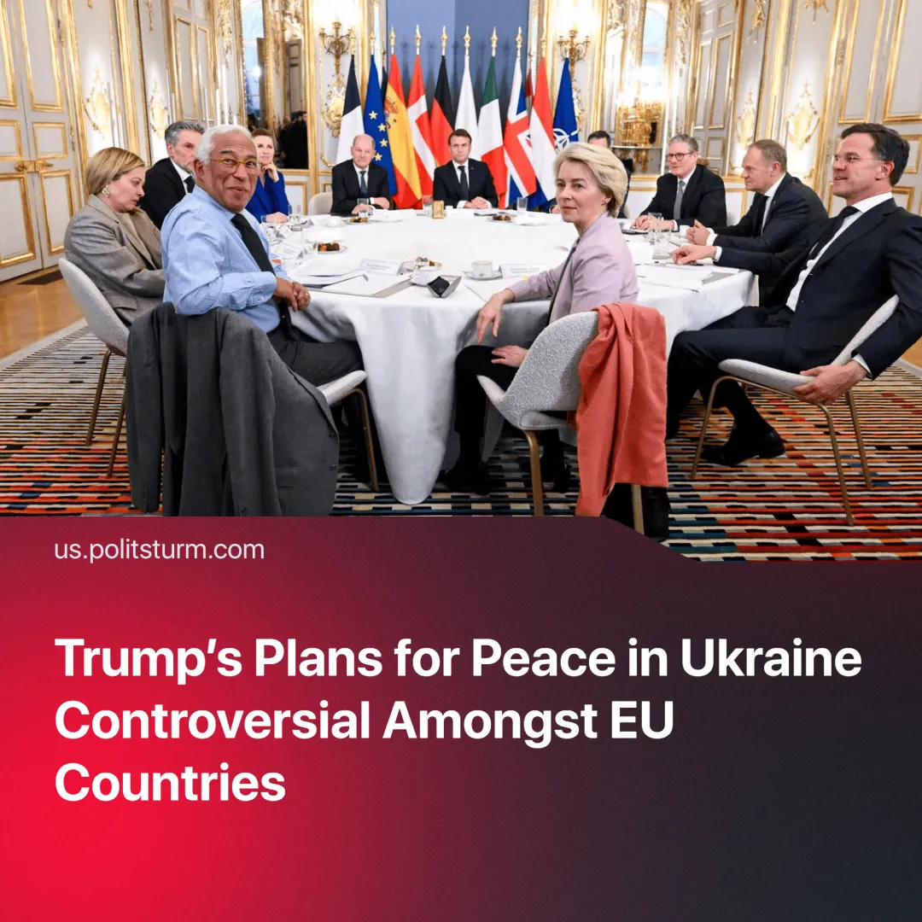

Original article
2025-02-21
2 min read

EU countries have reacted negatively to Trump’s intentions to initiate peace talks over the conflict in Ukraine.
Details. On 18th February talks began in Riyadh, Saudi Arabia, between Russian Foreign Minister Sergey Lavrov and U.S. Secretary of State Marco Rubio without Ukraine and the EU.
► EU countries have reacted negatively to this news. The phrase “no peace for Ukraine, without Ukraine” is being repeated by many European leaders.
► European leaders have gathered in Paris for an emergency summit on Ukraine. The Polish Prime Minister said that no decisions should be made without Ukraine and Europe.
► The UK Prime Minister, Keir Starmer, has said that "recent statements by the US administration should not come as a surprise" and that Europe will need to "take responsibility" for its security. He has also proposed to act as a bridge between Europe and the United States.
► The Paris talks also concluded that Europe should increase military spending and Starmer has stated he might consider deploying peacekeeping troops to Ukraine.
Context. As of January 2025, the EU has given approximately $145 billion in aid to Ukraine.
► Since Trump’s inauguration, the US has taken a more openly domineering stance with various other countries, including their allies: threats to annex Greenland (a part of Denmark – EU and NATO member), or threats to introduce tariffs on European goods.
► The crisis has had a significant economic impact on the European economy. EU firms have to deal with higher energy prices, reduced trade and potentially higher funding costs as banks try to avoid risk. In the year after the start of the conflict, the percentage of firms at risk of defaulting on their debt has surged from 10% to 17%.
► Additionally, Vice-President of the United States, JD Vance, recently gave a speech at the Munich Security Conference, where he attacked the EU for suppression of free speech and mishandling of migration. In his speech, he also defended the German far-right party, AfD.
Important to Know. EU concerns over Trump’s handling of the peace talks are not over genuine worry for the Ukrainian people, but rather due to conflicting interests between the USA and the EU.
► Trump attempts to gain control of a significant part of Ukraine’s rare earth minerals, valued at 500 billion USD. The US tries to reassert dominance over its sphere of influence and to force concessions out of other less powerful countries through the threat of tariffs.
► This is putting it directly into confrontation with the EU’s imperialist interests. Some European countries intend to lower tariffs on US goods to appease Trump, whilst others prepare retaliatory measures.
► Despite the tensions between the two blocs, Trump is still pushing for NATO members — many of whom are in the EU — to increase military spending. In the past, he has threatened to pull out of the military alliance should this demand not be met.
► However, military spending in the EU has already been increasing over the past eight years as they must ensure they are prepared for possible future conflicts.
Conclusion. The crisis over the Ukrainian peace talks, along with heightened tensions between the US and the EU, only exemplifies how capitalist alliances are temporary. New imperialist powers emerge and old ones fight to maintain or better their positions, a bitter struggle for the re-division of the world takes place. Workers of all nationalities are pitted against each other in the name of profit.

Original article

