Pandemic and Higher Food Prices Drive Hunger
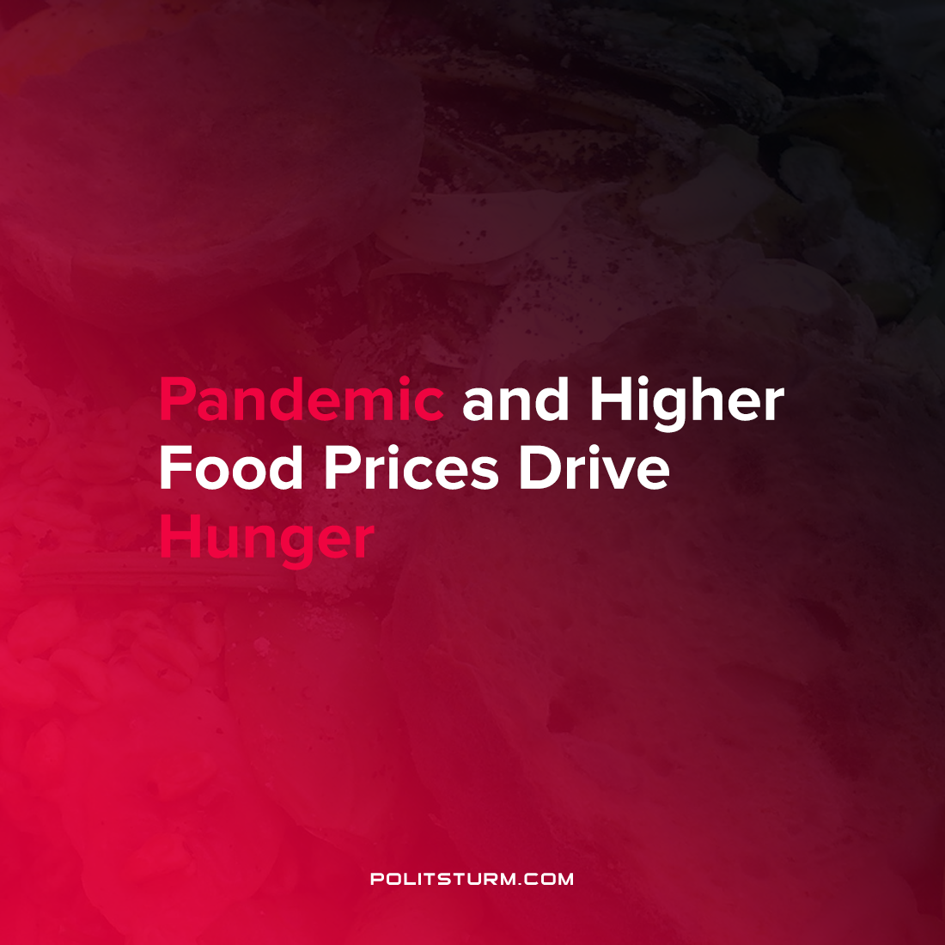

Original article
2021-08-13
1 min read

A report by the Food and Agriculture Organizations of the United Nations sought to research food insecurity and all forms of nutrition. Higher food costs and changes brought about by the COVID-19 pandemic are contributing to an increase in malnutrition.

“It has been estimated that with school closures during the COVID-19 pandemic, more than 320 million children around the world are missing out on school meals. As many of these children depend on the daily meals they receive at school for a large part of their daily nutrient requirements, the pandemic is aggravating the unaffordability of healthy diets to poor households” (The State of Food Insecurity and Nutrition in the World)
The projections of the report indicate that rather than eliminating or reducing malnutrition and hunger the world is set to see an increase in the coming years. The report estimates that an additional 83 to 132 million people were undernourished in 2020. Two billion people, roughly a quarter of the global population, experienced hunger in 2019.
In order to fight against this trend and to increase access to nutritious foods the report suggests the benefits of supporting small-scale food production who produce low cost food. However, one must acknowledge that the historical tendency of development is not towards fragmented, small-scale production but rather towards the increasing socialization of production on a large-scale.
The report acknowledges that enough food is produced to feed the global population and deems the current situation as unacceptable. However, it is impossible to abstract the issue of hunger away from the capitalist nature of food production which is anchored by profitability and returns to the private owners of the means of production. While on the one side there are problems associated with high-cost foods driving up food insecurity, on the other side the capitalists in this sector benefit from such an arrangement.
Source: 1

Original article

