Packers Sanitation Services Accused of Employing Child Labor
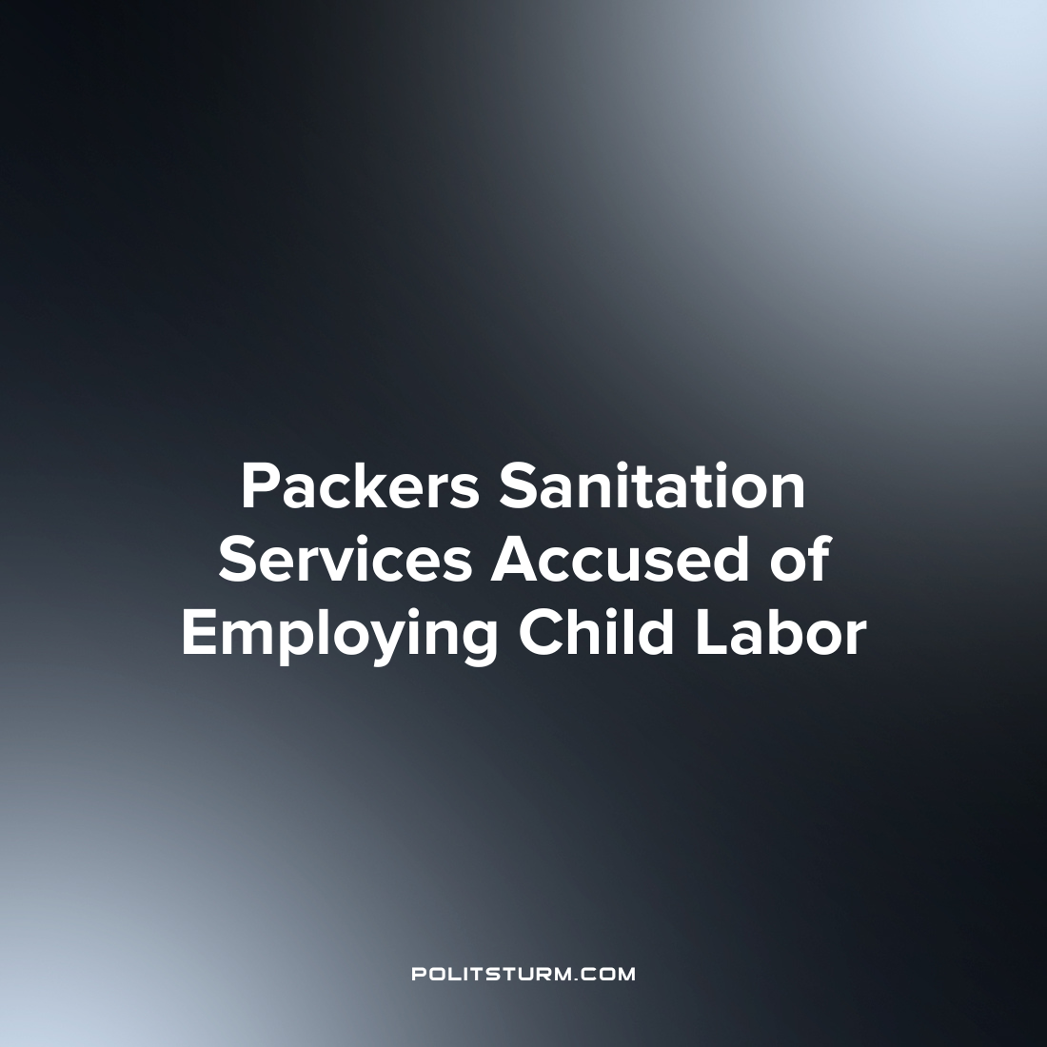

Original article
2022-11-12
1 min read

The U.S. Department of Labor (DOL) recently launched an investigation into the employment of minors in violation of the Fair Labor Standards Act. The company involved is called Packers Sanitation Services Inc., and it employs workers who primarily work in slaughterhouses and meat packing plants throughout the United States.
The federal investigation found that the company employed workers under the age of 14 at a JBS facility in Grand Island, Nebraska, and employed workers under the age of 16 to work overnight shifts. The Department also found that the company was employing minors to clean power equipment, including meat and bone cutting saws.
The DOL called on the court to issue an injunction that would restrain the company from using “oppressive child labor” at its workplaces throughout the country.
Capitalism has a long history of the capitalists using child labor and employing children in hazardous conditions. In order to maximize their profits, the capitalist class will take any action they deem necessary including the utilization of child labor in violation of child labor laws. While the investigation by the DOL did uncover the employment of child labor, the actions recommended by the department is to issue a restraining order to prevent the further employment of child labor. A government apparatus and court system under the control of the capitalist class will not end child labor as there will always be capitalists willing and able to break the law if employing child labor means increasing their profits.

Source: 1

Original article

