Over 50,000 British Railway Workers to Strike This Week
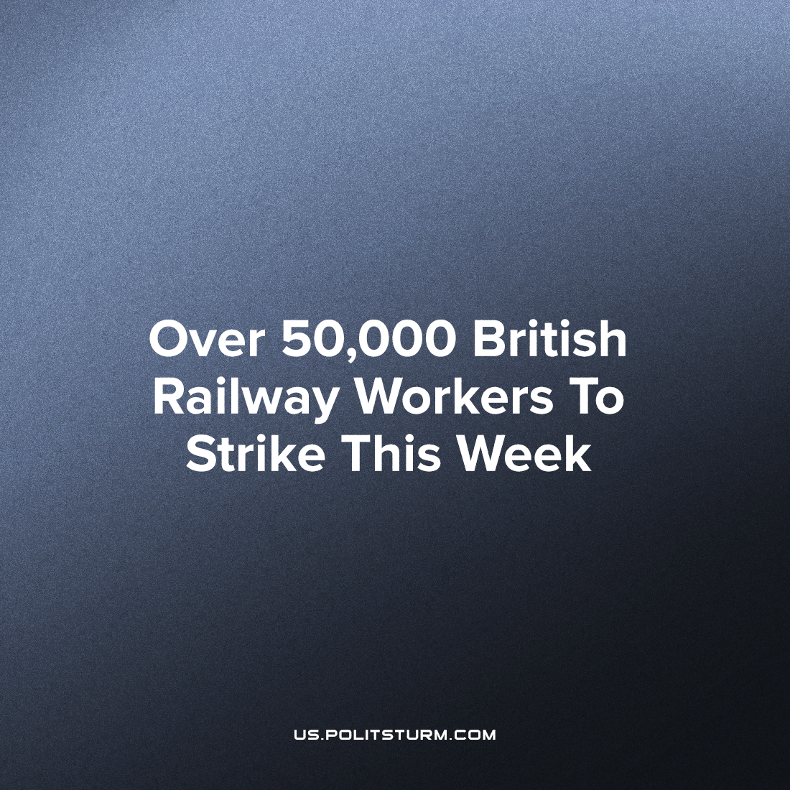

Original article
2022-06-21
4 min read

Britain’s biggest railway workers’ strike in 30 years, organized by the RMT Union, is taking place today. The union does not agree with the plans of companies to freeze the growth of salaries for employees and lay off some of them.
On the 24th of May, over 40,000 railway workers of the RMT (Rail, Maritime, and Transport) union balloted to strike for three days spread over this week. Unlike previous recent industrial action, this is not limited to train drivers and guards, but signallers and engineers too, meaning that maintenance, signalling and network co-ordination will also be affected. These jobs are highly skilled and along with the scale of the strikes (which are the largest rail strikes in the UK since 1989) makes hiring replacement strike-breakers not feasible. As a result of this, in addition to halting around 90% of passenger rail services, the strike will also affect a similar proportion of freight rail services which is the main supplier of goods for most retail (including grocers and supermarkets) across Great Britain. Coupled with the ongoing cost of living crisis, the strike could lead to widespread unrest and economic stoppage across the country.
Why are the RMT workers striking? Over the past few years thousands of railway workers have been made redundant and this year Network rail (the state monopoly on rail maintenance) have announced plans to cut annual expenditure by £100 million, in large part by firing 2,500 more rail maintenance workers. Not only is this a bleak prospect for those made redundant, but this will lead to 670,000 fewer hours of maintenance per year making British railway significantly less safe for passengers and workers alike. Similarly, workers’ pay has remained frozen and due to inflation alone (and not accounting for increased labour productivity) this means that in real terms each worker is paid on average 10% less than they were a couple years ago. At the same time Network rail have been outsourcing track renewals and engineering jobs, which could be done in-house for less. The executives demanding these cuts in expenditure are paid up to £585,000 a year, and the rail companies make over £500 million a year in profits. The executive’s callous response to the workers’ demands and as a justification for their own bloated salaries was essentially that the workers’ “should have worked harder in school”.
UK trade union law is amongst the most restrictive in Western Europe requiring mail-in votes with both a turnout of over 50% and a majority “yes” vote. Due to the fact that the vote must be send by mail (and cannot be in person), the union must maintain a contemporary address for each member. This law exists to make the organisation of such large scale strikes extremely difficult. In addition, the workers are employed by 15 different private rail service companies as well as the state monopoly on rail maintenance, which also serves to further hinder organisation and co-operation. Given these conditions, the fact that the RMT workers managed to gain a 71% turnout and an 89% majority is incredible. Despite this overwhelming majority, and the fact that this strike is in protest of an even greater share of the wealth created by the workers being ceded to the owners as well as to ensure the safety of the rail network which is in the interests of the public, the RMT workers are being demonised by the bourgeois media. Feigned concern about students missing education and patients missing appointments due to the strikes is common, while the leaders of the RMT union are stalked and endlessly slandered. Thankfully, the 1.4 million strong Unite union (as well as others) have promised industrial action of their own should the government infringe on the RMT workers’ right to strike.
Starting under the Margaret Thatcher regime, British rail industry and services have been privatised under the pretext of “increasing efficiency”. However, the price of British rail transport is the most expensive in Europe. In reality, it led to the birth of a private cartel in the rail transport industry, allowing the owners of this cartel’s ability to extort passengers and exploit the workers with greater ease, while at the same time, receiving billions of pounds of taxpayer money as subsidies. The so-called “Labour” party, when last in power, did nothing to halt or reverse the privatisations, and instead continued with them as well as initiating many of their own. The party’s nature is further revealed by the fact that it remains silent on these current strikes, and unsurprisingly many unions have cut ties and funding in recent years. As Lenin said more than 100 years ago:
“Of course, most of the [British] Labour Party’s members are workingmen. However, whether or not a party is really a political party of the workers does not depend solely upon a membership of workers but also upon the men that lead it, and the content of its actions and its political tactics. Only this latter determines whether we really have before us a political party of the proletariat. Regarded from this, the only correct, point of view, the Labour Party is a thoroughly bourgeois party, because, although made up of workers, it is led by reactionaries, and the worst kind of reactionaries at that, who act quite in the spirit of the bourgeoisie. It is an organisation of the bourgeoisie, which exists to systematically dupe the workers with the aid of the British Noskes and Scheidemanns.” – from “Speech On Affiliation To The British Labour Party”
While the efforts and goals of the striking workers’ is laudable, it must be recognised that should the strike succeed, victory will only be temporary. Capitalism is what led to the conditions where the workers’ wish to strike and will inevitably lead to the further impoverishment of not just the British railway workers, but workers all over the world. The only permanent solution to unemployment, workplace safety and the cost of living is socialism. And only a truly communist party can successfully lead the workers in moving the class struggle from the purely economic sphere to the political one.
Sources:
https://www.rmt.org.uk/news/rmt-declares-overwhelming-mandate-for-national-strike-action-on/
https://inews.co.uk/news/rail-strike-rmt-walkout-cancel-trains-freight-running-day-food-energy-shortages-1675416
https://www.rmt.org.uk/news/members-updates/rates-of-pay-and-conditions-of-service-2021–network-rail140222
https://www.rmt.org.uk/news/rmt-launch-3-days-of-national-train-strike-action/
https://www.tssa.org.uk/find-your-company/network-rail/news/nr-top-bosses-and-what-they-are-paid
https://www.tuc.org.uk/news/rail-cuts-will-compromise-safety-loss-670000-maintenance-hours-tuc-report#:~:text=Network%20Rail%20plans%20to%20cut%20annual%20expenditure%20by%20%C2%A3100,hours%20of%20maintenance%20work%20annually
https://www.tssa.org.uk/news-and-events/tssa-news/network-rail-leaders-offensive-and-out-of-touch-on-pay
https://www.local.gov.uk/our-support/workforce-and-hr-support/employment-relations/employment-law-topics-and-e-guides-6#:~:text=Only%20where%20such%20a%20ballot,voted%20to%20support%20the%20action.
https://www.unitetheunion.org/news-events/news/2022/may/unite-vows-to-confront-head-on-any-further-attacks-on-the-right-to-strike/
https://www.dailymail.co.uk/news/article-10922403/How-RMT-rail-strike-affect-London-Underground-Overground.html
https://www.vouchercloud.com/resources/train-prices-across-europe
https://www.marxists.org/archive/lenin/works/1920/jul/x03.htm#fw6

Original article

