Over 35% of Americans Face Eviction and Foreclosure
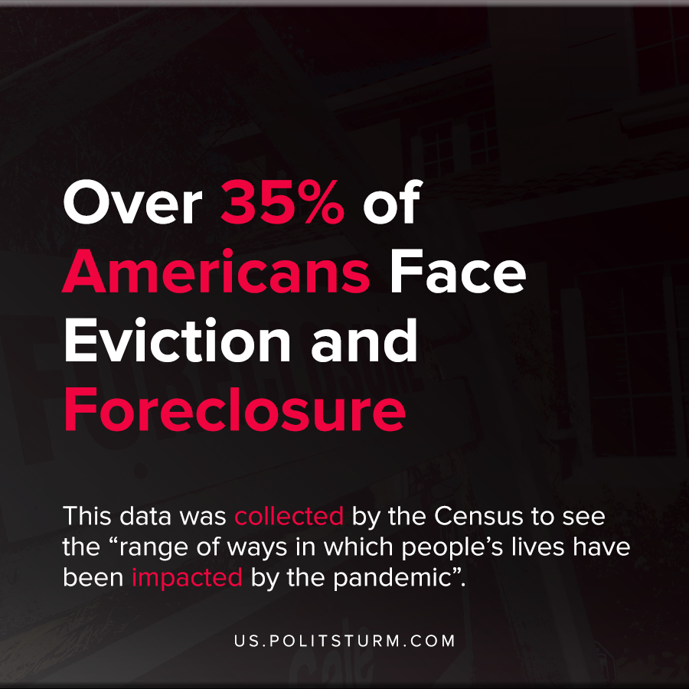

Original article
2020-12-22
1 min read

According to new Census Data, the percentage of American adults who are likely to be evicted or get foreclosed on is 35.5%. This figure is even more troubling for Washington, D.C. with an alarming 67.3% being at risk.
The survey takes the percentage of adults who are not current on their rent or mortgage payments and are likely or somewhat likely to be evicted or foreclosed upon in the next two months.
This data was collected by the Census to see the “range of ways in which people’s lives have been impacted by the pandemic”.
The workers who have lost employment during the crisis and have drawn down their savings are at risk for eviction and foreclosure. While the official unemployment figures have been on a decline since early this year, 2.2 million Americans have dropped out of the labor force entirely since February.
Private ownership over housing puts millions of Americans at risk of homelessness and in a very desperate position. The landlords and capitalist speculators benefit from this arrangement and extract material wealth in the form of rents and profits, while millions suffer the consequences.
Source: 1 , 2

Original article

