OSHA Fines Amazon $15,625 After Repeated Worker Safety Violations
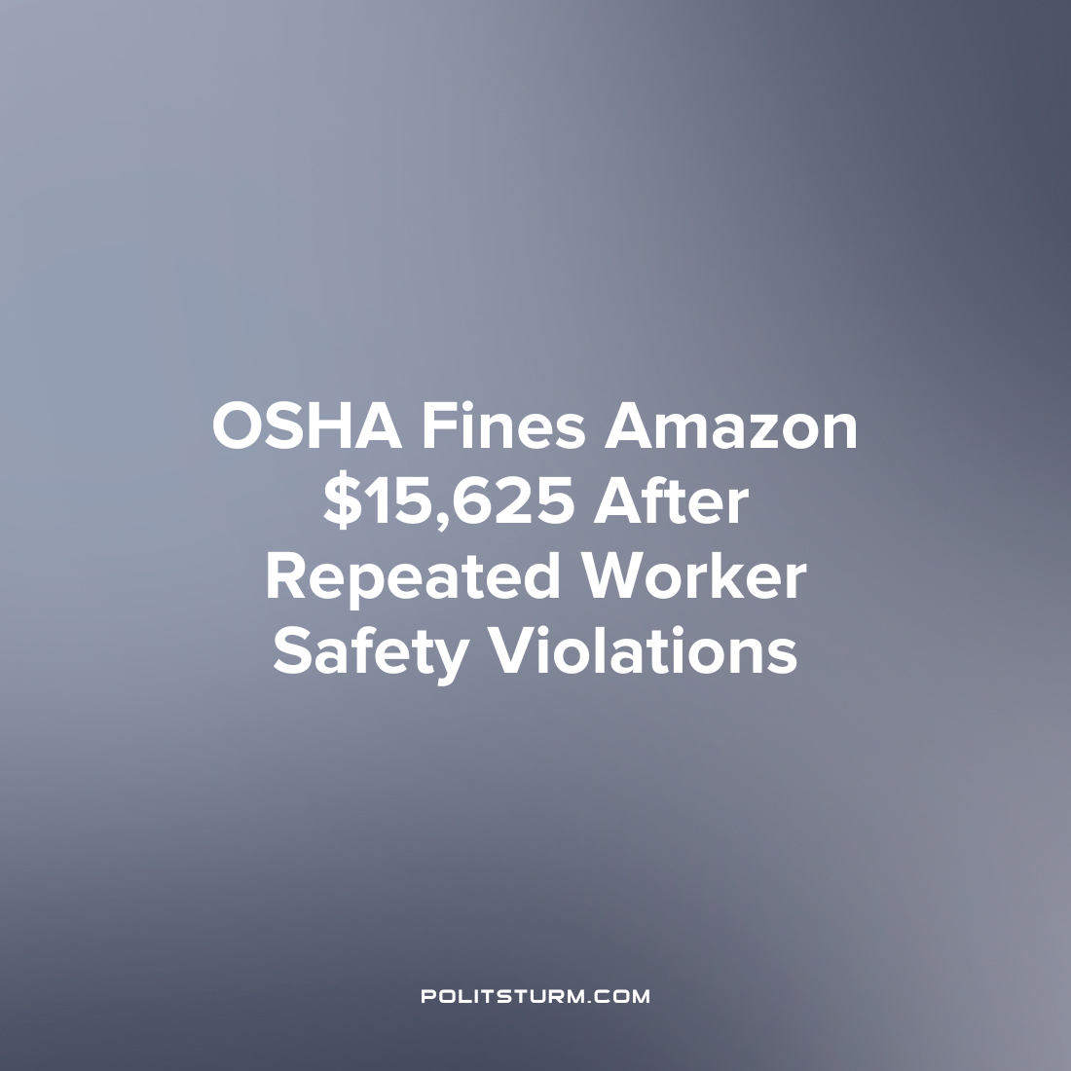

Original article
2023-03-02
1 min read

The U.S. Occupational Safety and Health Administration (OSHA) provided a news release where it cited Amazon “again” for exposing its workers to ergonomic hazards at work. This specific citation against Amazon was at the Colorado Springs, Colorado delivery station where an inspection came after a worker complained of a musculoskeletal disorder related to their processing speed at work and blocked fire exits.
The Colorado Springs location processed 5,000-10,000 packages per hour and up to 50,000 packages in a day. This is the third citation from the administration that has occurred against Amazon in 2023 alone, with the previous citations being related to similar violations that occurred across six locations.
“We continue to find that Amazon's work processes are designed for speed, not safety, and that these processes cause serious injuries to workers. Amazon needs to focus more of its passion for innovation and performance on eliminating the hazards that injure workers.” said OSHA Assistant Secretary Doug Parker.
In order to dissuade Amazon, OSHA proposed a fine of $15,625. Here we can see that the capitalists will favor the speed of production and the maximization of profits directly over the safety for the workers, and only face a minimal fine. Again, the capitalists can incorporate these fines as a cost of doing business and will continue running their operations in a manner which ensures the maximum profit despite the social consequences.
Source: 1

Original article

