Opioid Crisis Has Killed 500,000 Americans
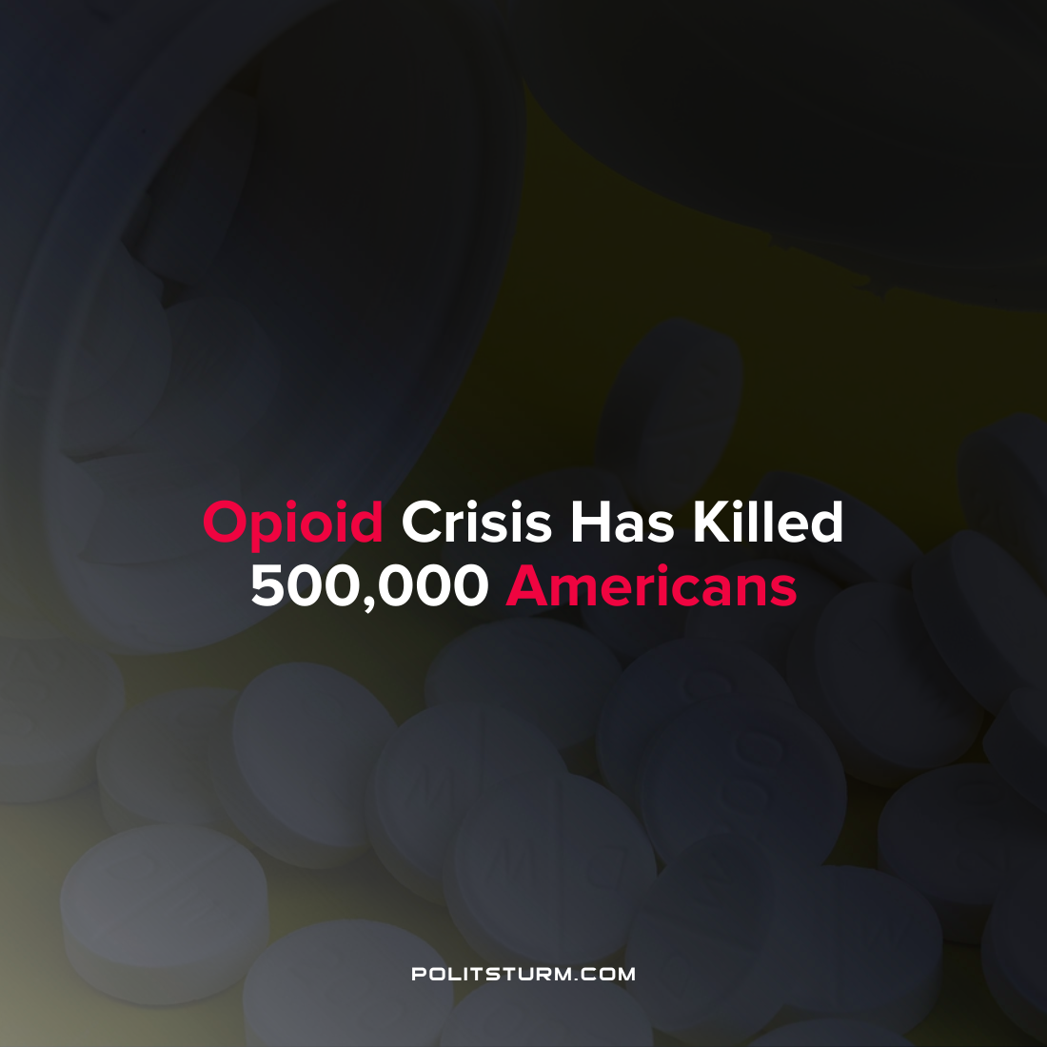

Original article
2022-04-22
1 min read

According to a report conducted by the House Committee on Oversight and Reform, a well-known private consulting firm McKinsey was advising opioid pharmaceutical giant Purdue Pharma while simultaneously contracting with the U.S government to regulate opioids. The opioid crisis has killed more than half a million Americans, primarily in rural areas of the country.

McKinsey has a long history of contracting with the Federal government and has received contracts valued at $956.2 million in taxpayer funds between 2006 and 2019. McKinsey was also instrumental in working with opioid manufacturers since 2004 such as Purdue, Johnson & Johnson, Mallinckrodt Pharmaceuticals and Endo International. Purdue’s OxyContin netted $35 billion in sales for the company due in part to McKinsey’s strategic initiatives to “Turbocharge Purdue’s Sales Engine”.

The report also alleges that McKinsey used its ties to the regulators as a way to solicit more business in the private sector by implying that due to its connections McKinsey consultants had “developed insights into the perspectives of the regulators themselves”. The obvious conflict of interest arises where a consultant firm working with private pharmaceutical companies is simultaneously advising the governmental agencies tasked with regulating said pharmaceuticals.

The findings of the committee are just another example of regulatory capture by private capitalist firms. McKinsey reaped massive government and private contracts and acted in a way to maximize its own profits, and the profits of pharmaceutical manufacturers. In doing so, the American taxpayers subsidized private corporations to provide consulting services to private and public entities which ultimately ended up distributing and regulating prescription opioids in a manner that killed half a million Americans. The problem is not simply a manner of insufficient regulation and conflicts of interest as McKinsey insists it acted in a lawful manner and was acting to maximize its profits. The problem is with the capitalist economic arrangement which drives private companies to maximize profits at all costs, including the lives of countless Americans.
Source: 1 2

Original article

