Once More About Soviet Soldiers' Courage
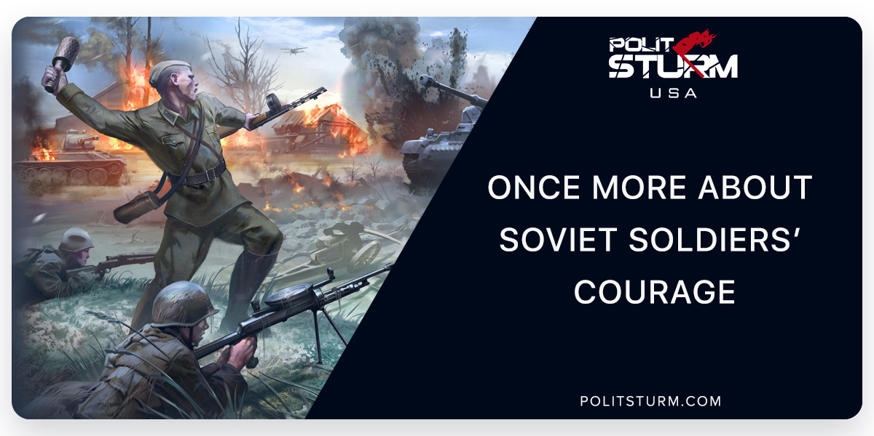

Original article
2018-05-09
9 min read

Myth: Soviet soldiers fought for fear of being executed.
In Russian historiography, the Second World War is called the Great Patriotic War for a reason. There wasn’t any family that hadn’t contributed to the victory over fascism following the slogan “All for the Front! All for Victory!”. Soviet citizens understood that either they would be able to defend themselves, their children and their country, or they would be destroyed and enslaved, and the majority of them immediately responded to the call of the Motherland.
In the first days of the war, long queues of volunteers stood near enlistment offices. In Moscow alone, the Red Army accepted more than 70 thousand applications for war service for 3 days. Those men who were physically unfit and teenagers who corrected their date of birth in the documents also craved to get to the front. In the summer and autumn of 1941, there were about 60 divisions and 200 separate militia regiments created, which approximately numbered 2 million people. Nobody kept out of it. Even the children of high-ranking party members didn’t hole up in the hinterland, but fought along with others. Many of them didn’t come back home, e.g., Stalin’s elder son Jacob, Frunze’s son Timur, Mikoyan’s son Vladimir, Khrushchev’s son Leonid, Voroshilov’s nephew Nikolay.
So-called “mass patriotism” was common. In the early morning of 22 June the fist attack on Brest Fortress was made. The forces of the German invaders, exceeding the number of the fortress defenders two times, destroyed cooperative defenses in a week, but isolated defensive groups and single soldiers retained hold of the fortress for more than 25 days by themselves.
Practically every division had heroes who had sacrificed their lives for the common victory over fascism: they opened attacks, took machine-gun fire with their own bodies, rammed German planes in the air. So, what was the reason for the mass heroism of Soviet soldiers? It was rooted not in superior orders and commands or a fear of being shot, but out of love for their homeland and awareness of the brutal truth of war: there could be only one winner.
The myth that Soviet soldiers fought solely for fear of being shot appeared mainly due to the wrong interpretation of Order No. 227 by the People’s Commissar of Defence of the USSR, known as the “Not one step back!” order. Usually, liberals, defenders of a narrow-minded humanism, often cite it as an argument proving the “inhumanity” of Stalin’s regime, but at the same time they forget that political methods in peace and war differ significantly.
In July of 1942, the Red Armies was in a poor condition. Moscow had been saved, but the front line lay only 150 km far from it. After the defeat near the capital, the Germans increased pressure and every day moved inland dozens of kilometers, capturing new cities and territories. Overestimation of their own forces and strategic blunders by Soviet leaders were the main reasons for the setbacks in the summer of 1942. In May the military operations at Kharkov and on Kerch Peninsula failed. The 4th tank army under Generaloberst Hoth broke through the front and rushed to the Don River on 28 June. The Germans partly captured Voronezh on 7 July, seized Rostov-on-Don on 23 July and continued moving to the North Caucasus and the Volga. The key agricultural and industrial areas with a population of about 70 million people became occupied. The Red Army retreated further inland.
All these facts forced Stalin to issue Order No. 227 of July 28, 1942. The order wasn’t published, but read « in all companies, cavalry squadrons, batteries, squadrons, commands and headquarters» and affected people deeply.
From the very first lines, the Supreme Commander honestly and openly declared that the Soviet Union bore terrible losses:
«Each commander, Red Army soldier and political commissar should understand that our means are not limitless. The territory of the Soviet state is not a desert, but people – workers, peasants, intelligentsia, our fathers, mothers, wives, brothers, children. The territory of the USSR which the enemy has captured and aims to capture is bread and other products for the army, metal and fuel for industry, factories, plants supplying the army with arms and ammunition, railroads… We have lost more than 70 million people, more than 800 million pounds of bread annually and more than 10 million tons of metal annually. Now we do not have predominance over the Germans in human reserves, in reserves of bread.»
These bitter, harsh words contrasted with the usual war propaganda which tried to emphasize only the success of the Red Army. Many people understood the main message that Stalin had wanted to bring home:
«To retreat further – means to waste ourselves and to waste at the same time our Motherland… Therefore it is necessary to eliminate talk that we have the capability endlessly to retreat, that we have a lot of territory, that our country is great and rich, that there is a large population, and that bread always will be abundant.… Not one step back! »
Is it possible to allow one part of an army to fight a fierce battle with an enemy and the other to run into the bushes leaving their comrades to die? In such moments, situations when a tired and demoralized army could turn back because of a few cowards and alarmists were really dangerous. « Part of the troops of the Southern front, following the panic-mongers, have left Rostov and Novochercassk without severe resistance and without orders from Moscow, covering their banners with shame.»
To strengthen discipline, Order No. 227 introduced the widespread creation of blocking units, and companies of penal battalions.
As for the blocking units, they had been used on separate fronts from the beginning of the war, but in August 1942 they were formed on all fronts. Stalin’s order demanded they «put them directly behind unstable divisions and require them in case of panic and scattered withdrawals of elements of the divisions to shoot in place panic-mongers and cowards and thus help the honest soldiers of the division execute their duty to the Motherland». However, ordinary people, and not “canibals” served among the barrier troops. They could open fire above the heads of running detachments or shoot cowards and alarmists in the front of a line, but every case was tried individually. None of the researchers have managed to find in the archives any fact confirming that blocking units shot to kill their own soldiers.
Anywhere from one to three penal battalions of 800 men on each front were intended for guilty officers, and penal companies (of 150-200 people, from five to ten in every army) were organized for soldiers and sergeants. Commanders and commissars from the battalion level and higher could be punished only by a verdict from the Front Military Tribunal; personal orders of the division commander or the commander of the army were required to punish junior officers; soldiers could be ordered by the regimental commander. Penalized soldiers (of all ranks) were usually sent to the hottest parts of the front «to give them an opportunity to redeem by blood their crimes against the Motherland». Average month losses in penal companies were 3-6 times higher than losses in common infantry companies, but we shouldn’t consider them condemned men. Some of them managed to be placed in penal companies several times and survive. A soldier could be sent to a penal unit for a period of 1 to 3 months and could also be set free on parole for battle honors or being wounded in action.
What could one get penalized for? Nowadays, former penal “heroes” like to complain about the hardships of life and barrier troops “breathing” on them from behind, but a few of them explain why they were sent to penal units. As a rule, they were sent there for military crimes: cowardice, disobedience, desertion, evading a battle, imitation of medical reports and bread tickets, dereliction of duty, intentional damage of equipment, etc.
Was it possible to find a more humane method of influence? Maybe there was, but since the days of Ancient Greece, where penalty units appeared, people haven’t invented anything new. While the penalty units had higher mortality rates than the normal combat battalions, this was much more humane than other possible alternatives; being shot on the spot.
427,910 people were sent to penal units during the war. In general, 34,476,700 people served in the Soviet Armed Forces in the same period. So, it turns out that the proportion of soldiers who were in penal companies and battalions was only 1.24%. Contrary to the assurances of the unscrupulous writers, the penal contribution to the Victory is relatively modest.
Thus, the vast majority of the Soviet citizens fought not because of a fear of shooting, but because they knew that every one of them was responsible for the salvation of the USSR, their homeland. The “Not one step back!” order became one of the most memorable during the war years, not only because of cruel, but necessary measures imposed by Stalin, but also because his words awakened the Soviet people and pointed the way to victory.

Original article

